UNITED STATES
SECURITIES AND EXCHANGE COMMISSION
Washington, DC 20549

FORM 8-K

CURRENT REPORT
PURSUANT TO SECTION 13 OR 15(d) OF THE
SECURITIES EXCHANGE ACT OF 1934

DATE OF REPORT (Date of earliest event reported): July 22, 2026

FIRST MERCHANTS CORPORATION
(Exact name of registrant as specified in its charter)
Indiana
(State or other jurisdiction of incorporation)
001-41342 |  |  | 35-1544218
(Commission File Number) |  |  | (IRS Employer Identification No.)

200 East Jackson Street
P.O. Box 792
Muncie, IN 47305-2814
(Address of principal executive offices, including zip code)

(765) 747-1500
(Registrant's telephone number, including area code)

Not Applicable
(Former name or former address, if changed since last report)
Title of Each Class |  |  | Trading Symbol(s) |  |  | Name of each exchange on which registered
Common Stock, $0.125 stated value per share |  |  | FRME |  |  | The Nasdaq Stock Market LLC
Depositary Shares, each representing a 1/100th interest in a share of Non-Cumulative Perpetual Preferred Stock, Series A |  |  | FRMEP |  |  | The Nasdaq Stock Market LLC

Check the appropriate box below if the Form 8-K filing is intended to simultaneously satisfy the filing obligation of the registrant under any of the following provisions:

☐ Written communications pursuant to Rule 425 under the Securities Act (17 CFR 230.425)
☐ Soliciting material pursuant to Rule 14a-12 under the Exchange Act (17 CFR 240.14a-12)
☐ Pre-commencement communications pursuant to Rule 14d-2(b) under the Exchange Act (17 CFR 240.14d-2(b))
☐ Pre-commencement communications pursuant to Rule 13e-4(c) under the Exchange Act (17 CFR 240.13e-4(c))

Indicate by check mark whether the registrant is an emerging growth company as defined in Rule 405 of the Securities Act of 1933 (§230.405 of this chapter) or Rule 12b-2 of the Securities Exchange Act of 1934 (§240.12b-2 of this chapter).

Emerging growth company ☐

If an emerging growth company, indicate by check mark if the registrant has elected not to use the extended transition period for complying with any new or revised financial accounting standards provided pursuant to Section 13(a) of the Exchange Act. ☐

ITEM 2.02 RESULTS OF OPERATIONS AND FINANCIAL CONDITION.

On July 22, 2026, First Merchants Corporation issued a press release to report its financial results for the second quarter ended June 30, 2026. A copy of the press release is furnished as Exhibit 99.1 to this Current Report on Form 8-K.

On July 23, 2026, First Merchants Corporation will conduct a second quarter 2026 earnings conference call and webcast at 9:00 a.m. (ET). A copy of the slide presentation utilized on the conference call is furnished as Exhibit 99.2 to this Current Report on Form 8-K.

The information in this Current Report on Form 8-K, including Exhibit 99.1 and Exhibit 99.2 hereto, shall not be deemed "filed" for purposes of Section 18 of the Securities Exchange Act of 1934, as amended, or otherwise subject to liability of that section. The information in this Current Report shall not be incorporated by reference into any filing or other document pursuant to the Securities Act of 1933, as amended, except as shall be expressly set forth by specific reference in such filing or document.

ITEM 9.01 FINANCIAL STATEMENTS AND EXHIBITS.

(a) Not applicable.

(b) Not applicable.

(c) Not applicable.

(d) Exhibits.

Exhibit 99.1 |  |  | Press Release, dated July 22, 2026, issued by First Merchants Corporation
Exhibit 99.2 |  |  | Slide Presentation, utilized on July 23, 2026 during conference call and webcast by First Merchants Corporation
Exhibit 104 |  |  | Cover Page Interactive Data File (embedded within the Inline XBRL document)

SIGNATURES

Pursuant to the requirements of the Securities Exchange Act of 1934, the Registrant has duly caused this report to be signed on its behalf by the undersigned hereunto duly authorized.

First Merchants Corporation
(Registrant)
By: /s/ Michele M. Kawiecki

Michele M. Kawiecki

Executive Vice President, Chief Financial Officer
(Principal Financial and Accounting Officer)
Dated: July 22, 2026

EXHIBIT INDEX

Exhibit No. |  |  | Description
99.1 |  |  | Press Release, dated July 22, 2026 issued by First Merchants Corporation
99.2 |  |  | Slide Presentation, utilized on July 23, 2026 during conference call and webcast by First Merchants Corporation
104 |  |  | Cover Page Interactive Data File (embedded within the Inline XBRL document)

N / E / W / S R / E / L / E / A / S / E

July 22, 2026

FOR IMMEDIATE RELEASE
For more information, contact:
Nicole M. Weaver, First Vice President and Director of Corporate Administration
765-521-7619
http://www.firstmerchants.com

SOURCE: First Merchants Corporation, Muncie, Indiana

FIRST MERCHANTS CORPORATION ANNOUNCES SECOND QUARTER 2026 RESULTS

First Merchants Corporation (NASDAQ - FRME) (the "Corporation" or "First Merchants")

Second Quarter 2026 Highlights:

•Net income available to common stockholders was $43.5 million, or $0.70 per diluted common share, compared to $27.7 million, or $0.45 per diluted common share, in the first quarter of 2026. On an adjusted basis1, net income totaled $46.4 million, or $0.74 per diluted common share, compared to $63.1 million, or $1.03 per diluted common share in the prior quarter.
•Adjusted pre-tax, pre-provision income1 of $84.6 million, compared to $78.7 million in the prior quarter and $70.7 million in the second quarter of 2025.
•Net interest margin on a fully taxable equivalent basis1 of 3.38%, up 3 basis points from the prior quarter and up 13 basis points from the second quarter of 2025.
•Loan growth of $221.7 million, or 5.8% annualized, on a linked quarter basis2.
•Sold $271.1 million of mortgage loans with a weighted average rate of 3.43% during the current quarter and deployed proceeds to fund loan growth and pay down high-cost funding. The loans had been moved to held-for-sale and marked to fair value in the first quarter.
•Deposit growth of $267.8 million, or 6.5% annualized, on a linked quarter basis.
•Robust capital position with Common Equity Tier 1 Capital Ratio of 11.16%.
•Repurchased 976,631 shares of common stock totaling $38.3 million year-to-date, including 336,145 shares totaling $13.4 million in the second quarter.
•Nonperforming assets to total assets were 56 basis points compared to 43 basis points on a linked quarter basis. Two commercial lending relationships with outstanding balances totaling $41.8 million were placed in nonaccrual status and associated reserves of $29.7 million were recorded.
•Adjusted efficiency ratio1 totaled 53.22% for the quarter.
•Successfully completed systems conversion of First Savings Financial Group, Inc. (“First Savings”) in mid-May.

"First Merchants continued to build momentum during the second quarter with expanding net interest margin, solid loan and deposit growth, and another quarter of strong commercial loan production," said Mark Hardwick, Chief Executive Officer. "While we identified two commercial lending relationships that were placed on nonaccrual, we acted promptly to recognize the associated reserves and believe our balance sheet remains well positioned. We successfully completed the integration of First Savings, further strengthening our statewide Indiana franchise and enhancing our ability to serve clients across Indiana, Ohio and Michigan. Our capital, liquidity and credit quality remain very strong and position us well to execute our long-term growth strategy and continue creating shareholder value."

Second Quarter Financial Results:

The Corporation reported second quarter 2026 net income available to common stockholders of $43.5 million compared to $56.4 million during the same period in 2025. Diluted earnings per common share for the period totaled $0.70 compared to $0.98 in the second quarter of 2025. Current quarter results included acquisition-related costs of $3.8 million that consist primarily of employee salaries, equipment, and professional fees. Excluding these non-core charges, adjusted earnings per common share1 for the second quarter of 2026 totaled $0.74 compared to $0.98 in the prior year period. Subsequent to quarter-end, based on additional information obtained regarding conditions that existed at June 30, 2026, two commercial lending relationships were placed on nonaccrual status and reserve levels were increased, resulting in elevated provision expense for the second quarter. The first was a $28.1 million participation in a shared national credit to a commercial authorized wireless retailer. The second was a credit to a commercial and residential roofing contractor with an outstanding balance of $13.7 million. Associated reserves for these credits totaled $29.7 million.

Total assets of the Corporation equaled $21.3 billion as of quarter-end and loans totaled $15.5 billion. Loans increased $2.2 billion during the last twelve months and $268.8 million on a linked quarter basis. During the second quarter, the Corporation completed the previously announced sale of $271.1 million of mortgage loans that had been transferred to held-for-sale during the first quarter. Additionally, mortgage loans totaling $47.1 million were returned to held-for-investment during the second quarter. Excluding loans acquired through First Savings and the impact of mortgage loan sale activity, the Corporation generated organic loan growth of $697.9 million, or 5.2% during the past twelve months. On a linked quarter basis, organic loan growth totaled $221.7 million, or 5.8% annualized.

Investment securities, totaling $3.3 billion, decreased $88.9 million, or 2.6% during the last twelve months and decreased $17.8 million, or 2.2% annualized on a linked quarter basis. Investment securities declined during the quarter due to principal paydowns and maturities, offset by an increase in the securities portfolio valuation.

Total deposits equaled $16.8 billion as of quarter-end and increased by $2.0 billion over the past twelve months. The acquisition of First Savings contributed $1.7 billion in deposits. Total deposits increased $267.8 million, or 6.5% annualized, on a linked quarter basis. The loan to deposit ratio of 92.7% at period end remained stable on a linked quarter basis.

The Corporation’s Allowance for Credit Losses – Loans (ACL) totaled $241.6 million as of quarter-end, or 1.56% of loans, an increase of $29.1 million from the prior quarter. Net charge-offs totaled $3.9 million and provision for credit losses of $33.0 million was recorded during the quarter. Reserves for unfunded commitments totaling $18.5 million remained unchanged from the previous quarter. Nonperforming assets to total assets were 0.56% for the second quarter of 2026, an increase of 13 basis points compared to 0.43% in the prior quarter. The increase in nonperforming assets and provision for credit losses reflects the impact of the two commercial lending relationships placed in nonaccrual status.

Net interest income, totaling $158.9 million for the quarter, increased $7.6 million, or 5.0%, compared to prior quarter and increased $25.9 million, or 19.5%, compared to the second quarter of 2025. Fully taxable equivalent net interest margin was 3.38%, an increase of three basis points compared to the prior quarter and an increase of 13 basis points compared to the second quarter of 2025.

Noninterest income totaled $37.2 million for the quarter, an increase of $31.3 million, compared to the prior quarter and an increase of $5.9 million compared to the second quarter of 2025. The linked quarter increase primarily reflects the negative valuation adjustment of $29.8 million recorded in the first quarter on mortgage loans sold in the second quarter. Also contributing to the increase were higher gains on sales of loans and derivative hedge fees.

Noninterest expense totaled $115.3 million for the quarter, a decrease of $9.8 million from the prior quarter and an increase of $21.7 million from the second quarter of 2025. Acquisition-related costs totaling $3.8 million were incurred during the quarter, including $1.4 million in professional and other outside services and $1.0 million in equipment costs. Acquisition-related costs recorded in the prior quarter totaled $17.0 million.

The Corporation’s total risk-based capital ratio equaled 12.98%, the common equity tier 1 capital ratio equaled 11.16%, and the tangible common equity ratio totaled 8.99%. These ratios continue to reflect the Corporation’s strong capital position.

1 See “Non-GAAP Financial Information” for reconciliation
2 Excludes $47.1 million of loans returned to held-for-investment from held-for-sale

CONFERENCE CALL

First Merchants Corporation will conduct an earnings conference call and webcast at 9:00 a.m. (ET) on Thursday, July 23, 2026.

To access via phone, participants will need to register using the following link where they will be provided a phone number and access code: (https://register-conf.media-server.com/register/BIc1f6f98686534d529e7f3d66c4d50b16)

To view the webcast and presentation slides, please go to (https://edge.media-server.com/mmc/p/hqyvbr3q) during the time of the call. A replay of the webcast will be available until July 23, 2027.

Detailed financial results are reported on the attached pages.

About First Merchants Corporation

First Merchants Corporation is a financial holding company headquartered in Muncie, Indiana. The Corporation has one full-service bank charter, First Merchants Bank. The Bank also operates as First Merchants Private Wealth Advisors (as a division of First Merchants Bank).

First Merchants Corporation’s common stock is traded on the NASDAQ Global Select Market System under the symbol FRME. Quotations are carried in daily newspapers and can be found on the company’s Internet web page (http://www.firstmerchants.com).

FIRST MERCHANTS and the Shield Logo are federally registered trademarks of First Merchants Corporation.

Forward-Looking Statements

This news release contains forward-looking statements made pursuant to the safe-harbor provisions of the Private Securities Litigation Reform Act of 1995. Such forward-looking statements can often, but not always, be identified by the use of words like “believe”, “continue”, “pattern”, “estimate”, “project”, “intend”, “anticipate”, “expect” and similar expressions or future or conditional verbs such as “will”, “would”, “should”, “could”, “might”, “can”, “may”, or similar expressions. These forward-looking statements include, but are not limited to, statements relating to the expected benefits of the merger between First Merchants and First Savings, including future financial and operating results, cost savings, enhanced revenues, and accretion/dilution to reported earnings that may be realized from the merger, as well as other statements of expectations regarding the merger, and other statements of First Merchants’ goals, intentions and expectations; statements regarding the First Merchants’ business plan and growth strategies; statements regarding the asset quality of First Merchants’ loan and investment portfolios; and estimates of First Merchants’ risks and future costs and benefits, whether with respect to the merger or otherwise. These forward-looking statements are subject to significant risks, assumptions and uncertainties that may cause results to differ materially from those set forth in forward-looking statements, including, among other things: the risk that the businesses of First Merchants and First Savings will not be integrated successfully or such integration may be more difficult, time-consuming or costly than expected; expected revenue synergies and cost savings from the merger may not be fully realized or realized within the expected time frame; revenues following the merger may be lower than expected; customer and employee relationships and business operations may be disrupted by the merger; possible changes in monetary and fiscal policies, and laws and regulations; the effects of easing restrictions on participants in the financial services industry; the cost and other effects of legal and administrative cases; possible changes in the credit-worthiness of customers and the possible impairment of collectability of loans; fluctuations in market rates of interest; competitive factors in the banking industry; changes in the banking legislation or regulatory requirements of federal and state agencies applicable to bank holding companies and banks like First Merchants’ affiliate bank; continued availability of earnings and excess capital sufficient for the lawful and prudent declaration of dividends; changes in market, economic, operational, liquidity (including the ability to grow and maintain core deposits and retain large uninsured deposits), credit and interest rate risks associated with First Merchants’ business; the impacts of epidemics, pandemics or other infectious disease outbreaks; and other risks and factors identified in each of First Merchants’ filings with the SEC. First Merchants undertakes no obligation to update any forward-looking statement, whether written or oral, relating to the matters discussed in this news release. In addition, First Merchants’ past results of operations do not necessarily indicate their anticipated future results.

Non-GAAP Financial Measures

This news release contains non-GAAP financial measures. For purposes of Regulation G, a non-GAAP financial measure is a numerical measure of the registrant’s historical or future financial performance, financial position or cash flows that excludes amounts, or is subject to adjustments that have the effect of excluding amounts, that are included in the most directly comparable measure calculated and presented in accordance with GAAP in the statement of income, balance sheet or statement of cash flows (or equivalent statements) of the issuer; or includes amounts, or is subject to adjustments that have the effect of including amounts, that are excluded from the most directly comparable measure so calculated and presented. In this regard, GAAP refers to generally accepted accounting principles in the United States. Pursuant to the requirements of Regulation G, First Merchants Corporation has provided reconciliations within this news release, as necessary, of the non-GAAP financial measure to the most directly comparable GAAP financial measure.

* * * *

CONSOLIDATED BALANCE SHEETS (Unaudited)
(Dollars In Thousands, Except Per Share Amounts) |  |  | June 30,
 |  |  | 2026 |  |  |  |  |  | 2025
ASSETS
Cash and due from banks |  |  | $ | 86,665 |  |  |  |  | $ | 81,567
Interest-bearing deposits |  |  | 529,432 |  |  |  |  |  | 223,343
Investment securities available for sale |  |  | 1,384,392 |  |  |  |  |  | 1,358,130
Investment securities held to maturity, net of allowance for credit losses of $245 in 2026 and 2025 |  |  | 1,907,684 |  |  |  |  |  | 2,022,826
Loans held for sale |  |  | 77,880 |  |  |  |  |  | 28,783
Loans |  |  | 15,530,737 |  |  |  |  |  | 13,296,759
Less: Allowance for credit losses - loans |  |  | (241,615) |  |  |  |  |  | (195,316)
Net loans |  |  | 15,289,122 |  |  |  |  |  | 13,101,443
Premises and equipment |  |  | 148,164 |  |  |  |  |  | 122,808
Federal Home Loan Bank stock |  |  | 70,818 |  |  |  |  |  | 47,290
Interest receivable |  |  | 101,927 |  |  |  |  |  | 93,258
Goodwill |  |  | 788,186 |  |  |  |  |  | 712,002
Other intangibles |  |  | 38,972 |  |  |  |  |  | 16,797
Cash surrender value of life insurance |  |  | 373,242 |  |  |  |  |  | 305,695
Other real estate owned |  |  | 1,562 |  |  |  |  |  | 177
Tax asset, deferred and receivable |  |  | 113,975 |  |  |  |  |  | 97,749
Other assets |  |  | 436,744 |  |  |  |  |  | 380,909
TOTAL ASSETS |  |  | $ | 21,348,765 |  |  |  |  | $ | 18,592,777
LIABILITIES
Deposits:
Noninterest-bearing |  |  | $ | 3,831,836 |  |  |  |  | $ | 2,197,416
Interest-bearing |  |  | 12,921,545 |  |  |  |  |  | 12,600,162
Total Deposits |  |  | 16,753,381 |  |  |  |  |  | 14,797,578
Borrowings:
Federal funds purchased |  |  | — |  |  |  |  |  | 85,000
Securities sold under repurchase agreements |  |  | 103,340 |  |  |  |  |  | 114,758
Federal Home Loan Bank advances |  |  | 1,414,059 |  |  |  |  |  | 898,702
Subordinated debentures and other borrowings |  |  | 86,350 |  |  |  |  |  | 62,617
Total Borrowings |  |  | 1,603,749 |  |  |  |  |  | 1,161,077
Interest payable |  |  | 17,491 |  |  |  |  |  | 16,174
Other liabilities |  |  | 276,967 |  |  |  |  |  | 269,996
Total Liabilities |  |  | 18,651,588 |  |  |  |  |  | 16,244,825
STOCKHOLDERS' EQUITY
Preferred Stock, $1,000 par value, $1,000 liquidation value:
Authorized -- 600 cumulative shares
Issued and outstanding - 125 cumulative shares |  |  | 125 |  |  |  |  |  | 125
Preferred Stock, Series A, no par value, $2,500 liquidation preference:
Authorized -- 10,000 non-cumulative perpetual shares
Issued and outstanding - 10,000 non-cumulative perpetual shares |  |  | 25,000 |  |  |  |  |  | 25,000
Common Stock, $0.125 stated value:
Authorized -- 100,000,000 shares
Issued and outstanding - 62,205,528 and 57,272,433 shares |  |  | 7,776 |  |  |  |  |  | 7,159
Additional paid-in capital |  |  | 1,358,975 |  |  |  |  |  | 1,163,170
Retained earnings |  |  | 1,438,894 |  |  |  |  |  | 1,342,473
Accumulated other comprehensive loss |  |  | (133,593) |  |  |  |  |  | (189,975)
Total Stockholders' Equity |  |  | 2,697,177 |  |  |  |  |  | 2,347,952
TOTAL LIABILITIES AND STOCKHOLDERS' EQUITY |  |  | $ | 21,348,765 |  |  |  |  | $ | 18,592,777

CONSOLIDATED STATEMENTS OF INCOME (Unaudited) |  |  | Three Months Ended |  |  |  |  |  |  |  |  |  |  |  | Six Months Ended
(Dollars In Thousands, Except Per Share Amounts) |  |  | June 30, |  |  |  |  |  |  |  |  |  |  |  | June 30,
 |  |  | 2026 |  |  |  |  |  | 2025 |  |  |  |  |  | 2026 |  |  |  |  |  | 2025
INTEREST INCOME
Loans:
Taxable |  |  | $ | 226,531 |  |  |  |  | $ | 195,173 |  |  |  |  | $ | 440,158 |  |  |  |  | $ | 382,901
Tax-exempt |  |  | 11,823 |  |  |  |  |  | 10,805 |  |  |  |  |  | 23,412 |  |  |  |  |  | 21,337
Investment securities:
Taxable |  |  | 7,355 |  |  |  |  |  | 8,266 |  |  |  |  |  | 14,902 |  |  |  |  |  | 16,638
Tax-exempt |  |  | 12,458 |  |  |  |  |  | 12,516 |  |  |  |  |  | 25,055 |  |  |  |  |  | 25,033
Deposits with financial institutions |  |  | 1,147 |  |  |  |  |  | 1,892 |  |  |  |  |  | 2,391 |  |  |  |  |  | 4,264
Federal Home Loan Bank stock |  |  | 1,525 |  |  |  |  |  | 1,083 |  |  |  |  |  | 3,490 |  |  |  |  |  | 2,080
Total Interest Income |  |  | 260,839 |  |  |  |  |  | 229,735 |  |  |  |  |  | 509,408 |  |  |  |  |  | 452,253
INTEREST EXPENSE
Deposits |  |  | 86,254 |  |  |  |  |  | 84,241 |  |  |  |  |  | 170,347 |  |  |  |  |  | 164,788
Federal funds purchased |  |  | 717 |  |  |  |  |  | 965 |  |  |  |  |  | 1,307 |  |  |  |  |  | 1,777
Securities sold under repurchase agreements |  |  | 419 |  |  |  |  |  | 663 |  |  |  |  |  | 751 |  |  |  |  |  | 1,405
Federal Home Loan Bank advances |  |  | 13,190 |  |  |  |  |  | 9,714 |  |  |  |  |  | 24,238 |  |  |  |  |  | 19,078
Subordinated debentures and other borrowings |  |  | 1,318 |  |  |  |  |  | 1,138 |  |  |  |  |  | 2,521 |  |  |  |  |  | 1,921
Total Interest Expense |  |  | 101,898 |  |  |  |  |  | 96,721 |  |  |  |  |  | 199,164 |  |  |  |  |  | 188,969
NET INTEREST INCOME |  |  | 158,941 |  |  |  |  |  | 133,014 |  |  |  |  |  | 310,244 |  |  |  |  |  | 263,284
Provision for credit losses |  |  | 33,000 |  |  |  |  |  | 5,600 |  |  |  |  |  | 37,900 |  |  |  |  |  | 9,800
NET INTEREST INCOME AFTER PROVISION FOR CREDIT LOSSES |  |  | 125,941 |  |  |  |  |  | 127,414 |  |  |  |  |  | 272,344 |  |  |  |  |  | 253,484
NONINTEREST INCOME
Service charges on deposit accounts |  |  | 9,372 |  |  |  |  |  | 8,566 |  |  |  |  |  | 18,409 |  |  |  |  |  | 16,638
Fiduciary and wealth management fees |  |  | 9,638 |  |  |  |  |  | 8,831 |  |  |  |  |  | 19,406 |  |  |  |  |  | 17,475
Card payment fees |  |  | 5,505 |  |  |  |  |  | 4,932 |  |  |  |  |  | 10,780 |  |  |  |  |  | 9,458
Net gains and fees on sales of loans |  |  | 7,742 |  |  |  |  |  | 5,849 |  |  |  |  |  | 14,253 |  |  |  |  |  | 10,871
Derivative hedge fees |  |  | 1,117 |  |  |  |  |  | 831 |  |  |  |  |  | 1,681 |  |  |  |  |  | 1,235
Other customer fees |  |  | 880 |  |  |  |  |  | 401 |  |  |  |  |  | 1,473 |  |  |  |  |  | 816
Earnings on bank-owned life insurance |  |  | 2,325 |  |  |  |  |  | 1,913 |  |  |  |  |  | 5,771 |  |  |  |  |  | 4,092
Net realized losses on sales of available for sale securities |  |  | — |  |  |  |  |  | (1) |  |  |  |  |  | — |  |  |  |  |  | (8)
Net loss on mortgage loans reclassified to held for sale |  |  | — |  |  |  |  |  | — |  |  |  |  |  | (29,755) |  |  |  |  |  | —
Other income (loss) |  |  | 577 |  |  |  |  |  | (19) |  |  |  |  |  | 967 |  |  |  |  |  | 774
Total Noninterest Income |  |  | 37,156 |  |  |  |  |  | 31,303 |  |  |  |  |  | 42,985 |  |  |  |  |  | 61,351
NONINTEREST EXPENSE
Salaries and employee benefits |  |  | 65,774 |  |  |  |  |  | 54,527 |  |  |  |  |  | 135,217 |  |  |  |  |  | 109,509
Net occupancy |  |  | 8,227 |  |  |  |  |  | 6,845 |  |  |  |  |  | 16,528 |  |  |  |  |  | 14,061
Equipment |  |  | 8,603 |  |  |  |  |  | 6,927 |  |  |  |  |  | 16,421 |  |  |  |  |  | 13,935
Marketing |  |  | 2,370 |  |  |  |  |  | 1,997 |  |  |  |  |  | 3,971 |  |  |  |  |  | 3,350
Outside data processing fees |  |  | 8,045 |  |  |  |  |  | 7,107 |  |  |  |  |  | 15,235 |  |  |  |  |  | 13,036
Printing and office supplies |  |  | 491 |  |  |  |  |  | 272 |  |  |  |  |  | 868 |  |  |  |  |  | 619
Intangible asset amortization |  |  | 2,706 |  |  |  |  |  | 1,505 |  |  |  |  |  | 5,008 |  |  |  |  |  | 3,031
FDIC assessments |  |  | 4,390 |  |  |  |  |  | 3,552 |  |  |  |  |  | 8,283 |  |  |  |  |  | 7,200
Other real estate owned and foreclosure expenses |  |  | 1,052 |  |  |  |  |  | 29 |  |  |  |  |  | 2,152 |  |  |  |  |  | 629
Professional and other outside services |  |  | 4,979 |  |  |  |  |  | 3,741 |  |  |  |  |  | 19,572 |  |  |  |  |  | 7,002
Other expenses |  |  | 8,710 |  |  |  |  |  | 7,096 |  |  |  |  |  | 17,237 |  |  |  |  |  | 14,128
Total Noninterest Expense |  |  | 115,347 |  |  |  |  |  | 93,598 |  |  |  |  |  | 240,492 |  |  |  |  |  | 186,500
Income Before Income Taxes |  |  | 47,750 |  |  |  |  |  | 65,119 |  |  |  |  |  | 74,837 |  |  |  |  |  | 128,335
Income tax expense |  |  | 3,770 |  |  |  |  |  | 8,287 |  |  |  |  |  | 2,701 |  |  |  |  |  | 16,164
NET INCOME |  |  | 43,980 |  |  |  |  |  | 56,832 |  |  |  |  |  | 72,136 |  |  |  |  |  | 112,171
Preferred stock dividends |  |  | 469 |  |  |  |  |  | 469 |  |  |  |  |  | 938 |  |  |  |  |  | 938
NET INCOME AVAILABLE TO COMMON STOCKHOLDERS |  |  | $ | 43,511 |  |  |  |  | $ | 56,363 |  |  |  |  | $ | 71,198 |  |  |  |  | $ | 111,233
PER SHARE DATA:
Basic Net Income Available to Common Stockholders |  |  | $ | 0.70 |  |  |  |  | $ | 0.98 |  |  |  |  | $ | 1.16 |  |  |  |  | $ | 1.93
Diluted Net Income Available to Common Stockholders |  |  | $ | 0.70 |  |  |  |  | $ | 0.98 |  |  |  |  | $ | 1.15 |  |  |  |  | $ | 1.92
Cash Dividends Paid to Common Stockholders |  |  | $ | 0.37 |  |  |  |  | $ | 0.36 |  |  |  |  | $ | 0.73 |  |  |  |  | $ | 0.71
Tangible Common Book Value Per Share1 |  |  | $ | 29.80 |  |  |  |  | $ | 27.90 |  |  |  |  | $ | 29.80 |  |  |  |  | $ | 27.90
Average Diluted Common Shares Outstanding (in thousands) |  |  | 62,574 |  |  |  |  |  | 57,773 |  |  |  |  |  | 61,795 |  |  |  |  |  | 58,005

FINANCIAL HIGHLIGHTS
(Dollars In Thousands) |  |  | Three Months Ended |  |  |  |  |  |  |  |  |  |  |  | Six Months Ended
 |  |  | June 30, |  |  |  |  |  |  |  |  |  |  |  | June 30,
 |  |  | 2026 |  |  |  |  |  | 2025 |  |  |  |  |  | 2026 |  |  |  |  |  | 2025
NET CHARGE-OFFS |  |  | $ | 3,905 |  |  |  |  | $ | 2,315 |  |  |  |  | $ | 14,161 |  |  |  |  | $ | 7,241
AVERAGE BALANCES:
Assets |  |  | $ | 21,253,171 |  |  |  |  | $ | 18,508,785 |  |  |  |  | $ | 20,832,683 |  |  |  |  | $ | 18,425,723
Loans |  |  | 15,423,286 |  |  |  |  |  | 13,211,729 |  |  |  |  |  | 15,175,407 |  |  |  |  |  | 13,077,288
Earning Assets |  |  | 19,583,204 |  |  |  |  |  | 17,158,984 |  |  |  |  |  | 19,215,138 |  |  |  |  |  | 17,060,278
Deposits |  |  | 16,638,273 |  |  |  |  |  | 14,632,113 |  |  |  |  |  | 16,360,912 |  |  |  |  |  | 14,526,314
Stockholders' Equity |  |  | 2,702,249 |  |  |  |  |  | 2,340,010 |  |  |  |  |  | 2,679,131 |  |  |  |  |  | 2,340,440
FINANCIAL RATIOS:
Return on Average Assets |  |  | 0.83 |  | % |  |  |  | 1.23 |  | % |  |  |  | 0.69 |  | % |  |  |  | 1.22 |  | %
Return on Average Stockholders' Equity |  |  | 6.44 |  |  |  |  |  | 9.63 |  |  |  |  |  | 5.32 |  |  |  |  |  | 9.51
Return on Tangible Common Stockholders' Equity1 |  |  | 9.80 |  |  |  |  |  | 14.49 |  |  |  |  |  | 8.10 |  |  |  |  |  | 14.30
Average Earning Assets to Average Assets |  |  | 92.14 |  |  |  |  |  | 92.71 |  |  |  |  |  | 92.24 |  |  |  |  |  | 92.59
Allowance for Credit Losses - Loans as % of Loans |  |  | 1.56 |  |  |  |  |  | 1.47 |  |  |  |  |  | 1.56 |  |  |  |  |  | 1.47
Net Charge-offs as % of Average Loans (Annualized) |  |  | 0.10 |  |  |  |  |  | 0.07 |  |  |  |  |  | 0.19 |  |  |  |  |  | 0.11
Average Stockholders' Equity to Average Assets |  |  | 12.71 |  |  |  |  |  | 12.64 |  |  |  |  |  | 12.86 |  |  |  |  |  | 12.70
Fully Taxable Equivalent (FTE) Yield on Average Earning Assets |  |  | 5.46 |  |  |  |  |  | 5.50 |  |  |  |  |  | 5.43 |  |  |  |  |  | 5.45
Interest Expense/Average Earning Assets |  |  | 2.08 |  |  |  |  |  | 2.25 |  |  |  |  |  | 2.07 |  |  |  |  |  | 2.22
Net Interest Margin FTE1 |  |  | 3.38 |  |  |  |  |  | 3.25 |  |  |  |  |  | 3.36 |  |  |  |  |  | 3.23
Efficiency Ratio1 |  |  | 55.11 |  |  |  |  |  | 53.99 |  |  |  |  |  | 63.75 |  |  |  |  |  | 54.26

ASSET QUALITY
(Dollars In Thousands) |  |  | June 30, |  |  |  |  |  | March 31, |  |  |  |  |  | December 31, |  |  |  |  |  | September 30, |  |  |  |  |  | June 30,
 |  |  | 2026 |  |  |  |  |  | 2026 |  |  |  |  |  | 2025 |  |  |  |  |  | 2025 |  |  |  |  |  | 2025
Nonaccrual Loans |  |  | $ | 118,203 |  |  |  |  | $ | 89,592 |  |  |  |  | $ | 71,773 |  |  |  |  | $ | 65,740 |  |  |  |  | $ | 67,358
Other Real Estate Owned and Repossessions |  |  | 1,562 |  |  |  |  |  | 1,264 |  |  |  |  |  | 658 |  |  |  |  |  | 1,270 |  |  |  |  |  | 177
Nonperforming Assets (NPA) |  |  | 119,765 |  |  |  |  |  | 90,856 |  |  |  |  |  | 72,431 |  |  |  |  |  | 67,010 |  |  |  |  |  | 67,535
Accruing Loans 90+ Days Delinquent |  |  | 9,738 |  |  |  |  |  | 4,078 |  |  |  |  |  | 2,042 |  |  |  |  |  | 1,925 |  |  |  |  |  | 4,443
NPAs & 90+ Days Delinquent |  |  | $ | 129,503 |  |  |  |  | $ | 94,934 |  |  |  |  | $ | 74,473 |  |  |  |  | $ | 68,935 |  |  |  |  | $ | 71,978
Allowance for Credit Losses - Loans |  |  | $ | 241,615 |  |  |  |  | $ | 212,520 |  |  |  |  | $ | 195,597 |  |  |  |  | $ | 194,468 |  |  |  |  | $ | 195,316
Quarterly Net Charge-offs |  |  | 3,905 |  |  |  |  |  | 10,256 |  |  |  |  |  | 6,021 |  |  |  |  |  | 5,148 |  |  |  |  |  | 2,315
NPAs / Assets % |  |  | 0.56 |  | % |  |  |  | 0.43 |  | % |  |  |  | 0.38 |  | % |  |  |  | 0.36 |  | % |  |  |  | 0.36 |  | %
NPAs & 90 Day / Assets % |  |  | 0.61 |  | % |  |  |  | 0.45 |  | % |  |  |  | 0.39 |  | % |  |  |  | 0.37 |  | % |  |  |  | 0.39 |  | %
NPAs / Loans and OREO % |  |  | 0.77 |  | % |  |  |  | 0.60 |  | % |  |  |  | 0.52 |  | % |  |  |  | 0.49 |  | % |  |  |  | 0.51 |  | %
Allowance for Credit Losses - Loans as % of Loans |  |  | 1.56 |  | % |  |  |  | 1.39 |  | % |  |  |  | 1.42 |  | % |  |  |  | 1.43 |  | % |  |  |  | 1.47 |  | %
Quarterly Net Charge-offs as % of Average Loans (Annualized) |  |  | 0.10 |  | % |  |  |  | 0.27 |  | % |  |  |  | 0.18 |  | % |  |  |  | 0.15 |  | % |  |  |  | 0.07 |  | %

CONSOLIDATED BALANCE SHEETS (Unaudited)
(Dollars In Thousands, Except Per Share Amounts) |  |  | June 30, |  |  |  |  |  | March 31, |  |  |  |  |  | December 31, |  |  |  |  |  | September 30, |  |  |  |  |  | June 30,
 |  |  | 2026 |  |  |  |  |  | 2026 |  |  |  |  |  | 2025 |  |  |  |  |  | 2025 |  |  |  |  |  | 2025
ASSETS
Cash and due from banks |  |  | $ | 86,665 |  |  |  |  | $ | 98,083 |  |  |  |  | $ | 84,158 |  |  |  |  | $ | 88,079 |  |  |  |  | $ | 81,567
Interest-bearing deposits |  |  | 529,432 |  |  |  |  |  | 175,354 |  |  |  |  |  | 196,300 |  |  |  |  |  | 168,706 |  |  |  |  |  | 223,343
Investment securities available for sale |  |  | 1,384,392 |  |  |  |  |  | 1,372,417 |  |  |  |  |  | 1,407,102 |  |  |  |  |  | 1,386,903 |  |  |  |  |  | 1,358,130
Investment securities held to maturity, net of allowance for credit losses |  |  | 1,907,684 |  |  |  |  |  | 1,937,485 |  |  |  |  |  | 1,971,539 |  |  |  |  |  | 1,995,488 |  |  |  |  |  | 2,022,826
Loans held for sale |  |  | 77,880 |  |  |  |  |  | 401,839 |  |  |  |  |  | 20,079 |  |  |  |  |  | 23,190 |  |  |  |  |  | 28,783
Loans |  |  | 15,530,737 |  |  |  |  |  | 15,261,889 |  |  |  |  |  | 13,791,707 |  |  |  |  |  | 13,591,174 |  |  |  |  |  | 13,296,759
Less: Allowance for credit losses - loans |  |  | (241,615) |  |  |  |  |  | (212,520) |  |  |  |  |  | (195,597) |  |  |  |  |  | (194,468) |  |  |  |  |  | (195,316)
Net loans |  |  | 15,289,122 |  |  |  |  |  | 15,049,369 |  |  |  |  |  | 13,596,110 |  |  |  |  |  | 13,396,706 |  |  |  |  |  | 13,101,443
Premises and equipment |  |  | 148,164 |  |  |  |  |  | 146,013 |  |  |  |  |  | 121,058 |  |  |  |  |  | 121,771 |  |  |  |  |  | 122,808
Federal Home Loan Bank stock |  |  | 70,818 |  |  |  |  |  | 70,835 |  |  |  |  |  | 47,245 |  |  |  |  |  | 47,264 |  |  |  |  |  | 47,290
Interest receivable |  |  | 101,927 |  |  |  |  |  | 97,026 |  |  |  |  |  | 93,374 |  |  |  |  |  | 89,102 |  |  |  |  |  | 93,258
Goodwill |  |  | 788,186 |  |  |  |  |  | 782,789 |  |  |  |  |  | 712,002 |  |  |  |  |  | 712,002 |  |  |  |  |  | 712,002
Other intangibles |  |  | 38,972 |  |  |  |  |  | 41,678 |  |  |  |  |  | 13,800 |  |  |  |  |  | 15,298 |  |  |  |  |  | 16,797
Cash surrender value of life insurance |  |  | 373,242 |  |  |  |  |  | 371,238 |  |  |  |  |  | 308,438 |  |  |  |  |  | 306,583 |  |  |  |  |  | 305,695
Other real estate owned |  |  | 1,562 |  |  |  |  |  | 1,264 |  |  |  |  |  | 658 |  |  |  |  |  | 1,270 |  |  |  |  |  | 177
Tax asset, deferred and receivable |  |  | 113,975 |  |  |  |  |  | 116,814 |  |  |  |  |  | 78,664 |  |  |  |  |  | 89,758 |  |  |  |  |  | 97,749
Other assets |  |  | 436,744 |  |  |  |  |  | 410,317 |  |  |  |  |  | 374,574 |  |  |  |  |  | 369,509 |  |  |  |  |  | 380,909
TOTAL ASSETS |  |  | $ | 21,348,765 |  |  |  |  | $ | 21,072,521 |  |  |  |  | $ | 19,025,101 |  |  |  |  | $ | 18,811,629 |  |  |  |  | $ | 18,592,777
LIABILITIES
Deposits:
Noninterest-bearing |  |  | $ | 3,831,836 |  |  |  |  | $ | 3,748,279 |  |  |  |  | $ | 2,137,262 |  |  |  |  | $ | 2,100,570 |  |  |  |  | $ | 2,197,416
Interest-bearing |  |  | 12,921,545 |  |  |  |  |  | 12,737,338 |  |  |  |  |  | 13,157,593 |  |  |  |  |  | 12,769,409 |  |  |  |  |  | 12,600,162
Total Deposits |  |  | 16,753,381 |  |  |  |  |  | 16,485,617 |  |  |  |  |  | 15,294,855 |  |  |  |  |  | 14,869,979 |  |  |  |  |  | 14,797,578
Borrowings:
Federal funds purchased |  |  | — |  |  |  |  |  | 170,000 |  |  |  |  |  | 40,000 |  |  |  |  |  | 199,370 |  |  |  |  |  | 85,000
Securities sold under repurchase agreements |  |  | 103,340 |  |  |  |  |  | 89,458 |  |  |  |  |  | 103,755 |  |  |  |  |  | 122,226 |  |  |  |  |  | 114,758
Federal Home Loan Bank advances |  |  | 1,414,059 |  |  |  |  |  | 1,299,192 |  |  |  |  |  | 798,549 |  |  |  |  |  | 798,626 |  |  |  |  |  | 898,702
Subordinated debentures and other borrowings |  |  | 86,350 |  |  |  |  |  | 86,345 |  |  |  |  |  | 57,630 |  |  |  |  |  | 57,632 |  |  |  |  |  | 62,617
Total Borrowings |  |  | 1,603,749 |  |  |  |  |  | 1,644,995 |  |  |  |  |  | 999,934 |  |  |  |  |  | 1,177,854 |  |  |  |  |  | 1,161,077
Interest payable |  |  | 17,491 |  |  |  |  |  | 18,890 |  |  |  |  |  | 18,235 |  |  |  |  |  | 18,240 |  |  |  |  |  | 16,174
Other liabilities |  |  | 276,967 |  |  |  |  |  | 250,454 |  |  |  |  |  | 245,410 |  |  |  |  |  | 333,154 |  |  |  |  |  | 269,996
Total Liabilities |  |  | 18,651,588 |  |  |  |  |  | 18,399,956 |  |  |  |  |  | 16,558,434 |  |  |  |  |  | 16,399,227 |  |  |  |  |  | 16,244,825
STOCKHOLDERS' EQUITY
Preferred Stock, $1,000 par value, $1,000 liquidation value:
Authorized -- 600 cumulative shares
Issued and outstanding - 125 cumulative shares |  |  | 125 |  |  |  |  |  | 125 |  |  |  |  |  | 125 |  |  |  |  |  | 125 |  |  |  |  |  | 125
Preferred Stock, Series A, no par value, $2,500 liquidation preference:
Authorized -- 10,000 non-cumulative perpetual shares
Issued and outstanding - 10,000 non-cumulative perpetual shares |  |  | 25,000 |  |  |  |  |  | 25,000 |  |  |  |  |  | 25,000 |  |  |  |  |  | 25,000 |  |  |  |  |  | 25,000
Common Stock, $0.125 stated value:
Authorized -- 100,000,000 shares
Issued and outstanding |  |  | 7,776 |  |  |  |  |  | 7,813 |  |  |  |  |  | 7,119 |  |  |  |  |  | 7,149 |  |  |  |  |  | 7,159
Additional paid-in capital |  |  | 1,358,975 |  |  |  |  |  | 1,369,879 |  |  |  |  |  | 1,150,816 |  |  |  |  |  | 1,158,026 |  |  |  |  |  | 1,163,170
Retained earnings |  |  | 1,438,894 |  |  |  |  |  | 1,418,609 |  |  |  |  |  | 1,413,742 |  |  |  |  |  | 1,377,966 |  |  |  |  |  | 1,342,473
Accumulated other comprehensive loss |  |  | (133,593) |  |  |  |  |  | (148,861) |  |  |  |  |  | (130,135) |  |  |  |  |  | (155,864) |  |  |  |  |  | (189,975)
Total Stockholders' Equity |  |  | 2,697,177 |  |  |  |  |  | 2,672,565 |  |  |  |  |  | 2,466,667 |  |  |  |  |  | 2,412,402 |  |  |  |  |  | 2,347,952
TOTAL LIABILITIES AND STOCKHOLDERS' EQUITY |  |  | $ | 21,348,765 |  |  |  |  | $ | 21,072,521 |  |  |  |  | $ | 19,025,101 |  |  |  |  | $ | 18,811,629 |  |  |  |  | $ | 18,592,777

CONSOLIDATED STATEMENTS OF INCOME (Unaudited)
(Dollars In Thousands, Except Per Share Amounts) |  |  | June 30, |  |  |  |  |  | March 31, |  |  |  |  |  | December 31, |  |  |  |  |  | September 30, |  |  |  |  |  | June 30,
 |  |  | 2026 |  |  |  |  |  | 2026 |  |  |  |  |  | 2025 |  |  |  |  |  | 2025 |  |  |  |  |  | 2025
INTEREST INCOME
Loans:
Taxable |  |  | $ | 226,531 |  |  |  |  | $ | 213,627 |  |  |  |  | $ | 203,120 |  |  |  |  | $ | 200,406 |  |  |  |  | $ | 195,173
Tax-exempt |  |  | 11,823 |  |  |  |  |  | 11,589 |  |  |  |  |  | 10,905 |  |  |  |  |  | 11,173 |  |  |  |  |  | 10,805
Investment securities:
Taxable |  |  | 7,355 |  |  |  |  |  | 7,547 |  |  |  |  |  | 7,736 |  |  |  |  |  | 8,288 |  |  |  |  |  | 8,266
Tax-exempt |  |  | 12,458 |  |  |  |  |  | 12,597 |  |  |  |  |  | 12,459 |  |  |  |  |  | 12,460 |  |  |  |  |  | 12,516
Deposits with financial institutions |  |  | 1,147 |  |  |  |  |  | 1,244 |  |  |  |  |  | 2,187 |  |  |  |  |  | 1,676 |  |  |  |  |  | 1,892
Federal Home Loan Bank stock |  |  | 1,525 |  |  |  |  |  | 1,965 |  |  |  |  |  | 1,037 |  |  |  |  |  | 1,092 |  |  |  |  |  | 1,083
Total Interest Income |  |  | 260,839 |  |  |  |  |  | 248,569 |  |  |  |  |  | 237,444 |  |  |  |  |  | 235,095 |  |  |  |  |  | 229,735
INTEREST EXPENSE
Deposits |  |  | 86,254 |  |  |  |  |  | 84,093 |  |  |  |  |  | 88,670 |  |  |  |  |  | 90,821 |  |  |  |  |  | 84,241
Federal funds purchased |  |  | 717 |  |  |  |  |  | 590 |  |  |  |  |  | 218 |  |  |  |  |  | 224 |  |  |  |  |  | 965
Securities sold under repurchase agreements |  |  | 419 |  |  |  |  |  | 332 |  |  |  |  |  | 405 |  |  |  |  |  | 654 |  |  |  |  |  | 663
Federal Home Loan Bank advances |  |  | 13,190 |  |  |  |  |  | 11,048 |  |  |  |  |  | 8,047 |  |  |  |  |  | 8,638 |  |  |  |  |  | 9,714
Subordinated debentures and other borrowings |  |  | 1,318 |  |  |  |  |  | 1,203 |  |  |  |  |  | 1,040 |  |  |  |  |  | 1,093 |  |  |  |  |  | 1,138
Total Interest Expense |  |  | 101,898 |  |  |  |  |  | 97,266 |  |  |  |  |  | 98,380 |  |  |  |  |  | 101,430 |  |  |  |  |  | 96,721
NET INTEREST INCOME |  |  | 158,941 |  |  |  |  |  | 151,303 |  |  |  |  |  | 139,064 |  |  |  |  |  | 133,665 |  |  |  |  |  | 133,014
Provision for credit losses |  |  | 33,000 |  |  |  |  |  | 4,900 |  |  |  |  |  | 7,150 |  |  |  |  |  | 4,300 |  |  |  |  |  | 5,600
NET INTEREST INCOME AFTER PROVISION FOR CREDIT LOSSES |  |  | 125,941 |  |  |  |  |  | 146,403 |  |  |  |  |  | 131,914 |  |  |  |  |  | 129,365 |  |  |  |  |  | 127,414
NONINTEREST INCOME
Service charges on deposit accounts |  |  | 9,372 |  |  |  |  |  | 9,037 |  |  |  |  |  | 8,704 |  |  |  |  |  | 8,921 |  |  |  |  |  | 8,566
Fiduciary and wealth management fees |  |  | 9,638 |  |  |  |  |  | 9,768 |  |  |  |  |  | 9,175 |  |  |  |  |  | 8,842 |  |  |  |  |  | 8,831
Card payment fees |  |  | 5,505 |  |  |  |  |  | 5,275 |  |  |  |  |  | 5,325 |  |  |  |  |  | 5,007 |  |  |  |  |  | 4,932
Net gains and fees on sales of loans |  |  | 7,742 |  |  |  |  |  | 6,511 |  |  |  |  |  | 5,421 |  |  |  |  |  | 4,983 |  |  |  |  |  | 5,849
Derivative hedge fees |  |  | 1,117 |  |  |  |  |  | 564 |  |  |  |  |  | 1,053 |  |  |  |  |  | 1,097 |  |  |  |  |  | 831
Other customer fees |  |  | 880 |  |  |  |  |  | 593 |  |  |  |  |  | 315 |  |  |  |  |  | 414 |  |  |  |  |  | 401
Earnings on bank-owned life insurance |  |  | 2,325 |  |  |  |  |  | 3,446 |  |  |  |  |  | 1,854 |  |  |  |  |  | 1,667 |  |  |  |  |  | 1,913
Net realized losses on sales of available for sale securities |  |  | — |  |  |  |  |  | — |  |  |  |  |  | — |  |  |  |  |  | — |  |  |  |  |  | (1)
Net loss on mortgage loans reclassified to held for sale |  |  | — |  |  |  |  |  | (29,755) |  |  |  |  |  | — |  |  |  |  |  | — |  |  |  |  |  | —
Other income (loss) |  |  | 577 |  |  |  |  |  | 390 |  |  |  |  |  | 1,259 |  |  |  |  |  | 1,546 |  |  |  |  |  | (19)
Total Noninterest Income |  |  | 37,156 |  |  |  |  |  | 5,829 |  |  |  |  |  | 33,106 |  |  |  |  |  | 32,477 |  |  |  |  |  | 31,303
NONINTEREST EXPENSE
Salaries and employee benefits |  |  | 65,774 |  |  |  |  |  | 69,443 |  |  |  |  |  | 58,254 |  |  |  |  |  | 57,317 |  |  |  |  |  | 54,527
Net occupancy |  |  | 8,227 |  |  |  |  |  | 8,301 |  |  |  |  |  | 7,283 |  |  |  |  |  | 7,057 |  |  |  |  |  | 6,845
Equipment |  |  | 8,603 |  |  |  |  |  | 7,818 |  |  |  |  |  | 7,681 |  |  |  |  |  | 6,998 |  |  |  |  |  | 6,927
Marketing |  |  | 2,370 |  |  |  |  |  | 1,601 |  |  |  |  |  | 2,324 |  |  |  |  |  | 2,120 |  |  |  |  |  | 1,997
Outside data processing fees |  |  | 8,045 |  |  |  |  |  | 7,190 |  |  |  |  |  | 7,509 |  |  |  |  |  | 6,943 |  |  |  |  |  | 7,107
Printing and office supplies |  |  | 491 |  |  |  |  |  | 377 |  |  |  |  |  | 450 |  |  |  |  |  | 311 |  |  |  |  |  | 272
Intangible asset amortization |  |  | 2,706 |  |  |  |  |  | 2,302 |  |  |  |  |  | 1,498 |  |  |  |  |  | 1,499 |  |  |  |  |  | 1,505
FDIC assessments |  |  | 4,390 |  |  |  |  |  | 3,893 |  |  |  |  |  | 2,684 |  |  |  |  |  | 3,526 |  |  |  |  |  | 3,552
Other real estate owned and foreclosure expenses |  |  | 1,052 |  |  |  |  |  | 1,100 |  |  |  |  |  | 775 |  |  |  |  |  | 121 |  |  |  |  |  | 29
Professional and other outside services |  |  | 4,979 |  |  |  |  |  | 14,593 |  |  |  |  |  | 3,774 |  |  |  |  |  | 3,718 |  |  |  |  |  | 3,741
Other expenses |  |  | 8,710 |  |  |  |  |  | 8,527 |  |  |  |  |  | 7,290 |  |  |  |  |  | 6,951 |  |  |  |  |  | 7,096
Total Noninterest Expense |  |  | 115,347 |  |  |  |  |  | 125,145 |  |  |  |  |  | 99,522 |  |  |  |  |  | 96,561 |  |  |  |  |  | 93,598
Income Before Income Taxes |  |  | 47,750 |  |  |  |  |  | 27,087 |  |  |  |  |  | 65,498 |  |  |  |  |  | 65,281 |  |  |  |  |  | 65,119
Income tax expense (benefit) |  |  | 3,770 |  |  |  |  |  | (1,069) |  |  |  |  |  | 8,433 |  |  |  |  |  | 8,516 |  |  |  |  |  | 8,287
NET INCOME |  |  | 43,980 |  |  |  |  |  | 28,156 |  |  |  |  |  | 57,065 |  |  |  |  |  | 56,765 |  |  |  |  |  | 56,832
Preferred stock dividends |  |  | 469 |  |  |  |  |  | 469 |  |  |  |  |  | 469 |  |  |  |  |  | 468 |  |  |  |  |  | 469
NET INCOME AVAILABLE TO COMMON STOCKHOLDERS |  |  | $ | 43,511 |  |  |  |  | $ | 27,687 |  |  |  |  | $ | 56,596 |  |  |  |  | $ | 56,297 |  |  |  |  | $ | 56,363
PER SHARE DATA:
Basic Net Income Available to Common Stockholders |  |  | $ | 0.70 |  |  |  |  | $ | 0.46 |  |  |  |  | $ | 0.99 |  |  |  |  | $ | 0.98 |  |  |  |  | $ | 0.98
Diluted Net Income Available to Common Stockholders |  |  | $ | 0.70 |  |  |  |  | $ | 0.45 |  |  |  |  | $ | 0.99 |  |  |  |  | $ | 0.98 |  |  |  |  | $ | 0.98
Cash Dividends Paid to Common Stockholders |  |  | $ | 0.37 |  |  |  |  | $ | 0.36 |  |  |  |  | $ | 0.36 |  |  |  |  | $ | 0.36 |  |  |  |  | $ | 0.36
Tangible Common Book Value Per Share1 |  |  | $ | 29.80 |  |  |  |  | $ | 29.34 |  |  |  |  | $ | 30.18 |  |  |  |  | $ | 29.08 |  |  |  |  | $ | 27.90
Average Diluted Common Shares Outstanding (in thousands) |  |  | 62,574 |  |  |  |  |  | 61,008 |  |  |  |  |  | 57,442 |  |  |  |  |  | 57,448 |  |  |  |  |  | 57,773
FINANCIAL RATIOS:
Return on Average Assets |  |  | 0.83 |  | % |  |  |  | 0.55 |  | % |  |  |  | 1.20 |  | % |  |  |  | 1.22 |  | % |  |  |  | 1.23 |  | %
Return on Average Stockholders' Equity |  |  | 6.44 |  |  |  |  |  | 4.17 |  |  |  |  |  | 9.23 |  |  |  |  |  | 9.51 |  |  |  |  |  | 9.63
Return on Tangible Common Stockholders' Equity1 |  |  | 9.80 |  |  |  |  |  | 6.39 |  |  |  |  |  | 13.57 |  |  |  |  |  | 14.21 |  |  |  |  |  | 14.49
Average Earning Assets to Average Assets |  |  | 92.14 |  |  |  |  |  | 92.33 |  |  |  |  |  | 92.69 |  |  |  |  |  | 92.73 |  |  |  |  |  | 92.71
Allowance for Credit Losses - Loans as % of Total Loans |  |  | 1.56 |  |  |  |  |  | 1.39 |  |  |  |  |  | 1.42 |  |  |  |  |  | 1.43 |  |  |  |  |  | 1.47
Net Charge-offs as % of Average Loans (Annualized) |  |  | 0.10 |  |  |  |  |  | 0.27 |  |  |  |  |  | 0.18 |  |  |  |  |  | 0.15 |  |  |  |  |  | 0.07
Average Stockholders' Equity to Average Assets |  |  | 12.71 |  |  |  |  |  | 13.01 |  |  |  |  |  | 12.88 |  |  |  |  |  | 12.71 |  |  |  |  |  | 12.64
Fully Taxable Equivalent (FTE) Yield on Average Earning Assets |  |  | 5.46 |  |  |  |  |  | 5.41 |  |  |  |  |  | 5.52 |  |  |  |  |  | 5.58 |  |  |  |  |  | 5.50
Interest Expense/Average Earning Assets |  |  | 2.08 |  |  |  |  |  | 2.06 |  |  |  |  |  | 2.23 |  |  |  |  |  | 2.34 |  |  |  |  |  | 2.25
Net Interest Margin FTE1 |  |  | 3.38 |  |  |  |  |  | 3.35 |  |  |  |  |  | 3.29 |  |  |  |  |  | 3.24 |  |  |  |  |  | 3.25
Efficiency Ratio1 |  |  | 55.11 |  |  |  |  |  | 74.45 |  |  |  |  |  | 54.52 |  |  |  |  |  | 55.09 |  |  |  |  |  | 53.99

LOANS
(Dollars In Thousands) |  |  | June 30, |  |  |  |  |  | March 31, |  |  |  |  |  | December 31, |  |  |  |  |  | September 30, |  |  |  |  |  | June 30,
 |  |  | 2026 |  |  |  |  |  | 2026 |  |  |  |  |  | 2025 |  |  |  |  |  | 2025 |  |  |  |  |  | 2025
Commercial and industrial loans |  |  | $ | 4,720,441 |  |  |  |  | $ | 4,611,596 |  |  |  |  | $ | 4,478,282 |  |  |  |  | $ | 4,604,895 |  |  |  |  | $ | 4,440,924
Agricultural land, production and other loans to farmers |  |  | 323,348 |  |  |  |  |  | 310,788 |  |  |  |  |  | 283,125 |  |  |  |  |  | 275,817 |  |  |  |  |  | 265,172
Real estate loans:
Construction |  |  | 874,419 |  |  |  |  |  | 899,895 |  |  |  |  |  | 804,775 |  |  |  |  |  | 789,021 |  |  |  |  |  | 836,033
Commercial real estate, non-owner occupied |  |  | 3,271,620 |  |  |  |  |  | 3,192,337 |  |  |  |  |  | 2,338,666 |  |  |  |  |  | 2,304,889 |  |  |  |  |  | 2,171,092
Commercial real estate, owner occupied |  |  | 1,368,627 |  |  |  |  |  | 1,334,959 |  |  |  |  |  | 1,237,100 |  |  |  |  |  | 1,232,117 |  |  |  |  |  | 1,226,797
Residential |  |  | 2,361,480 |  |  |  |  |  | 2,273,860 |  |  |  |  |  | 2,420,310 |  |  |  |  |  | 2,412,783 |  |  |  |  |  | 2,397,094
Home equity |  |  | 1,118,662 |  |  |  |  |  | 1,104,739 |  |  |  |  |  | 710,980 |  |  |  |  |  | 687,021 |  |  |  |  |  | 673,961
Individuals' loans for household and other personal expenditures |  |  | 149,878 |  |  |  |  |  | 153,283 |  |  |  |  |  | 155,436 |  |  |  |  |  | 138,703 |  |  |  |  |  | 141,045
Public finance and other commercial loans |  |  | 1,342,262 |  |  |  |  |  | 1,380,432 |  |  |  |  |  | 1,363,033 |  |  |  |  |  | 1,145,928 |  |  |  |  |  | 1,144,641
Loans |  |  | 15,530,737 |  |  |  |  |  | 15,261,889 |  |  |  |  |  | 13,791,707 |  |  |  |  |  | 13,591,174 |  |  |  |  |  | 13,296,759
Allowance for credit losses - loans |  |  | (241,615) |  |  |  |  |  | (212,520) |  |  |  |  |  | (195,597) |  |  |  |  |  | (194,468) |  |  |  |  |  | (195,316)
NET LOANS |  |  | $ | 15,289,122 |  |  |  |  | $ | 15,049,369 |  |  |  |  | $ | 13,596,110 |  |  |  |  | $ | 13,396,706 |  |  |  |  | $ | 13,101,443

DEPOSITS
(Dollars In Thousands) |  |  | June 30, |  |  |  |  |  | March 31, |  |  |  |  |  | December 31, |  |  |  |  |  | September 30, |  |  |  |  |  | June 30,
 |  |  | 2026 |  |  |  |  |  | 2026 |  |  |  |  |  | 2025 |  |  |  |  |  | 2025 |  |  |  |  |  | 2025
Demand deposits |  |  | $ | 8,570,517 |  |  |  |  | $ | 8,009,548 |  |  |  |  | $ | 7,770,473 |  |  |  |  | $ | 7,645,698 |  |  |  |  | $ | 7,798,695
Savings deposits |  |  | 6,043,560 |  |  |  |  |  | 6,204,526 |  |  |  |  |  | 5,481,785 |  |  |  |  |  | 5,164,707 |  |  |  |  |  | 4,984,659
Certificates and other time deposits of $100,000 or less |  |  | 666,369 |  |  |  |  |  | 665,639 |  |  |  |  |  | 603,690 |  |  |  |  |  | 627,828 |  |  |  |  |  | 617,857
Certificates and other time deposits of $100,000 or more |  |  | 1,054,075 |  |  |  |  |  | 1,012,922 |  |  |  |  |  | 915,293 |  |  |  |  |  | 910,337 |  |  |  |  |  | 891,139
Brokered certificates of deposits (1) |  |  | 418,860 |  |  |  |  |  | 592,982 |  |  |  |  |  | 523,614 |  |  |  |  |  | 521,409 |  |  |  |  |  | 505,228
TOTAL DEPOSITS |  |  | $ | 16,753,381 |  |  |  |  | $ | 16,485,617 |  |  |  |  | $ | 15,294,855 |  |  |  |  | $ | 14,869,979 |  |  |  |  | $ | 14,797,578

(1) Total brokered deposits of $1.3 billion, which includes brokered CD's of $418.9 million at June 30, 2026.

CONSOLIDATED AVERAGE BALANCE SHEET AND NET INTEREST MARGIN ANALYSIS
(Dollars In Thousands)
 |  |  | Three Months Ended
 |  |  | June 30, 2026 |  |  |  |  |  |  |  |  |  |  |  |  |  |  |  |  |  | June 30, 2025
 |  |  | Average Balance |  |  |  |  |  | Interest  Income /  Expense |  |  |  |  |  | Average  Rate |  |  |  |  |  | Average Balance |  |  |  |  |  | Interest  Income /  Expense |  |  |  |  |  | Average  Rate
ASSETS
Interest-bearing deposits |  |  | $ | 228,468 |  |  |  |  | $ | 1,147 |  |  |  |  | 2.01 |  | % |  |  |  | $ | 252,613 |  |  |  |  | $ | 1,892 |  |  |  |  | 3.00 |  | %
Federal Home Loan Bank stock |  |  | 70,826 |  |  |  |  |  | 1,525 |  |  |  |  |  | 8.61 |  |  |  |  |  | 46,598 |  |  |  |  |  | 1,083 |  |  |  |  |  | 9.30
Investment Securities: (1)
Taxable |  |  | 1,457,179 |  |  |  |  |  | 7,355 |  |  |  |  |  | 2.02 |  |  |  |  |  | 1,605,718 |  |  |  |  |  | 8,266 |  |  |  |  |  | 2.06
Tax-exempt (2) |  |  | 2,024,323 |  |  |  |  |  | 15,769 |  |  |  |  |  | 3.12 |  |  |  |  |  | 2,042,326 |  |  |  |  |  | 15,843 |  |  |  |  |  | 3.10
Total Investment Securities |  |  | 3,481,502 |  |  |  |  |  | 23,124 |  |  |  |  |  | 2.66 |  |  |  |  |  | 3,648,044 |  |  |  |  |  | 24,109 |  |  |  |  |  | 2.64
Loans held for sale |  |  | 379,122 |  |  |  |  |  | 4,541 |  |  |  |  |  | 4.79 |  |  |  |  |  | 25,411 |  |  |  |  |  | 389 |  |  |  |  |  | 6.12
Loans: (3)
Commercial |  |  | 10,809,590 |  |  |  |  |  | 172,562 |  |  |  |  |  | 6.39 |  |  |  |  |  | 9,006,650 |  |  |  |  |  | 154,108 |  |  |  |  |  | 6.84
Real estate mortgage |  |  | 2,133,638 |  |  |  |  |  | 26,859 |  |  |  |  |  | 5.04 |  |  |  |  |  | 2,200,521 |  |  |  |  |  | 25,062 |  |  |  |  |  | 4.56
HELOC and installment |  |  | 1,281,529 |  |  |  |  |  | 22,569 |  |  |  |  |  | 7.04 |  |  |  |  |  | 834,901 |  |  |  |  |  | 15,614 |  |  |  |  |  | 7.48
Tax-exempt (2) |  |  | 1,198,529 |  |  |  |  |  | 14,903 |  |  |  |  |  | 4.97 |  |  |  |  |  | 1,144,246 |  |  |  |  |  | 13,677 |  |  |  |  |  | 4.78
Total Loans, including loans held for sale |  |  | 15,802,408 |  |  |  |  |  | 241,434 |  |  |  |  |  | 6.11 |  |  |  |  |  | 13,211,729 |  |  |  |  |  | 208,850 |  |  |  |  |  | 6.32
Total Earning Assets |  |  | 19,583,204 |  |  |  |  |  | 267,230 |  |  |  |  |  | 5.46 |  | % |  |  |  | 17,158,984 |  |  |  |  |  | 235,934 |  |  |  |  |  | 5.50 |  | %
Total Non-Earning Assets |  |  | 1,669,967 |  |  |  |  |  |  |  |  |  |  |  |  |  |  |  |  |  | 1,349,801
TOTAL ASSETS |  |  | $ | 21,253,171 |  |  |  |  |  |  |  |  |  |  |  |  |  |  |  |  | $ | 18,508,785
LIABILITIES
Interest-Bearing Deposits:
Interest-bearing deposits |  |  | $ | 4,515,106 |  |  |  |  | $ | 31,239 |  |  |  |  | 2.77 |  | % |  |  |  | $ | 5,545,158 |  |  |  |  | $ | 35,303 |  |  |  |  | 2.55 |  | %
Money market deposits |  |  | 4,731,251 |  |  |  |  |  | 33,269 |  |  |  |  |  | 2.81 |  |  |  |  |  | 3,613,952 |  |  |  |  |  | 28,714 |  |  |  |  |  | 3.18
Savings deposits |  |  | 1,424,566 |  |  |  |  |  | 2,279 |  |  |  |  |  | 0.64 |  |  |  |  |  | 1,282,951 |  |  |  |  |  | 2,513 |  |  |  |  |  | 0.78
Certificates and other time deposits |  |  | 2,241,647 |  |  |  |  |  | 19,467 |  |  |  |  |  | 3.47 |  |  |  |  |  | 2,003,682 |  |  |  |  |  | 17,711 |  |  |  |  |  | 3.54
Total Interest-Bearing Deposits |  |  | 12,912,570 |  |  |  |  |  | 86,254 |  |  |  |  |  | 2.67 |  |  |  |  |  | 12,445,743 |  |  |  |  |  | 84,241 |  |  |  |  |  | 2.71
Borrowings |  |  | 1,640,431 |  |  |  |  |  | 15,644 |  |  |  |  |  | 3.81 |  |  |  |  |  | 1,250,519 |  |  |  |  |  | 12,480 |  |  |  |  |  | 3.99
Total Interest-Bearing Liabilities |  |  | 14,553,001 |  |  |  |  |  | 101,898 |  |  |  |  |  | 2.80 |  |  |  |  |  | 13,696,262 |  |  |  |  |  | 96,721 |  |  |  |  |  | 2.82
Noninterest-bearing deposits |  |  | 3,725,703 |  |  |  |  |  |  |  |  |  |  |  |  |  |  |  |  |  | 2,186,370
Other liabilities |  |  | 272,218 |  |  |  |  |  |  |  |  |  |  |  |  |  |  |  |  |  | 286,143
Total Liabilities |  |  | 18,550,922 |  |  |  |  |  |  |  |  |  |  |  |  |  |  |  |  |  | 16,168,775
STOCKHOLDERS' EQUITY |  |  | 2,702,249 |  |  |  |  |  |  |  |  |  |  |  |  |  |  |  |  |  | 2,340,010
TOTAL LIABILITIES AND STOCKHOLDERS' EQUITY |  |  | $ | 21,253,171 |  |  |  |  |  |  |  |  |  |  |  |  |  |  |  |  | $ | 18,508,785
Net Interest Income (FTE) |  |  |  |  |  |  |  |  | $ | 165,332 |  |  |  |  |  |  |  |  |  |  |  |  |  |  |  |  | $ | 139,213
Net Interest Spread (FTE) (4) |  |  |  |  |  |  |  |  |  |  |  |  |  |  | 2.66 |  | % |  |  |  |  |  |  |  |  |  |  |  |  |  |  |  | 2.68 |  | %
Net Interest Margin (FTE):
Interest Income (FTE) / Average Earning Assets |  |  |  |  |  |  |  |  |  |  |  |  |  |  | 5.46 |  | % |  |  |  |  |  |  |  |  |  |  |  |  |  |  |  | 5.50 |  | %
Interest Expense / Average Earning Assets |  |  |  |  |  |  |  |  |  |  |  |  |  |  | 2.08 |  | % |  |  |  |  |  |  |  |  |  |  |  |  |  |  |  | 2.25 |  | %
Net Interest Margin (FTE) (5) |  |  |  |  |  |  |  |  |  |  |  |  |  |  | 3.38 |  | % |  |  |  |  |  |  |  |  |  |  |  |  |  |  |  | 3.25 |  | %
(1) Average balance of securities is computed based on the average of the historical amortized cost balances without the effects of the fair value adjustments. Annualized amounts are computed using a 30/360 day basis.
(2) Tax-exempt securities and loans are presented on a fully taxable equivalent basis, using a marginal tax rate of 21 percent for 2026 and 2025. These totals equal $6.4 million and $6.2 million for the three months ended June 30, 2026 and 2025, respectively.
(3) Non accruing loans have been included in the average balances.
(4) Net Interest Spread (FTE) is interest income expressed as a percentage of average earning assets minus interest expense expressed as a percentage of average interest-bearing liabilities.
(5) Net Interest Margin (FTE) is interest income expressed as a percentage of average earning assets minus interest expense expressed as a percentage of average earning assets.

CONSOLIDATED AVERAGE BALANCE SHEET AND NET INTEREST MARGIN ANALYSIS
(Dollars In Thousands)
 |  |  | Six Months Ended
 |  |  | June 30, 2026 |  |  |  |  |  |  |  |  |  |  |  |  |  |  |  |  |  | June 30, 2025
 |  |  | Average Balance |  |  |  |  |  | Interest  Income /  Expense |  |  |  |  |  | Average  Rate |  |  |  |  |  | Average Balance |  |  |  |  |  | Interest  Income /  Expense |  |  |  |  |  | Average  Rate
ASSETS
Federal Funds Sold
Interest-bearing deposits |  |  | $ | 220,361 |  |  |  |  | $ | 2,391 |  |  |  |  | 2.17 |  | % |  |  |  | $ | 273,200 |  |  |  |  | $ | 4,264 |  |  |  |  | 3.12 |  | %
Federal Home Loan Bank stock |  |  | 66,795 |  |  |  |  |  | 3,490 |  |  |  |  |  | 10.45 |  |  |  |  |  | 45,296 |  |  |  |  |  | 2,080 |  |  |  |  |  | 9.18
Investment Securities: (1)
Taxable |  |  | 1,483,615 |  |  |  |  |  | 14,902 |  |  |  |  |  | 2.01 |  |  |  |  |  | 1,620,005 |  |  |  |  |  | 16,638 |  |  |  |  |  | 2.05
Tax-exempt (2) |  |  | 2,043,092 |  |  |  |  |  | 31,715 |  |  |  |  |  | 3.10 |  |  |  |  |  | 2,044,489 |  |  |  |  |  | 31,687 |  |  |  |  |  | 3.10
Total Investment Securities |  |  | 3,526,707 |  |  |  |  |  | 46,617 |  |  |  |  |  | 2.64 |  |  |  |  |  | 3,664,494 |  |  |  |  |  | 48,325 |  |  |  |  |  | 2.64
Loans held for sale |  |  | 225,868 |  |  |  |  |  | 5,968 |  |  |  |  |  | 5.28 |  |  |  |  |  | 23,190 |  |  |  |  |  | 708 |  |  |  |  |  | 6.11
Loans: (3)
Commercial |  |  | 10,523,765 |  |  |  |  |  | 337,327 |  |  |  |  |  | 6.41 |  |  |  |  |  | 8,889,119 |  |  |  |  |  | 301,880 |  |  |  |  |  | 6.79
Real estate mortgage |  |  | 2,250,726 |  |  |  |  |  | 54,774 |  |  |  |  |  | 4.87 |  |  |  |  |  | 2,195,988 |  |  |  |  |  | 49,508 |  |  |  |  |  | 4.51
HELOC and installment |  |  | 1,203,122 |  |  |  |  |  | 42,089 |  |  |  |  |  | 7.00 |  |  |  |  |  | 831,904 |  |  |  |  |  | 30,805 |  |  |  |  |  | 7.41
Tax-exempt (2) |  |  | 1,197,794 |  |  |  |  |  | 29,537 |  |  |  |  |  | 4.93 |  |  |  |  |  | 1,137,087 |  |  |  |  |  | 27,009 |  |  |  |  |  | 4.75
Total Loans, including loans held for sale |  |  | 15,401,275 |  |  |  |  |  | 469,695 |  |  |  |  |  | 6.10 |  |  |  |  |  | 13,077,288 |  |  |  |  |  | 409,910 |  |  |  |  |  | 6.27
Total Earning Assets |  |  | 19,215,138 |  |  |  |  |  | 522,193 |  |  |  |  |  | 5.43 |  | % |  |  |  | 17,060,278 |  |  |  |  |  | 464,579 |  |  |  |  |  | 5.45 |  | %
Total Non-Earning Assets |  |  | 1,617,545 |  |  |  |  |  |  |  |  |  |  |  |  |  |  |  |  |  | 1,365,445
TOTAL ASSETS |  |  | $ | 20,832,683 |  |  |  |  |  |  |  |  |  |  |  |  |  |  |  |  | $ | 18,425,723
LIABILITIES
Interest-Bearing deposits:
Interest-bearing deposits |  |  | $ | 4,970,120 |  |  |  |  | $ | 61,020 |  |  |  |  | 2.46 |  | % |  |  |  | $ | 5,533,858 |  |  |  |  | $ | 69,909 |  |  |  |  | 2.53 |  | %
Money market deposits |  |  | 4,649,219 |  |  |  |  |  | 65,317 |  |  |  |  |  | 2.81 |  |  |  |  |  | 3,526,461 |  |  |  |  |  | 54,666 |  |  |  |  |  | 3.10
Savings deposits |  |  | 1,398,327 |  |  |  |  |  | 4,512 |  |  |  |  |  | 0.65 |  |  |  |  |  | 1,291,133 |  |  |  |  |  | 4,958 |  |  |  |  |  | 0.77
Certificates and other time deposits |  |  | 2,242,527 |  |  |  |  |  | 39,498 |  |  |  |  |  | 3.52 |  |  |  |  |  | 1,975,923 |  |  |  |  |  | 35,255 |  |  |  |  |  | 3.57
Total Interest-Bearing Deposits |  |  | 13,260,193 |  |  |  |  |  | 170,347 |  |  |  |  |  | 2.57 |  |  |  |  |  | 12,327,375 |  |  |  |  |  | 164,788 |  |  |  |  |  | 2.67
Borrowings |  |  | 1,524,974 |  |  |  |  |  | 28,817 |  |  |  |  |  | 3.78 |  |  |  |  |  | 1,256,688 |  |  |  |  |  | 24,181 |  |  |  |  |  | 3.85
Total Interest-Bearing Liabilities |  |  | 14,785,167 |  |  |  |  |  | 199,164 |  |  |  |  |  | 2.69 |  |  |  |  |  | 13,584,063 |  |  |  |  |  | 188,969 |  |  |  |  |  | 2.78
Noninterest-bearing deposits |  |  | 3,100,719 |  |  |  |  |  |  |  |  |  |  |  |  |  |  |  |  |  | 2,198,939
Other liabilities |  |  | 267,666 |  |  |  |  |  |  |  |  |  |  |  |  |  |  |  |  |  | 302,281
Total Liabilities |  |  | 18,153,552 |  |  |  |  |  |  |  |  |  |  |  |  |  |  |  |  |  | 16,085,283
STOCKHOLDERS' EQUITY |  |  | 2,679,131 |  |  |  |  |  |  |  |  |  |  |  |  |  |  |  |  |  | 2,340,440
TOTAL LIABILITIES AND STOCKHOLDERS' EQUITY |  |  | $ | 20,832,683 |  |  |  |  |  |  |  |  |  |  |  |  |  |  |  |  | $ | 18,425,723
Net Interest Income (FTE) |  |  |  |  |  |  |  |  | $ | 323,029 |  |  |  |  |  |  |  |  |  |  |  |  |  |  |  |  | $ | 275,610
Net Interest Spread (FTE) (4) |  |  |  |  |  |  |  |  |  |  |  |  |  |  | 2.74 |  | % |  |  |  |  |  |  |  |  |  |  |  |  |  |  |  | 2.67 |  | %
Net Interest Margin (FTE):
Interest Income (FTE) / Average Earning Assets |  |  |  |  |  |  |  |  |  |  |  |  |  |  | 5.43 |  | % |  |  |  |  |  |  |  |  |  |  |  |  |  |  |  | 5.45 |  | %
Interest Expense / Average Earning Assets |  |  |  |  |  |  |  |  |  |  |  |  |  |  | 2.07 |  | % |  |  |  |  |  |  |  |  |  |  |  |  |  |  |  | 2.22 |  | %
Net Interest Margin (FTE) (5) |  |  |  |  |  |  |  |  |  |  |  |  |  |  | 3.36 |  | % |  |  |  |  |  |  |  |  |  |  |  |  |  |  |  | 3.23 |  | %
(1) Average balance of securities is computed based on the average of the historical amortized cost balances without the effects of the fair value adjustments. Annualized amounts are computed using a 30/360 day basis.
(2) Tax-exempt securities and loans are presented on a fully taxable equivalent basis, using a marginal tax rate of 21 percent for 2026 and 2025. These totals equal $12.8 million and $12.3 million for the six months ended June 30, 2026 and 2025, respectively.
(3) Non accruing loans have been included in the average balances.
(4) Net Interest Spread (FTE) is interest income expressed as a percentage of average earning assets minus interest expense expressed as a percentage of average interest-bearing liabilities.
(5) Net Interest Margin (FTE) is interest income expressed as a percentage of average earning assets minus interest expense expressed as a percentage of average earning assets.

ADJUSTED NET INCOME AND DILUTED EARNINGS PER COMMON SHARE (NON-GAAP)
(Dollars In Thousands, Except Per Share Amounts) |  |  | Three Months Ended |  |  |  |  |  |  |  |  |  |  |  |  |  |  |  |  |  |  |  |  |  |  |  |  |  |  |  |  |  | Six Months Ended
 |  |  | June 30, |  |  |  |  |  | March 31, |  |  |  |  |  | December 31, |  |  |  |  |  | September 30, |  |  |  |  |  | June 30, |  |  |  |  |  | June 30, |  |  |  |  |  | June 30,
 |  |  | 2026 |  |  |  |  |  | 2026 |  |  |  |  |  | 2025 |  |  |  |  |  | 2025 |  |  |  |  |  | 2025 |  |  |  |  |  | 2026 |  |  |  |  |  | 2025
Net Income Available to Common Stockholders (GAAP) |  |  | $ | 43,511 |  |  |  |  | $ | 27,687 |  |  |  |  | $ | 56,596 |  |  |  |  | $ | 56,297 |  |  |  |  | $ | 56,363 |  |  |  |  | $ | 71,198 |  |  |  |  | $ | 111,233
Adjustments:
Net realized losses on sales of available for sale securities |  |  | — |  |  |  |  |  | — |  |  |  |  |  | — |  |  |  |  |  | — |  |  |  |  |  | 1 |  |  |  |  |  | — |  |  |  |  |  | 8
Net loss on mortgage loans reclassified to held for sale |  |  | — |  |  |  |  |  | 29,755 |  |  |  |  |  | — |  |  |  |  |  | — |  |  |  |  |  | — |  |  |  |  |  | 29,755 |  |  |  |  |  | —
Acquisition-related expenses |  |  | 3,830 |  |  |  |  |  | 16,968 |  |  |  |  |  | 524 |  |  |  |  |  | 276 |  |  |  |  |  | — |  |  |  |  |  | 20,798 |  |  |  |  |  | —
Non-core expenses (1)(2) |  |  | — |  |  |  |  |  | — |  |  |  |  |  | (743) |  |  |  |  |  | 633 |  |  |  |  |  | — |  |  |  |  |  | — |  |  |  |  |  | —
Tax on adjustments |  |  | (925) |  |  |  |  |  | (11,279) |  |  |  |  |  | 53 |  |  |  |  |  | (220) |  |  |  |  |  | — |  |  |  |  |  | (12,204) |  |  |  |  |  | (2)
Adjusted Net Income Available to Common Stockholders (non-GAAP) |  |  | $ | 46,416 |  |  |  |  | $ | 63,131 |  |  |  |  | $ | 56,430 |  |  |  |  | $ | 56,986 |  |  |  |  | $ | 56,364 |  |  |  |  | $ | 109,547 |  |  |  |  | $ | 111,239
Average Diluted Common Shares Outstanding (in thousands) |  |  | 62,574 |  |  |  |  |  | 61,008 |  |  |  |  |  | 57,442 |  |  |  |  |  | 57,448 |  |  |  |  |  | 57,773 |  |  |  |  |  | 61,795 |  |  |  |  |  | 58,005
Diluted Earnings Per Common Share (GAAP) |  |  | $ | 0.70 |  |  |  |  | $ | 0.45 |  |  |  |  | $ | 0.99 |  |  |  |  | $ | 0.98 |  |  |  |  | $ | 0.98 |  |  |  |  | $ | 1.15 |  |  |  |  | $ | 1.92
Adjustments:
Net realized losses on sales of available for sale securities |  |  | — |  |  |  |  |  | — |  |  |  |  |  | — |  |  |  |  |  | — |  |  |  |  |  | — |  |  |  |  |  | — |  |  |  |  |  | —
Net loss on mortgage loans reclassified to held for sale |  |  | — |  |  |  |  |  | 0.49 |  |  |  |  |  | — |  |  |  |  |  | — |  |  |  |  |  | — |  |  |  |  |  | 0.48 |  |  |  |  |  | —
Acquisition-related expenses |  |  | 0.06 |  |  |  |  |  | 0.28 |  |  |  |  |  | — |  |  |  |  |  | — |  |  |  |  |  | — |  |  |  |  |  | 0.34 |  |  |  |  |  | —
Non-core expenses (1)(2) |  |  | — |  |  |  |  |  | — |  |  |  |  |  | (0.01) |  |  |  |  |  | 0.01 |  |  |  |  |  | — |  |  |  |  |  | — |  |  |  |  |  | —
Tax on adjustments |  |  | (0.02) |  |  |  |  |  | (0.19) |  |  |  |  |  | — |  |  |  |  |  | — |  |  |  |  |  | — |  |  |  |  |  | (0.20) |  |  |  |  |  | —
Adjusted Diluted Earnings Per Common Share (non-GAAP) |  |  | $ | 0.74 |  |  |  |  | $ | 1.03 |  |  |  |  | $ | 0.98 |  |  |  |  | $ | 0.99 |  |  |  |  | $ | 0.98 |  |  |  |  | $ | 1.77 |  |  |  |  | $ | 1.92
(1) Non-core expenses in the Three Months Ended December 31, 2025 included a $0.7 million reduction in the FDIC special assessment
(2) Non-core expenses in the Three Months Ended September 30, 2025 included $0.6 million of severance costs

PRE-TAX, PRE-PROVISION ("PTPP") EARNINGS, AS ADJUSTED (NON-GAAP)
(Dollars In Thousands) |  |  | Three Months Ended |  |  |  |  |  |  |  |  |  |  |  |  |  |  |  |  |  |  |  |  |  |  |  |  |  |  |  |  |  | Six Months Ended
 |  |  | June 30, |  |  |  |  |  | March 31, |  |  |  |  |  | December 31, |  |  |  |  |  | September 30, |  |  |  |  |  | June 30, |  |  |  |  |  | June 30, |  |  |  |  |  | June 30,
 |  |  | 2026 |  |  |  |  |  | 2026 |  |  |  |  |  | 2025 |  |  |  |  |  | 2025 |  |  |  |  |  | 2025 |  |  |  |  |  | 2026 |  |  |  |  |  | 2025
Net Interest Income (GAAP) |  |  | $ | 158,941 |  |  |  |  | $ | 151,303 |  |  |  |  | $ | 139,064 |  |  |  |  | $ | 133,665 |  |  |  |  | $ | 133,014 |  |  |  |  | $ | 310,244 |  |  |  |  | $ | 263,284
Noninterest Income (GAAP) |  |  | 37,156 |  |  |  |  |  | 5,829 |  |  |  |  |  | 33,106 |  |  |  |  |  | 32,477 |  |  |  |  |  | 31,303 |  |  |  |  |  | 42,985 |  |  |  |  |  | 61,351
Total Revenue |  |  | 196,097 |  |  |  |  |  | 157,132 |  |  |  |  |  | 172,170 |  |  |  |  |  | 166,142 |  |  |  |  |  | 164,317 |  |  |  |  |  | 353,229 |  |  |  |  |  | 324,635
Less: Noninterest Expense (GAAP) |  |  | (115,347) |  |  |  |  |  | (125,145) |  |  |  |  |  | (99,522) |  |  |  |  |  | (96,561) |  |  |  |  |  | (93,598) |  |  |  |  |  | (240,492) |  |  |  |  |  | (186,500)
Add: Net Realized Losses on Sales of Available for Sale Securities |  |  | — |  |  |  |  |  | — |  |  |  |  |  | — |  |  |  |  |  | — |  |  |  |  |  | 1 |  |  |  |  |  | — |  |  |  |  |  | 8
Add: Net loss on mortgage loans reclassified to held for sale |  |  | — |  |  |  |  |  | 29,755 |  |  |  |  |  | — |  |  |  |  |  | — |  |  |  |  |  | — |  |  |  |  |  | 29,755 |  |  |  |  |  | —
Add: Acquisition-Related Expenses (non-GAAP) |  |  | 3,830 |  |  |  |  |  | 16,968 |  |  |  |  |  | 524 |  |  |  |  |  | 276 |  |  |  |  |  | — |  |  |  |  |  | 20,798 |  |  |  |  |  | —
Add: Non-core Expenses (1)(2) (non-GAAP) |  |  | — |  |  |  |  |  | — |  |  |  |  |  | (743) |  |  |  |  |  | 633 |  |  |  |  |  | — |  |  |  |  |  | — |  |  |  |  |  | —
Pre-Tax, Pre-Provision Earnings (non-GAAP) |  |  | $ | 84,580 |  |  |  |  | $ | 78,710 |  |  |  |  | $ | 72,429 |  |  |  |  | $ | 70,490 |  |  |  |  | $ | 70,720 |  |  |  |  | $ | 163,290 |  |  |  |  | $ | 138,143
Average Assets (GAAP) |  |  | $ | 21,253,171 |  |  |  |  | $ | 20,407,523 |  |  |  |  | $ | 19,039,989 |  |  |  |  | $ | 18,637,581 |  |  |  |  | $ | 18,508,785 |  |  |  |  | $ | 20,832,683 |  |  |  |  | $ | 18,425,723
Average Equity (GAAP) |  |  | $ | 2,702,249 |  |  |  |  | $ | 2,655,756 |  |  |  |  | $ | 2,452,005 |  |  |  |  | $ | 2,367,971 |  |  |  |  | $ | 2,340,010 |  |  |  |  | $ | 2,679,131 |  |  |  |  | $ | 2,340,440
PTPP/Average Assets (PTPP ROA) |  |  | 1.59 |  | % |  |  |  | 1.54 |  | % |  |  |  | 1.52 |  | % |  |  |  | 1.51 |  | % |  |  |  | 1.53 |  | % |  |  |  | 1.57 |  | % |  |  |  | 1.50 |  | %
PTPP/Average Equity (PTPP ROE) |  |  | 12.52 |  | % |  |  |  | 11.86 |  | % |  |  |  | 11.82 |  | % |  |  |  | 11.91 |  | % |  |  |  | 12.09 |  | % |  |  |  | 12.19 |  | % |  |  |  | 11.80 |  | %

(1) Non-core expenses in the Three Months Ended December 31, 2025 included a $0.7 million reduction in the FDIC special assessment
(2) Non-core expenses in the Three Months Ended September 30, 2025 included $0.6 million of severance costs

NET INTEREST MARGIN (FTE) (NON-GAAP)
(Dollars in Thousands)
 |  |  | Three Months Ended |  |  |  |  |  |  |  |  |  |  |  |  |  |  |  |  |  |  |  |  |  |  |  |  |  |  |  |  |  | Six Months Ended
 |  |  | June 30, |  |  |  |  |  | March 31, |  |  |  |  |  | December 31, |  |  |  |  |  | September 30, |  |  |  |  |  | June 30, |  |  |  |  |  | June 30, |  |  |  |  |  | June 30,
 |  |  | 2026 |  |  |  |  |  | 2026 |  |  |  |  |  | 2025 |  |  |  |  |  | 2025 |  |  |  |  |  | 2025 |  |  |  |  |  | 2026 |  |  |  |  |  | 2025
Net Interest Income (GAAP) |  |  | $ | 158,941 |  |  |  |  | $ | 151,303 |  |  |  |  | $ | 139,064 |  |  |  |  | $ | 133,665 |  |  |  |  | $ | 133,014 |  |  |  |  | $ | 310,244 |  |  |  |  | $ | 263,284
Fully Taxable Equivalent ("FTE") Adjustment |  |  | 6,391 |  |  |  |  |  | 6,394 |  |  |  |  |  | 6,185 |  |  |  |  |  | 6,209 |  |  |  |  |  | 6,199 |  |  |  |  |  | 12,785 |  |  |  |  |  | 12,326
Net Interest Income (FTE) (Non-GAAP) |  |  | $ | 165,332 |  |  |  |  | $ | 157,697 |  |  |  |  | $ | 145,249 |  |  |  |  | $ | 139,874 |  |  |  |  | $ | 139,213 |  |  |  |  | $ | 323,029 |  |  |  |  | $ | 275,610
Average Earning Assets (GAAP) |  |  | $ | 19,583,204 |  |  |  |  | $ | 18,842,984 |  |  |  |  | $ | 17,648,233 |  |  |  |  | $ | 17,282,901 |  |  |  |  | $ | 17,158,984 |  |  |  |  | $ | 19,215,138 |  |  |  |  | $ | 17,060,278
Net Interest Margin (GAAP) |  |  | 3.25 |  | % |  |  |  | 3.21 |  | % |  |  |  | 3.15 |  | % |  |  |  | 3.09 |  | % |  |  |  | 3.10 |  | % |  |  |  | 3.23 |  | % |  |  |  | 3.09 |  | %
FTE Adjustment |  |  | 0.13 |  | % |  |  |  | 0.14 |  | % |  |  |  | 0.14 |  | % |  |  |  | 0.15 |  | % |  |  |  | 0.15 |  | % |  |  |  | 0.13 |  | % |  |  |  | 0.14 |  | %
Net Interest Margin (FTE) (Non-GAAP) |  |  | 3.38 |  | % |  |  |  | 3.35 |  | % |  |  |  | 3.29 |  | % |  |  |  | 3.24 |  | % |  |  |  | 3.25 |  | % |  |  |  | 3.36 |  | % |  |  |  | 3.23 |  | %

RETURN ON TANGIBLE COMMON EQUITY (NON-GAAP)
(Dollars In Thousands) |  |  | Three Months Ended |  |  |  |  |  |  |  |  |  |  |  |  |  |  |  |  |  |  |  |  |  |  |  |  |  |  |  |  |  | Six Months Ended
 |  |  | June 30, |  |  |  |  |  | March 31, |  |  |  |  |  | December 31, |  |  |  |  |  | September 30, |  |  |  |  |  | June 30, |  |  |  |  |  | June 30, |  |  |  |  |  | June 30,
 |  |  | 2026 |  |  |  |  |  | 2026 |  |  |  |  |  | 2025 |  |  |  |  |  | 2025 |  |  |  |  |  | 2025 |  |  |  |  |  | 2026 |  |  |  |  |  | 2025
Total Average Stockholders' Equity (GAAP) |  |  | $ | 2,702,249 |  |  |  |  | $ | 2,655,756 |  |  |  |  | $ | 2,452,005 |  |  |  |  | $ | 2,367,971 |  |  |  |  | $ | 2,340,010 |  |  |  |  | $ | 2,679,131 |  |  |  |  | $ | 2,340,440
Less: Average Preferred Stock |  |  | (25,125) |  |  |  |  |  | (25,125) |  |  |  |  |  | (25,125) |  |  |  |  |  | (25,125) |  |  |  |  |  | (25,125) |  |  |  |  |  | (25,125) |  |  |  |  |  | (25,125)
Less: Average Intangible Assets, Net of Tax |  |  | (813,608) |  |  |  |  |  | (784,490) |  |  |  |  |  | (723,466) |  |  |  |  |  | (724,619) |  |  |  |  |  | (725,813) |  |  |  |  |  | (799,129) |  |  |  |  |  | (726,362)
Average Tangible Common Equity, Net of Tax (non-GAAP) |  |  | $ | 1,863,516 |  |  |  |  | $ | 1,846,141 |  |  |  |  | $ | 1,703,414 |  |  |  |  | $ | 1,618,227 |  |  |  |  | $ | 1,589,072 |  |  |  |  | $ | 1,854,877 |  |  |  |  | $ | 1,588,953
Net Income Available to Common Stockholders (GAAP) |  |  | $ | 43,511 |  |  |  |  | $ | 27,687 |  |  |  |  | $ | 56,596 |  |  |  |  | $ | 56,297 |  |  |  |  | $ | 56,363 |  |  |  |  | $ | 71,198 |  |  |  |  | $ | 111,233
Plus: Intangible Asset Amortization, Net of Tax |  |  | 2,137 |  |  |  |  |  | 1,819 |  |  |  |  |  | 1,183 |  |  |  |  |  | 1,185 |  |  |  |  |  | 1,188 |  |  |  |  |  | 3,956 |  |  |  |  |  | 2,394
Tangible Net Income (Non-GAAP) |  |  | $ | 45,648 |  |  |  |  | $ | 29,506 |  |  |  |  | $ | 57,779 |  |  |  |  | $ | 57,482 |  |  |  |  | $ | 57,551 |  |  |  |  | $ | 75,154 |  |  |  |  | $ | 113,627
Return on Tangible Common Equity (non-GAAP) |  |  | 9.80 |  | % |  |  |  | 6.39 |  | % |  |  |  | 13.57 |  | % |  |  |  | 14.21 |  | % |  |  |  | 14.49 |  | % |  |  |  | 8.10 |  | % |  |  |  | 14.30 |  | %

EFFICIENCY RATIO (NON-GAAP)
(Dollars In Thousands) |  |  | Three Months Ended |  |  |  |  |  |  |  |  |  |  |  |  |  |  |  |  |  |  |  |  |  |  |  |  |  |  |  |  |  | Six Months Ended
 |  |  | June 30, |  |  |  |  |  | March 31, |  |  |  |  |  | December 31, |  |  |  |  |  | September 30, |  |  |  |  |  | June 30, |  |  |  |  |  | June 30, |  |  |  |  |  | June 30,
 |  |  | 2026 |  |  |  |  |  | 2026 |  |  |  |  |  | 2025 |  |  |  |  |  | 2025 |  |  |  |  |  | 2025 |  |  |  |  |  | 2026 |  |  |  |  |  | 2025
Noninterest Expense (GAAP) |  |  | $ | 115,347 |  |  |  |  | $ | 125,145 |  |  |  |  | $ | 99,522 |  |  |  |  | $ | 96,561 |  |  |  |  | $ | 93,598 |  |  |  |  | $ | 240,492 |  |  |  |  | $ | 186,500
Less: Intangible Asset Amortization |  |  | (2,706) |  |  |  |  |  | (2,302) |  |  |  |  |  | (1,498) |  |  |  |  |  | (1,499) |  |  |  |  |  | (1,505) |  |  |  |  |  | (5,008) |  |  |  |  |  | (3,031)
Less: OREO and Foreclosure Expenses |  |  | (1,052) |  |  |  |  |  | (1,100) |  |  |  |  |  | (775) |  |  |  |  |  | (121) |  |  |  |  |  | (29) |  |  |  |  |  | (2,152) |  |  |  |  |  | (629)
Adjusted Noninterest Expense (non-GAAP) |  |  | $ | 111,589 |  |  |  |  | $ | 121,743 |  |  |  |  | $ | 97,249 |  |  |  |  | $ | 94,941 |  |  |  |  | $ | 92,064 |  |  |  |  | $ | 233,332 |  |  |  |  | $ | 182,840
Net Interest Income (GAAP) |  |  | $ | 158,941 |  |  |  |  | $ | 151,303 |  |  |  |  | $ | 139,064 |  |  |  |  | $ | 133,665 |  |  |  |  | $ | 133,014 |  |  |  |  | $ | 310,244 |  |  |  |  | $ | 263,284
Plus: Fully Taxable Equivalent Adjustment |  |  | 6,391 |  |  |  |  |  | 6,394 |  |  |  |  |  | 6,185 |  |  |  |  |  | 6,209 |  |  |  |  |  | 6,199 |  |  |  |  |  | 12,785 |  |  |  |  |  | 12,326
Net Interest Income on a Fully Taxable Equivalent Basis (non-GAAP) |  |  | $ | 165,332 |  |  |  |  | $ | 157,697 |  |  |  |  | $ | 145,249 |  |  |  |  | $ | 139,874 |  |  |  |  | $ | 139,213 |  |  |  |  | $ | 323,029 |  |  |  |  | $ | 275,610
Noninterest Income (GAAP) |  |  | $ | 37,156 |  |  |  |  | $ | 5,829 |  |  |  |  | $ | 33,106 |  |  |  |  | $ | 32,477 |  |  |  |  | $ | 31,303 |  |  |  |  | $ | 42,985 |  |  |  |  | $ | 61,351
Less: Investment Securities (Gains) Losses |  |  | — |  |  |  |  |  | — |  |  |  |  |  | — |  |  |  |  |  | — |  |  |  |  |  | 1 |  |  |  |  |  | — |  |  |  |  |  | 8
Adjusted Noninterest Income (non-GAAP) |  |  | $ | 37,156 |  |  |  |  | $ | 5,829 |  |  |  |  | $ | 33,106 |  |  |  |  | $ | 32,477 |  |  |  |  | $ | 31,304 |  |  |  |  | $ | 42,985 |  |  |  |  | $ | 61,359
Adjusted Revenue (non-GAAP) |  |  | $ | 202,488 |  |  |  |  | $ | 163,526 |  |  |  |  | $ | 178,355 |  |  |  |  | $ | 172,351 |  |  |  |  | $ | 170,517 |  |  |  |  | $ | 366,014 |  |  |  |  | $ | 336,969
Efficiency Ratio (non-GAAP) |  |  | 55.11 |  | % |  |  |  | 74.45 |  | % |  |  |  | 54.52 |  | % |  |  |  | 55.09 |  | % |  |  |  | 53.99 |  | % |  |  |  | 63.75 |  | % |  |  |  | 54.26 |  | %
Adjusted Noninterest Expense (non-GAAP) |  |  | $ | 111,589 |  |  |  |  | $ | 121,743 |  |  |  |  | $ | 97,249 |  |  |  |  | $ | 94,941 |  |  |  |  | $ | 92,064 |  |  |  |  | $ | 233,332 |  |  |  |  | $ | 182,840
Less: Acquisition-related Expenses |  |  | (3,830) |  |  |  |  |  | (16,968) |  |  |  |  |  | (524) |  |  |  |  |  | (276) |  |  |  |  |  | — |  |  |  |  |  | (20,798) |  |  |  |  |  | —
Less: Non-core Expenses (1)(2) |  |  | — |  |  |  |  |  | — |  |  |  |  |  | 743 |  |  |  |  |  | (633) |  |  |  |  |  | — |  |  |  |  |  | — |  |  |  |  |  | —
Adjusted Noninterest Expense Excluding Non-core Expenses (non-GAAP) |  |  | $ | 107,759 |  |  |  |  | $ | 104,775 |  |  |  |  | $ | 97,468 |  |  |  |  | $ | 94,032 |  |  |  |  | $ | 92,064 |  |  |  |  | $ | 212,534 |  |  |  |  | $ | 182,840
Adjusted Revenue (non-GAAP) |  |  | $ | 202,488 |  |  |  |  | $ | 163,526 |  |  |  |  | $ | 178,355 |  |  |  |  | $ | 172,351 |  |  |  |  | $ | 170,517 |  |  |  |  | $ | 366,014 |  |  |  |  | $ | 336,969
Add: Net loss on mortgage loans reclassified to held for sale |  |  | — |  |  |  |  |  | 29,755 |  |  |  |  |  | — |  |  |  |  |  | — |  |  |  |  |  | — |  |  |  |  |  | 29,755 |  |  |  |  |  | —
Adjusted Revenue Excluding Net loss on mortgage loans reclassified to held for sale (non-GAAP) |  |  | $ | 202,488 |  |  |  |  | $ | 193,281 |  |  |  |  | $ | 178,355 |  |  |  |  | $ | 172,351 |  |  |  |  | $ | 170,517 |  |  |  |  | $ | 395,769 |  |  |  |  | $ | 336,969
Adjusted Efficiency Ratio (non-GAAP) |  |  | 53.22 |  | % |  |  |  | 54.21 |  | % |  |  |  | 54.65 |  | % |  |  |  | 54.56 |  | % |  |  |  | 53.99 |  | % |  |  |  | 53.70 |  | % |  |  |  | 54.26 |  | %

(1) Non-core expenses in the Three Months Ended December 31, 2025 included a $0.7 million reduction in the FDIC special assessment
(2) Non-core expenses in the Three Months Ended September 30, 2025 included $0.6 million of severance costs



Investor Update Second Quarter 2026

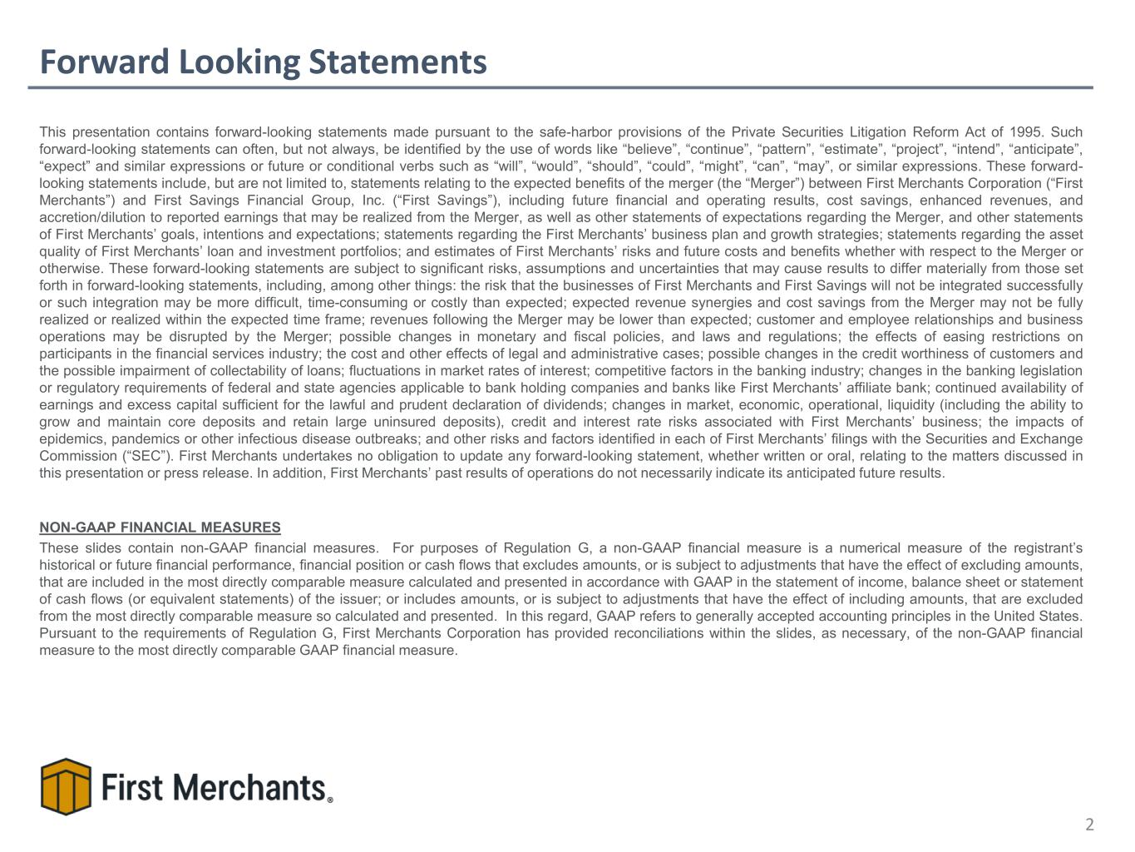
Forward Looking Statements This presentation contains forward-looking statements made pursuant to the safe-harbor provisions of the Private Securities Litigation Reform Act of 1995. Such forward-looking statements can often, but not always, be identified by the use of words like “believe”, “continue”, “pattern”, “estimate”, “project”, “intend”, “anticipate”, “expect” and similar expressions or future or conditional verbs such as “will”, “would”, “should”, “could”, “might”, “can”, “may”, or similar expressions. These forward- looking statements include, but are not limited to, statements relating to the expected benefits of the merger (the “Merger”) between First Merchants Corporation (“First Merchants”) and First Savings Financial Group, Inc. (“First Savings”), including future financial and operating results, cost savings, enhanced revenues, and accretion/dilution to reported earnings that may be realized from the Merger, as well as other statements of expectations regarding the Merger, and other statements of First Merchants’ goals, intentions and expectations; statements regarding the First Merchants’ business plan and growth strategies; statements regarding the asset quality of First Merchants’ loan and investment portfolios; and estimates of First Merchants’ risks and future costs and benefits whether with respect to the Merger or otherwise. These forward-looking statements are subject to significant risks, assumptions and uncertainties that may cause results to differ materially from those set forth in forward-looking statements, including, among other things: the risk that the businesses of First Merchants and First Savings will not be integrated successfully or such integration may be more difficult, time-consuming or costly than expected; expected revenue synergies and cost savings from the Merger may not be fully realized or realized within the expected time frame; revenues following the Merger may be lower than expected; customer and employee relationships and business operations may be disrupted by the Merger; possible changes in monetary and fiscal policies, and laws and regulations; the effects of easing restrictions on participants in the financial services industry; the cost and other effects of legal and administrative cases; possible changes in the credit worthiness of customers and the possible impairment of collectability of loans; fluctuations in market rates of interest; competitive factors in the banking industry; changes in the banking legislation or regulatory requirements of federal and state agencies applicable to bank holding companies and banks like First Merchants’ affiliate bank; continued availability of earnings and excess capital sufficient for the lawful and prudent declaration of dividends; changes in market, economic, operational, liquidity (including the ability to grow and maintain core deposits and retain large uninsured deposits), credit and interest rate risks associated with First Merchants’ business; the impacts of epidemics, pandemics or other infectious disease outbreaks; and other risks and factors identified in each of First Merchants’ filings with the Securities and Exchange Commission (“SEC”). First Merchants undertakes no obligation to update any forward-looking statement, whether written or oral, relating to the matters discussed in this presentation or press release. In addition, First Merchants’ past results of operations do not necessarily indicate its anticipated future results. NON-GAAP FINANCIAL MEASURES These slides contain non-GAAP financial measures. For purposes of Regulation G, a non-GAAP financial measure is a numerical measure of the registrant’s historical or future financial performance, financial position or cash flows that excludes amounts, or is subject to adjustments that have the effect of excluding amounts, that are included in the most directly comparable measure calculated and presented in accordance with GAAP in the statement of income, balance sheet or statement of cash flows (or equivalent statements) of the issuer; or includes amounts, or is subject to adjustments that have the effect of including amounts, that are excluded from the most directly comparable measure so calculated and presented. In this regard, GAAP refers to generally accepted accounting principles in the United States. Pursuant to the requirements of Regulation G, First Merchants Corporation has provided reconciliations within the slides, as necessary, of the non-GAAP financial measure to the most directly comparable GAAP financial measure. 2


Executive Management Team 3 Mark Hardwick Chief Executive Officer Mark K. Hardwick currently serves as the Chief Executive Officer of First Merchants Corporation and First Merchants Bank. Mark joined First Merchants in November of 1997 as Corporate Controller and was promoted to Chief Financial Officer in April of 2002. In 2016, Mark’s title expanded to include Chief Operating Officer, overseeing the leadership responsibilities for finance, operations, technology, risk, legal, and facilities for the corporation. Prior to joining First Merchants Corporation, Mark served as a senior accountant with BKD, LLP in Indianapolis. Mark is a graduate of Ball State University with a Master of Business Administration and Bachelor’s degree in Accounting. He is also a certified public accountant and a graduate of the Stonier School of Banking. FMB: 28 Yrs Banking: 28 Yrs FMB: 11 Yrs Banking: 23 Yrs Michele Kawiecki Chief Financial Officer Michele Kawiecki currently serves as Executive Vice President and Chief Financial Officer for First Merchants Corporation and First Merchants Bank. Michele joined First Merchants in 2015 as Director of Finance. Prior to joining First Merchants, Michele spent 12 years with UMB Financial Corporation in Kansas City, Missouri having served as Senior Vice President of Capital Management and Assistant Treasurer; Director of Corporate Development and the Enterprise Project Management Office; and Chief Risk Officer. Prior to UMB, she worked for PriceWaterhouseCoopers LLP as an Audit Manager. Michele earned both a Master of Science in Accounting and an Executive Master of Business Administration from the University of Missouri-Kansas City and a Bachelor’s degree in Accounting from Dakota Wesleyan University. FMB: 18 Yrs Banking: 37 Yrs Mike Stewart President Mike Stewart currently serves as President for First Merchants Corporation and First Merchants Bank overseeing the Commercial, Private Wealth, and Consumer Lines of Business for the Bank. Mike joined the bank in 2008 as Chief Banking Officer. Prior to joining First Merchants, Mike spent 18 years with National City Bank in various commercial sales and credit roles. Mike has a Master of Business Administration from Butler University and a Bachelor’s degree in Finance from Millikin University. FMB: 18 Yrs Banking: 36 Yrs John Martin Chief Credit Officer John Martin currently serves as Executive Vice President and Chief Credit Officer of First Merchants Corporation overseeing the Commercial, Small Business and Consumer Credit functions, as well as Bank Operations and the Mortgage Line of Business. Prior to joining First Merchants, John spent 18 years with National City Bank in various sales and senior credit roles. John is a graduate of Indiana University where he earned a Bachelor of Arts in Economics. He also holds a Master of Business Administration in Finance from Case Western Reserve University. Mark Hardwick – 11/03/1997 Mike Stewart - 02/01/2008 1988 Banking Start John Martin – 12/31/2007 Michele Kawiecki – 03/02/2015

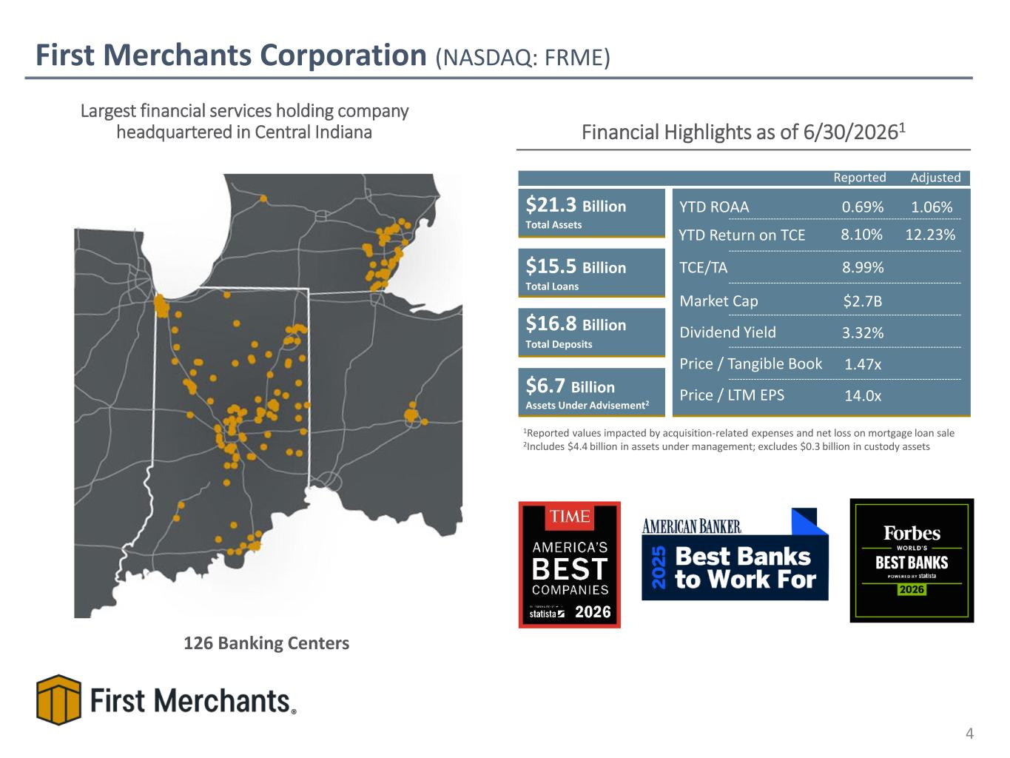
First Merchants Corporation (NASDAQ: FRME) Financial Highlights as of 6/30/20261 $21.3 Billion $15.5 Billion $16.8 Billion $6.7 Billion Assets Under Advisement2 Total Assets Total Loans Total Deposits TCE/TA YTD Return on TCE YTD ROAA Dividend Yield Price / Tangible Book Price / LTM EPS 0.69% 8.99% 8.10% 3.32% 1.47x 14.0x Market Cap $2.7B Largest financial services holding company headquartered in Central Indiana 126 Banking Centers 1Reported values impacted by acquisition-related expenses and net loss on mortgage loan sale 2Includes $4.4 billion in assets under management; excludes $0.3 billion in custody assets 4 1.06% 12.23% Reported Adjusted

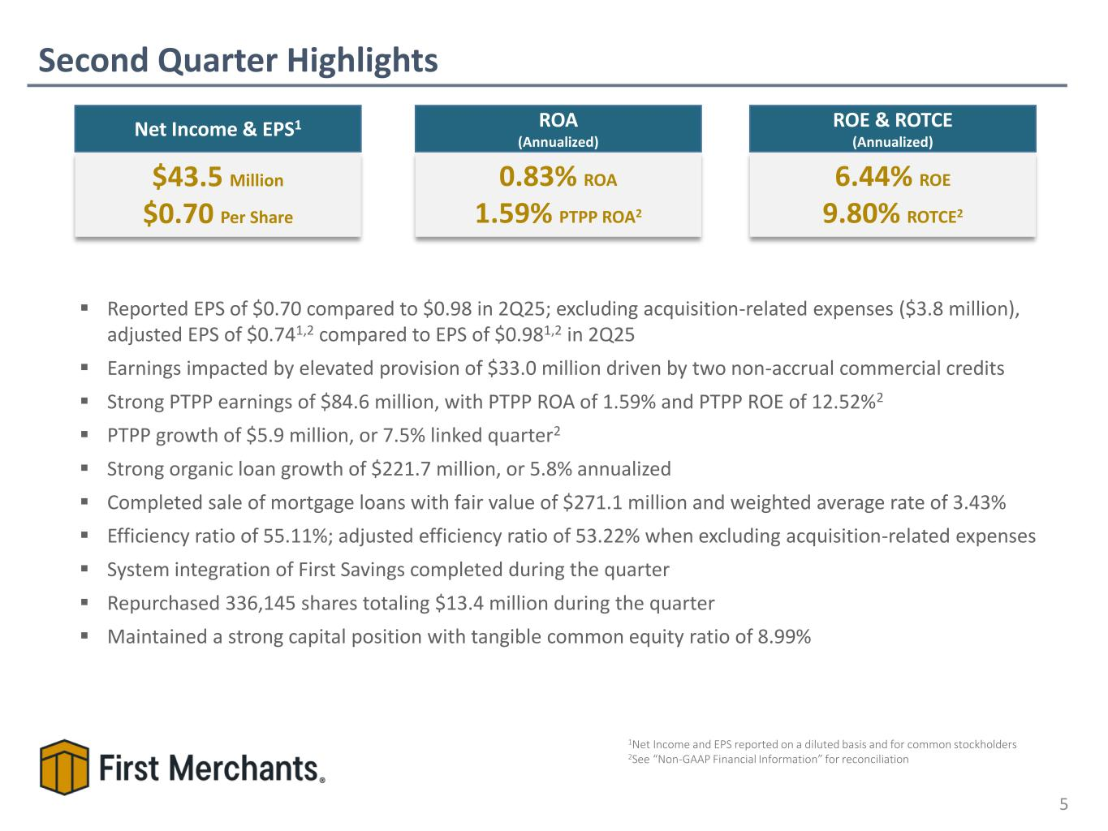
Second Quarter Highlights 5 ▪ Reported EPS of $0.70 compared to $0.98 in 2Q25; excluding acquisition-related expenses ($3.8 million), adjusted EPS of $0.741,2 compared to EPS of $0.981,2 in 2Q25 ▪ Earnings impacted by elevated provision of $33.0 million driven by two non-accrual commercial credits ▪ Strong PTPP earnings of $84.6 million, with PTPP ROA of 1.59% and PTPP ROE of 12.52%2 ▪ PTPP growth of $5.9 million, or 7.5% linked quarter2 ▪ Strong organic loan growth of $221.7 million, or 5.8% annualized ▪ Completed sale of mortgage loans with fair value of $271.1 million and weighted average rate of 3.43% ▪ Efficiency ratio of 55.11%; adjusted efficiency ratio of 53.22% when excluding acquisition-related expenses ▪ System integration of First Savings completed during the quarter ▪ Repurchased 336,145 shares totaling $13.4 million during the quarter ▪ Maintained a strong capital position with tangible common equity ratio of 8.99% 6.44% ROE 9.80% ROTCE2 ROE & ROTCE (Annualized) $43.5 Million $0.70 Per Share Net Income & EPS1 1Net Income and EPS reported on a diluted basis and for common stockholders 2See “Non-GAAP Financial Information” for reconciliation 0.83% ROA 1.59% PTPP ROA2 ROA (Annualized)

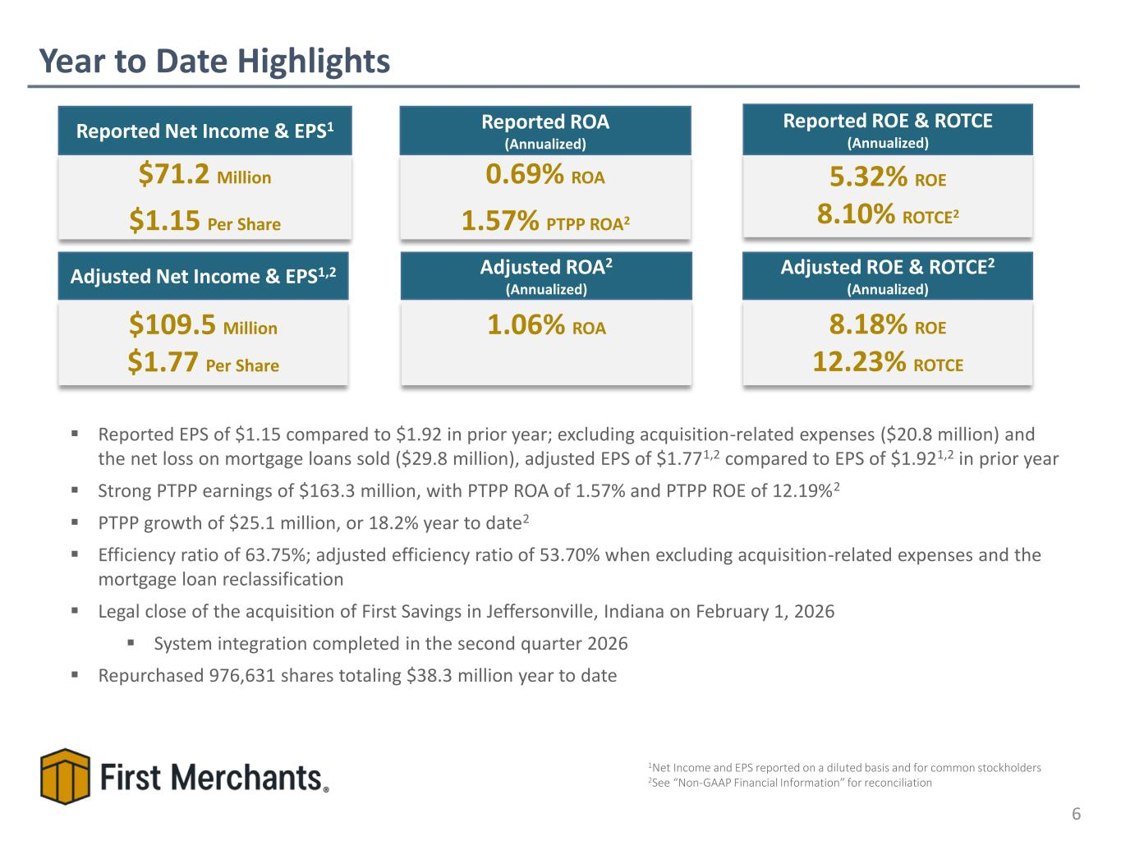
Year to Date Highlights 6 5.32% ROE 8.10% ROTCE2 Reported ROE & ROTCE (Annualized) $71.2 Million $1.15 Per Share Reported Net Income & EPS1 0.69% ROA 1.57% PTPP ROA2 Reported ROA (Annualized) ▪ Reported EPS of $1.15 compared to $1.92 in prior year; excluding acquisition-related expenses ($20.8 million) and the net loss on mortgage loans sold ($29.8 million), adjusted EPS of $1.771,2 compared to EPS of $1.921,2 in prior year ▪ Strong PTPP earnings of $163.3 million, with PTPP ROA of 1.57% and PTPP ROE of 12.19%2 ▪ PTPP growth of $25.1 million, or 18.2% year to date2 ▪ Efficiency ratio of 63.75%; adjusted efficiency ratio of 53.70% when excluding acquisition-related expenses and the mortgage loan reclassification ▪ Legal close of the acquisition of First Savings in Jeffersonville, Indiana on February 1, 2026 ▪ System integration completed in the second quarter 2026 ▪ Repurchased 976,631 shares totaling $38.3 million year to date $109.5 Million $1.77 Per Share Adjusted Net Income & EPS1,2 8.18% ROE 12.23% ROTCE Adjusted ROE & ROTCE2 (Annualized) 1.06% ROA Adjusted ROA2 (Annualized) 1Net Income and EPS reported on a diluted basis and for common stockholders 2See “Non-GAAP Financial Information” for reconciliation

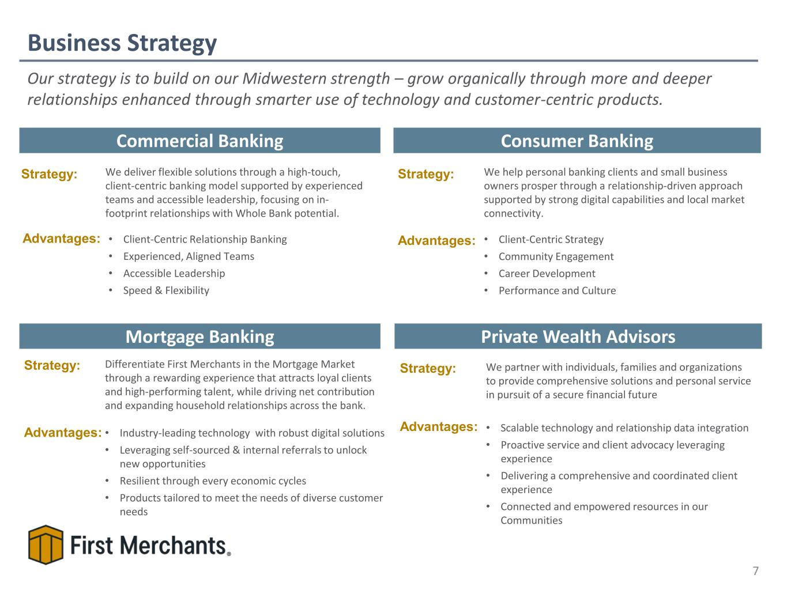
Business Strategy 7 Commercial Banking Private Wealth Advisors Consumer Banking Mortgage Banking Strategy: Advantages: We deliver flexible solutions through a high-touch, client-centric banking model supported by experienced teams and accessible leadership, focusing on in- footprint relationships with Whole Bank potential. • Client-Centric Relationship Banking • Experienced, Aligned Teams • Accessible Leadership • Speed & Flexibility Strategy: We help personal banking clients and small business owners prosper through a relationship-driven approach supported by strong digital capabilities and local market connectivity. • Client-Centric Strategy • Community Engagement • Career Development • Performance and Culture Advantages: Strategy: We partner with individuals, families and organizations to provide comprehensive solutions and personal service in pursuit of a secure financial future • Scalable technology and relationship data integration • Proactive service and client advocacy leveraging experience • Delivering a comprehensive and coordinated client experience • Connected and empowered resources in our Communities Advantages: Strategy: Differentiate First Merchants in the Mortgage Market through a rewarding experience that attracts loyal clients and high-performing talent, while driving net contribution and expanding household relationships across the bank. • Industry-leading technology with robust digital solutions • Leveraging self-sourced & internal referrals to unlock new opportunities • Resilient through every economic cycles • Products tailored to meet the needs of diverse customer needs Advantages: Our strategy is to build on our Midwestern strength – grow organically through more and deeper relationships enhanced through smarter use of technology and customer-centric products.

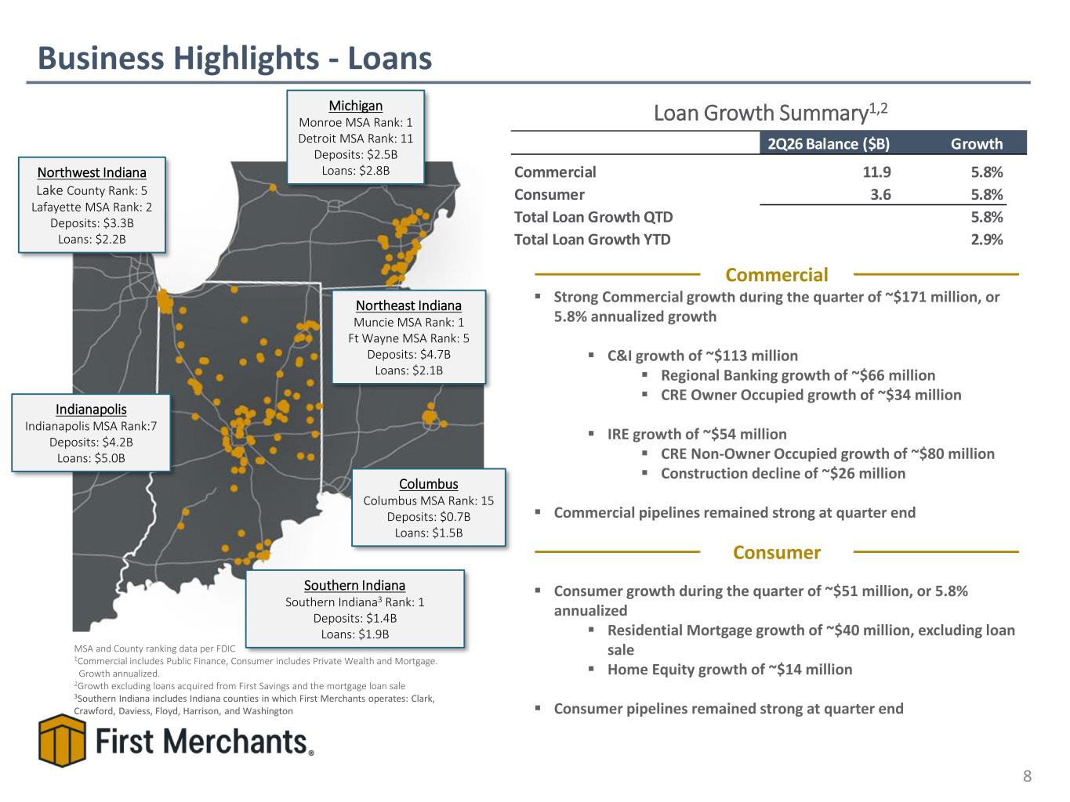
Loan Growth Summary1,2 Business Highlights - Loans 8 MSA and County ranking data per FDIC 1Commercial includes Public Finance, Consumer includes Private Wealth and Mortgage. Growth annualized. 2Growth excluding loans acquired from First Savings and the mortgage loan sale 3Southern Indiana includes Indiana counties in which First Merchants operates: Clark, Crawford, Daviess, Floyd, Harrison, and Washington Indianapolis Indianapolis MSA Rank:7 Deposits: $4.2B Loans: $5.0B Columbus Columbus MSA Rank: 15 Deposits: $0.7B Loans: $1.5B Northwest Indiana Lake County Rank: 5 Lafayette MSA Rank: 2 Deposits: $3.3B Loans: $2.2B Northeast Indiana Muncie MSA Rank: 1 Ft Wayne MSA Rank: 5 Deposits: $4.7B Loans: $2.1B Michigan Monroe MSA Rank: 1 Detroit MSA Rank: 11 Deposits: $2.5B Loans: $2.8B Southern Indiana Southern Indiana3 Rank: 1 Deposits: $1.4B Loans: $1.9B ▪ Strong Commercial growth during the quarter of ~$171 million, or 5.8% annualized growth ▪ C&I growth of ~$113 million ▪ Regional Banking growth of ~$66 million ▪ CRE Owner Occupied growth of ~$34 million ▪ IRE growth of ~$54 million ▪ CRE Non-Owner Occupied growth of ~$80 million ▪ Construction decline of ~$26 million ▪ Commercial pipelines remained strong at quarter end ▪ Consumer growth during the quarter of ~$51 million, or 5.8% annualized ▪ Residential Mortgage growth of ~$40 million, excluding loan sale ▪ Home Equity growth of ~$14 million ▪ Consumer pipelines remained strong at quarter end Commercial Consumer 2Q26 Balance ($B) Growth Commercial 11.9 5.8% Consumer 3.6 5.8% Total Loan Growth QTD 5.8% Total Loan Growth YTD 2.9%

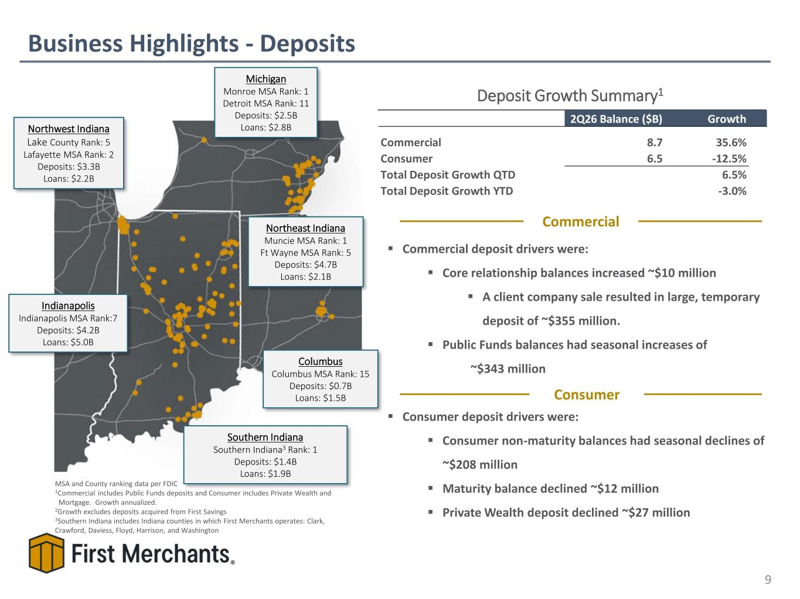
Deposit Growth Summary1 Business Highlights - Deposits 9 MSA and County ranking data per FDIC 1Commercial includes Public Funds deposits and Consumer includes Private Wealth and Mortgage. Growth annualized. 2Growth excludes deposits acquired from First Savings 3Southern Indiana includes Indiana counties in which First Merchants operates: Clark, Crawford, Daviess, Floyd, Harrison, and Washington ▪ Commercial deposit drivers were: ▪ Core relationship balances increased ~$10 million ▪ A client company sale resulted in large, temporary deposit of ~$355 million. ▪ Public Funds balances had seasonal increases of ~$343 million ▪ Consumer deposit drivers were: ▪ Consumer non-maturity balances had seasonal declines of ~$208 million ▪ Maturity balance declined ~$12 million ▪ Private Wealth deposit declined ~$27 million Indianapolis Indianapolis MSA Rank:7 Deposits: $4.2B Loans: $5.0B Columbus Columbus MSA Rank: 15 Deposits: $0.7B Loans: $1.5B Northwest Indiana Lake County Rank: 5 Lafayette MSA Rank: 2 Deposits: $3.3B Loans: $2.2B Northeast Indiana Muncie MSA Rank: 1 Ft Wayne MSA Rank: 5 Deposits: $4.7B Loans: $2.1B Michigan Monroe MSA Rank: 1 Detroit MSA Rank: 11 Deposits: $2.5B Loans: $2.8B Southern Indiana Southern Indiana3 Rank: 1 Deposits: $1.4B Loans: $1.9B 2Q26 Balance ($B) Growth Commercial 8.7 35.6% Consumer 6.5 -12.5% Total Deposit Growth QTD 6.5% Total Deposit Growth YTD -3.0% Commercial Consumer

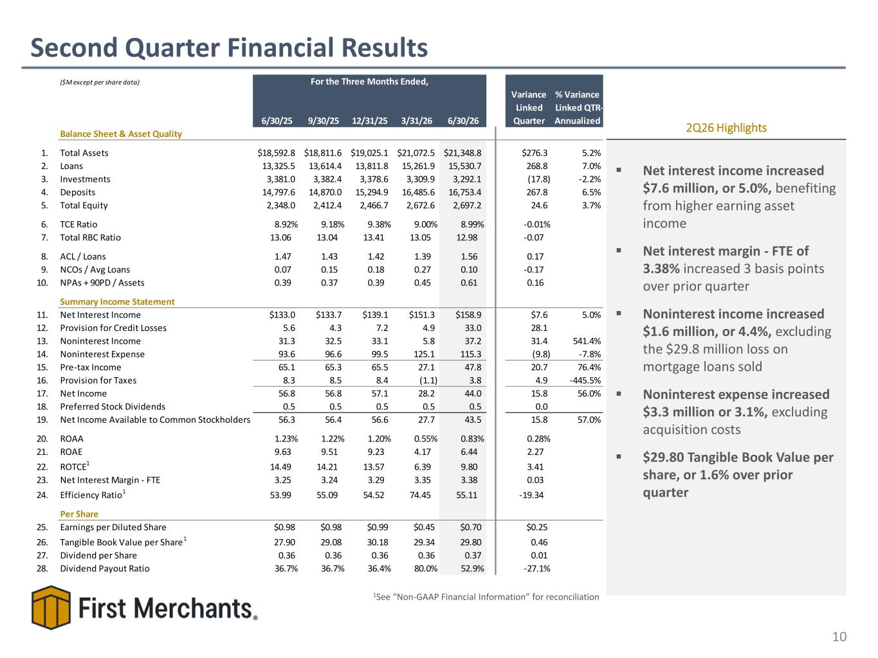
Second Quarter Financial Results 10 ▪ Net interest income increased $7.6 million, or 5.0%, benefiting from higher earning asset income ▪ Net interest margin - FTE of 3.38% increased 3 basis points over prior quarter ▪ Noninterest income increased $1.6 million, or 4.4%, excluding the $29.8 million loss on mortgage loans sold ▪ Noninterest expense increased $3.3 million or 3.1%, excluding acquisition costs ▪ $29.80 Tangible Book Value per share, or 1.6% over prior quarter 2Q26 Highlights 1See “Non-GAAP Financial Information” for reconciliation ($M except per share data) 6/30/25 9/30/25 12/31/25 3/31/26 6/30/26 Variance Linked Quarter % Variance Linked QTR- Annualized Balance Sheet & Asset Quality 1. Total Assets $18,592.8 $18,811.6 $19,025.1 $21,072.5 $21,348.8 $276.3 5.2% 2. Loans 13,325.5 13,614.4 13,811.8 15,261.9 15,530.7 268.8 7.0% 3. Investments 3,381.0 3,382.4 3,378.6 3,309.9 3,292.1 (17.8) -2.2% 4. Deposits 14,797.6 14,870.0 15,294.9 16,485.6 16,753.4 267.8 6.5% 5. Total Equity 2,348.0 2,412.4 2,466.7 2,672.6 2,697.2 24.6 3.7% 6. TCE Ratio 8.92% 9.18% 9.38% 9.00% 8.99% -0.01% 7. Total RBC Ratio 13.06 13.04 13.41 13.05 12.98 -0.07 8. ACL / Loans 1.47 1.43 1.42 1.39 1.56 0.17 9. NCOs / Avg Loans 0.07 0.15 0.18 0.27 0.10 -0.17 10. NPAs + 90PD / Assets 0.39 0.37 0.39 0.45 0.61 0.16 Summary Income Statement 11. Net Interest Income $133.0 $133.7 $139.1 $151.3 $158.9 $7.6 5.0% 12. Provision for Credit Losses 5.6 4.3 7.2 4.9 33.0 28.1 13. Noninterest Income 31.3 32.5 33.1 5.8 37.2 31.4 541.4% 14. Noninterest Expense 93.6 96.6 99.5 125.1 115.3 (9.8) -7.8% 15. Pre-tax Income 65.1 65.3 65.5 27.1 47.8 20.7 76.4% 16. Provision for Taxes 8.3 8.5 8.4 (1.1) 3.8 4.9 -445.5% 17. Net Income 56.8 56.8 57.1 28.2 44.0 15.8 56.0% 18. Preferred Stock Dividends 0.5 0.5 0.5 0.5 0.5 0.0 19. Net Income Available to Common Stockholders 56.3 56.4 56.6 27.7 43.5 15.8 57.0% 20. ROAA 1.23% 1.22% 1.20% 0.55% 0.83% 0.28% 21. ROAE 9.63 9.51 9.23 4.17 6.44 2.27 22. ROTCE1 14.49 14.21 13.57 6.39 9.80 3.41 23. Net Interest Margin - FTE 3.25 3.24 3.29 3.35 3.38 0.03 24. Efficiency Ratio1 53.99 55.09 54.52 74.45 55.11 -19.34 Per Share 25. Earnings per Diluted Share $0.98 $0.98 $0.99 $0.45 $0.70 $0.25 26. Tangible Book Value per Share1 27.90 29.08 30.18 29.34 29.80 0.46 27. Dividend per Share 0.36 0.36 0.36 0.36 0.37 0.01 28. Dividend Payout Ratio 36.7% 36.7% 36.4% 80.0% 52.9% -27.1% For the Three Months Ended,

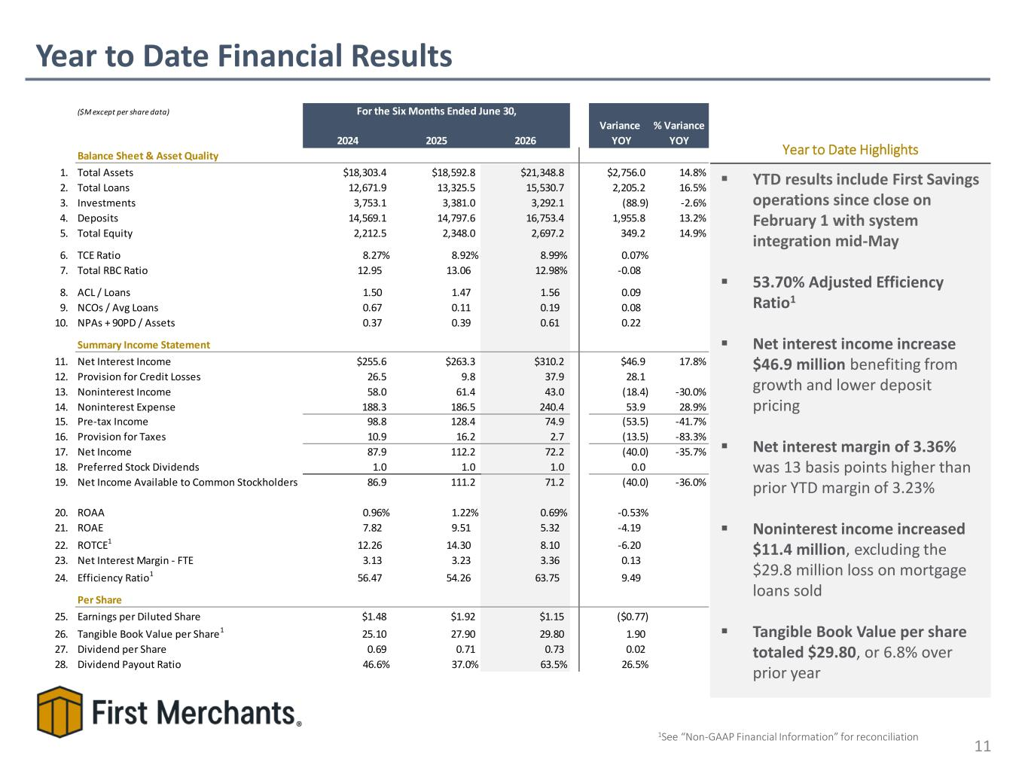
Year to Date Financial Results 11 ▪ YTD results include First Savings operations since close on February 1 with system integration mid-May ▪ 53.70% Adjusted Efficiency Ratio1 ▪ Net interest income increase $46.9 million benefiting from growth and lower deposit pricing ▪ Net interest margin of 3.36% was 13 basis points higher than prior YTD margin of 3.23% ▪ Noninterest income increased $11.4 million, excluding the $29.8 million loss on mortgage loans sold ▪ Tangible Book Value per share totaled $29.80, or 6.8% over prior year Year to Date Highlights 1See “Non-GAAP Financial Information” for reconciliation ($M except per share data) 2024 2025 2026 Variance YOY % Variance YOY Balance Sheet & Asset Quality 1. Total Assets $18,303.4 $18,592.8 $21,348.8 $2,756.0 14.8% 2. Total Loans 12,671.9 13,325.5 15,530.7 2,205.2 16.5% 3. Investments 3,753.1 3,381.0 3,292.1 (88.9) -2.6% 4. Deposits 14,569.1 14,797.6 16,753.4 1,955.8 13.2% 5. Total Equity 2,212.5 2,348.0 2,697.2 349.2 14.9% 6. TCE Ratio 8.27% 8.92% 8.99% 0.07% 7. Total RBC Ratio 12.95 13.06 12.98% -0.08 8. ACL / Loans 1.50 1.47 1.56 0.09 9. NCOs / Avg Loans 0.67 0.11 0.19 0.08 10. NPAs + 90PD / Assets 0.37 0.39 0.61 0.22 Summary Income Statement 11. Net Interest Income $255.6 $263.3 $310.2 $46.9 17.8% 12. Provision for Credit Losses 26.5 9.8 37.9 28.1 13. Noninterest Income 58.0 61.4 43.0 (18.4) -30.0% 14. Noninterest Expense 188.3 186.5 240.4 53.9 28.9% 15. Pre-tax Income 98.8 128.4 74.9 (53.5) -41.7% 16. Provision for Taxes 10.9 16.2 2.7 (13.5) -83.3% 17. Net Income 87.9 112.2 72.2 (40.0) -35.7% 18. Preferred Stock Dividends 1.0 1.0 1.0 0.0 19. Net Income Available to Common Stockholders 86.9 111.2 71.2 (40.0) -36.0% 20. ROAA 0.96% 1.22% 0.69% -0.53% 21. ROAE 7.82 9.51 5.32 -4.19 22. ROTCE1 12.26 14.30 8.10 -6.20 23. Net Interest Margin - FTE 3.13 3.23 3.36 0.13 24. Efficiency Ratio1 56.47 54.26 63.75 9.49 Per Share 25. Earnings per Diluted Share $1.48 $1.92 $1.15 ($0.77) 26. Tangible Book Value per Share1 25.10 27.90 29.80 1.90 27. Dividend per Share 0.69 0.71 0.73 0.02 28. Dividend Payout Ratio 46.6% 37.0% 63.5% 26.5% For the Six Months Ended June 30,

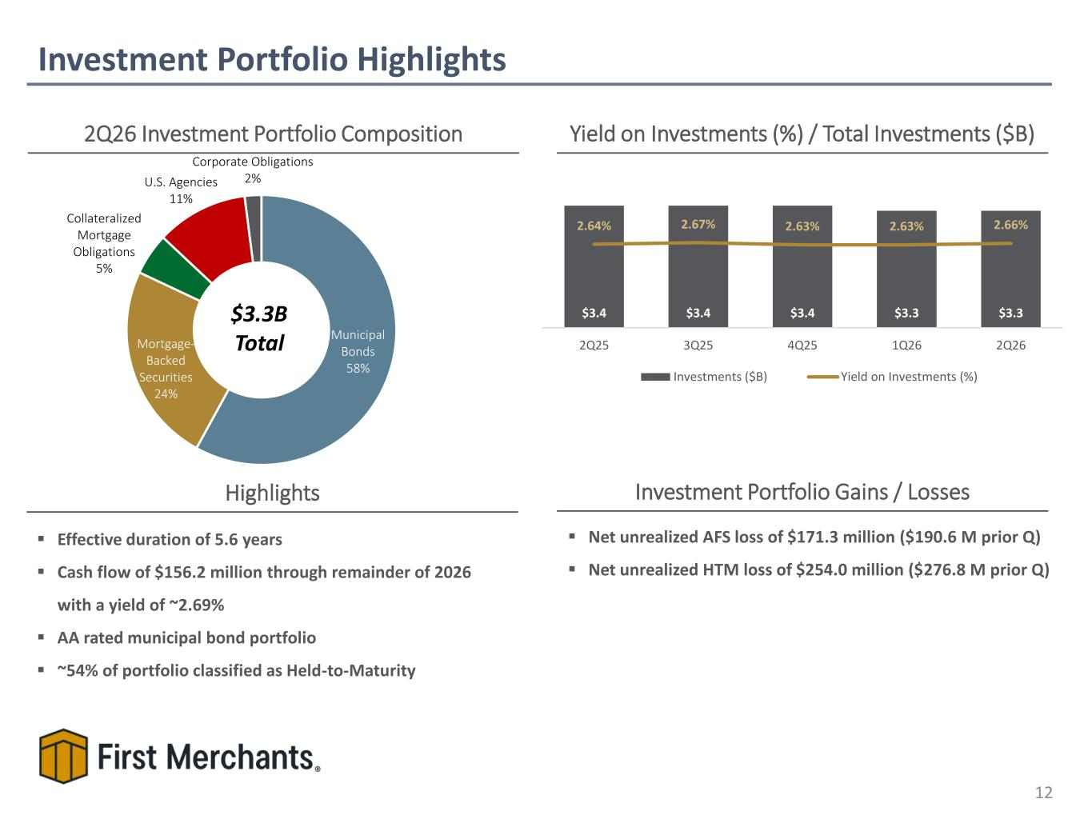
▪ Net unrealized AFS loss of $171.3 million ($190.6 M prior Q) ▪ Net unrealized HTM loss of $254.0 million ($276.8 M prior Q) Investment Portfolio Highlights 12 2Q26 Investment Portfolio Composition Yield on Investments (%) / Total Investments ($B) $3.3B Total Investment Portfolio Gains / LossesHighlights ▪ Effective duration of 5.6 years ▪ Cash flow of $156.2 million through remainder of 2026 with a yield of ~2.69% ▪ AA rated municipal bond portfolio ▪ ~54% of portfolio classified as Held-to-Maturity Municipal Bonds 58% Mortgage- Backed Securities 24% Collateralized Mortgage Obligations 5% U.S. Agencies 11% Corporate Obligations 2% $3.4 $3.4 $3.4 $3.3 $3.3 2.64% 2.67% 2.63% 2.63% 2.66% 2Q25 3Q25 4Q25 1Q26 2Q26 Investments ($B) Yield on Investments (%)

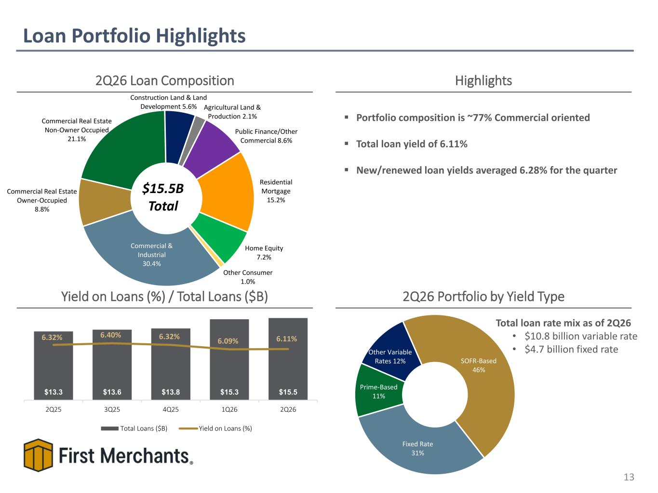
Loan Portfolio Highlights 13 2Q26 Loan Composition Yield on Loans (%) / Total Loans ($B) $15.5B Total 2Q26 Portfolio by Yield Type Highlights Total loan rate mix as of 2Q26 • $10.8 billion variable rate • $4.7 billion fixed rate ▪ Portfolio composition is ~77% Commercial oriented ▪ Total loan yield of 6.11% ▪ New/renewed loan yields averaged 6.28% for the quarter $0.9 $0.7 $0.7$0.4$0.7$0.7 Commercial & Industrial 30.4% Commercial Real Estate Owner-Occupied 8.8% Commercial Real Estate Non-Owner Occupied 21.1% Construction Land & Land Development 5.6% Agricultural Land & Production 2.1% Public Finance/Other Commercial 8.6% Residential Mortgage 15.2% Home Equity 7.2% Other Consumer 1.0% $13.3 $13.6 $13.8 $15.3 $15.5 6.32% 6.40% 6.32% 6.09% 6.11% 2Q25 3Q25 4Q25 1Q26 2Q26 Total Loans ($B) Yield on Loans (%) Fixed Rate 31% Prime-Based 11% Other Variable Rates 12% SOFR-Based 46%

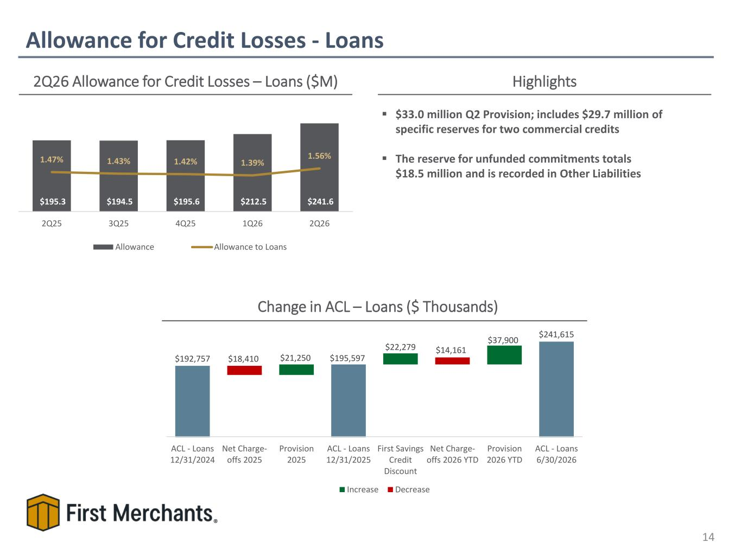
$192,757 $195,597 $241,615 $21,250 $22,279 $37,900 $18,410 $14,161 ACL - Loans 12/31/2024 Net Charge- offs 2025 Provision 2025 ACL - Loans 12/31/2025 First Savings Credit Discount Net Charge- offs 2026 YTD Provision 2026 YTD ACL - Loans 6/30/2026 Increase Decrease Allowance for Credit Losses - Loans 14 2Q26 Allowance for Credit Losses – Loans ($M) Highlights Change in ACL – Loans ($ Thousands) ▪ $33.0 million Q2 Provision; includes $29.7 million of specific reserves for two commercial credits ▪ The reserve for unfunded commitments totals $18.5 million and is recorded in Other Liabilities $195.3 $194.5 $195.6 $212.5 $241.6 1.47% 1.43% 1.42% 1.39% 1.56% 2Q25 3Q25 4Q25 1Q26 2Q26 Allowance Allowance to Loans

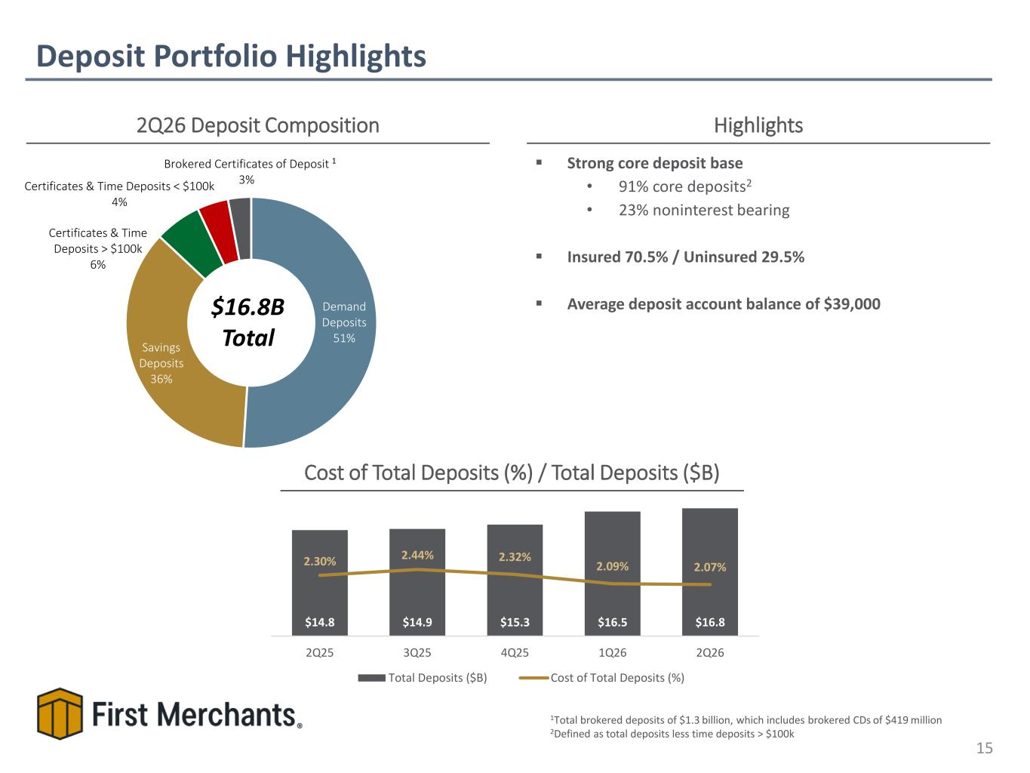
Demand Deposits 51% Savings Deposits 36% Certificates & Time Deposits > $100k 6% Certificates & Time Deposits < $100k 4% Brokered Certificates of Deposit 3% Deposit Portfolio Highlights 15 2Q26 Deposit Composition Highlights $16.8B Total 1Total brokered deposits of $1.3 billion, which includes brokered CDs of $419 million 2Defined as total deposits less time deposits > $100k Cost of Total Deposits (%) / Total Deposits ($B) ▪ Strong core deposit base • 91% core deposits2 • 23% noninterest bearing ▪ Insured 70.5% / Uninsured 29.5% ▪ Average deposit account balance of $39,000 1 $14.8 $14.9 $15.3 $16.5 $16.8 2.30% 2.44% 2.32% 2.09% 2.07% 2Q25 3Q25 4Q25 1Q26 2Q26 Total Deposits ($B) Cost of Total Deposits (%)

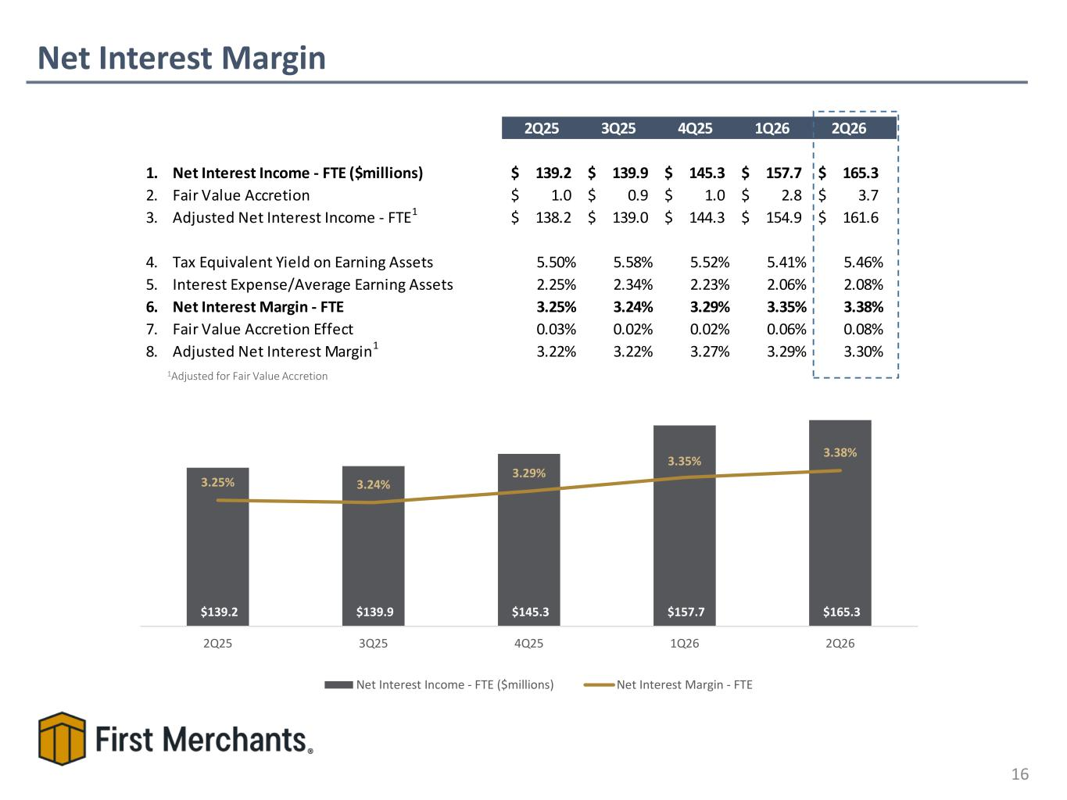
2Q25 3Q25 4Q25 1Q26 2Q26 1. Net Interest Income - FTE ($millions) 139.2$ 139.9$ 145.3$ 157.7$ 165.3$ 2. Fair Value Accretion 1.0$ 0.9$ 1.0$ 2.8$ 3.7$ 3. Adjusted Net Interest Income - FTE1 138.2$ 139.0$ 144.3$ 154.9$ 161.6$ 4. Tax Equivalent Yield on Earning Assets 5.50% 5.58% 5.52% 5.41% 5.46% 5. Interest Expense/Average Earning Assets 2.25% 2.34% 2.23% 2.06% 2.08% 6. Net Interest Margin - FTE 3.25% 3.24% 3.29% 3.35% 3.38% 7. Fair Value Accretion Effect 0.03% 0.02% 0.02% 0.06% 0.08% 8. Adjusted Net Interest Margin1 3.22% 3.22% 3.27% 3.29% 3.30% Net Interest Margin 16 $105.1$97.1 $97.3 $105.1 $107.0$97.8 $107.0 $97.3 $105.1 $110.0$109.2 $107.0 $105.1 $109.2 $110.0 $106.9 1Adjusted for Fair Value Accretion $139.2 $139.9 $145.3 $157.7 $165.3 3.25% 3.24% 3.29% 3.35% 3.38% 2Q25 3Q25 4Q25 1Q26 2Q26 Net Interest Income - FTE ($millions) Net Interest Margin - FTE

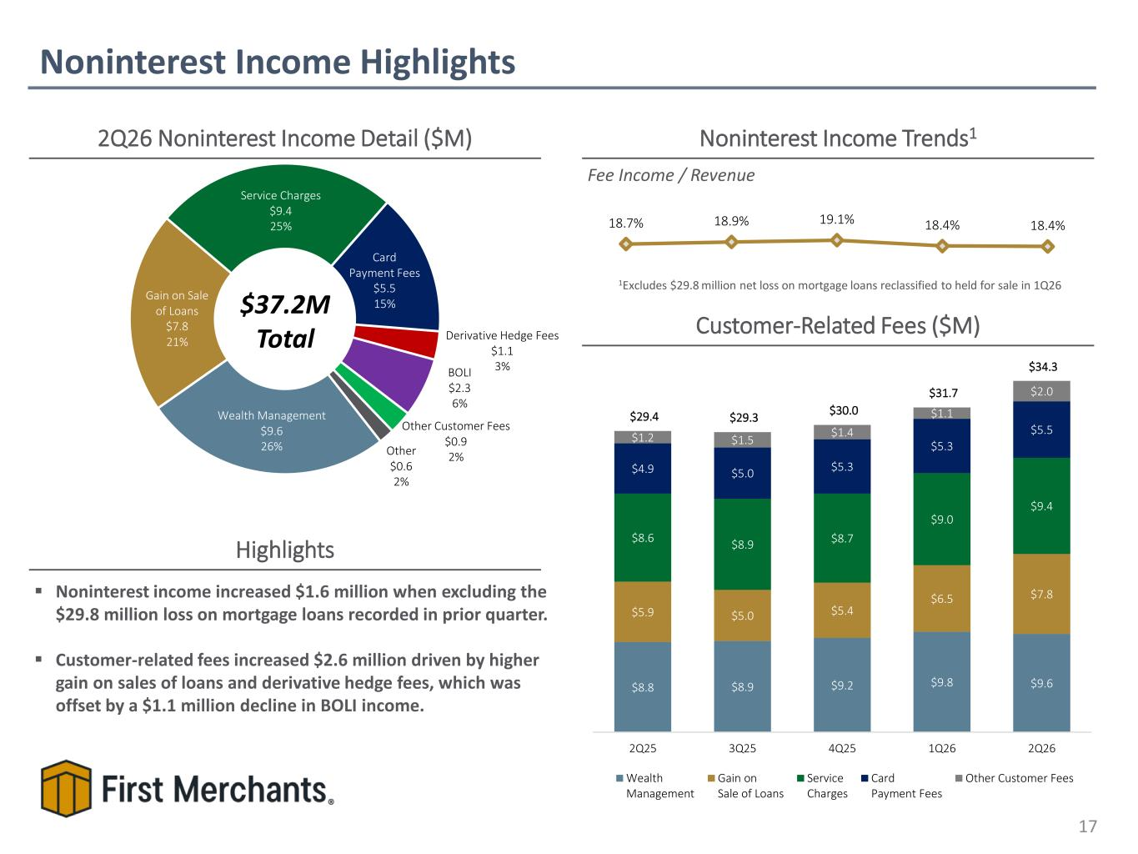
18.7% 18.9% 19.1% 18.4% 18.4% Wealth Management $9.6 26% Gain on Sale of Loans $7.8 21% Service Charges $9.4 25% Card Payment Fees $5.5 15% Derivative Hedge Fees $1.1 3%BOLI $2.3 6% Other Customer Fees $0.9 2%Other $0.6 2% Noninterest Income Highlights 17 2Q26 Noninterest Income Detail ($M) $37.2M Total Noninterest Income Trends1 Fee Income / Revenue Highlights ▪ Noninterest income increased $1.6 million when excluding the $29.8 million loss on mortgage loans recorded in prior quarter. ▪ Customer-related fees increased $2.6 million driven by higher gain on sales of loans and derivative hedge fees, which was offset by a $1.1 million decline in BOLI income. Customer-Related Fees ($M) 1Excludes $29.8 million net loss on mortgage loans reclassified to held for sale in 1Q26 $8.8 $8.9 $9.2 $9.8 $9.6 $5.9 $5.0 $5.4 $6.5 $7.8 $8.6 $8.9 $8.7 $9.0 $9.4 $4.9 $5.0 $5.3 $5.3 $5.5 $1.2 $1.5 $1.4 $1.1 $2.0 $29.4 $29.3 $30.0 $31.7 $34.3 2Q25 3Q25 4Q25 1Q26 2Q26 Wealth Management Gain on Sale of Loans Service Charges Card Payment Fees Other Customer Fees

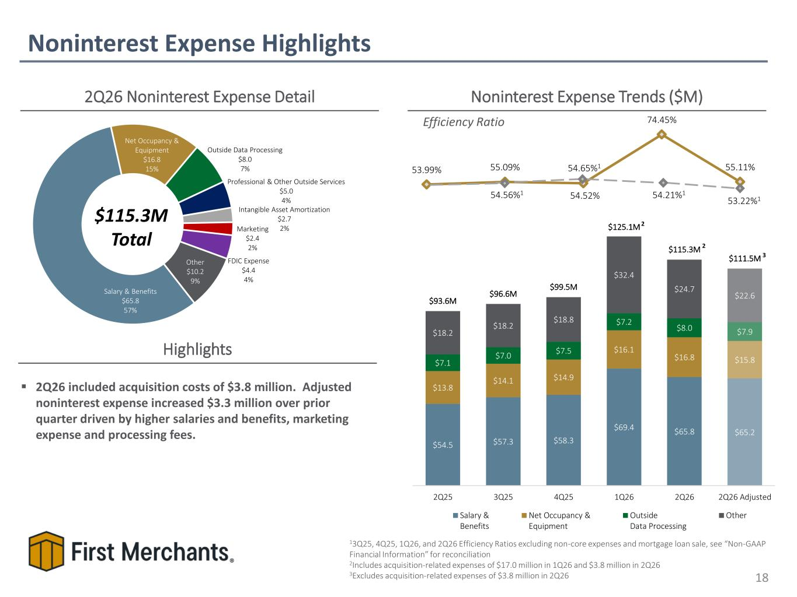
53.99% 55.09% 54.52% 74.45% 55.11% Noninterest Expense Highlights 18 2Q26 Noninterest Expense Detail $115.3M Total Noninterest Expense Trends ($M) Efficiency Ratio Highlights ▪ 2Q26 included acquisition costs of $3.8 million. Adjusted noninterest expense increased $3.3 million over prior quarter driven by higher salaries and benefits, marketing expense and processing fees. 13Q25, 4Q25, 1Q26, and 2Q26 Efficiency Ratios excluding non-core expenses and mortgage loan sale, see “Non-GAAP Financial Information” for reconciliation 2Includes acquisition-related expenses of $17.0 million in 1Q26 and $3.8 million in 2Q26 3Excludes acquisition-related expenses of $3.8 million in 2Q26 54.21%154.56%1 54.65%1 Salary & Benefits $65.8 57% Net Occupancy & Equipment $16.8 15% Outside Data Processing $8.0 7% Professional & Other Outside Services $5.0 4% Intangible Asset Amortization $2.7 2%Marketing $2.4 2% FDIC Expense $4.4 4% Other $10.2 9% 53.22%1 $54.5 $57.3 $58.3 $69.4 $65.8 $65.2 $13.8 $14.1 $14.9 $16.1 $16.8 $15.8 $7.1 $7.0 $7.5 $7.2 $8.0 $7.9 $18.2 $18.2 $18.8 $32.4 $24.7 $22.6 $93.6M $96.6M $99.5M $125.1M $115.3M $111.5M 2Q25 3Q25 4Q25 1Q26 2Q26 2Q26 Adjusted Salary & Benefits Net Occupancy & Equipment Outside Data Processing Other 2 2 3

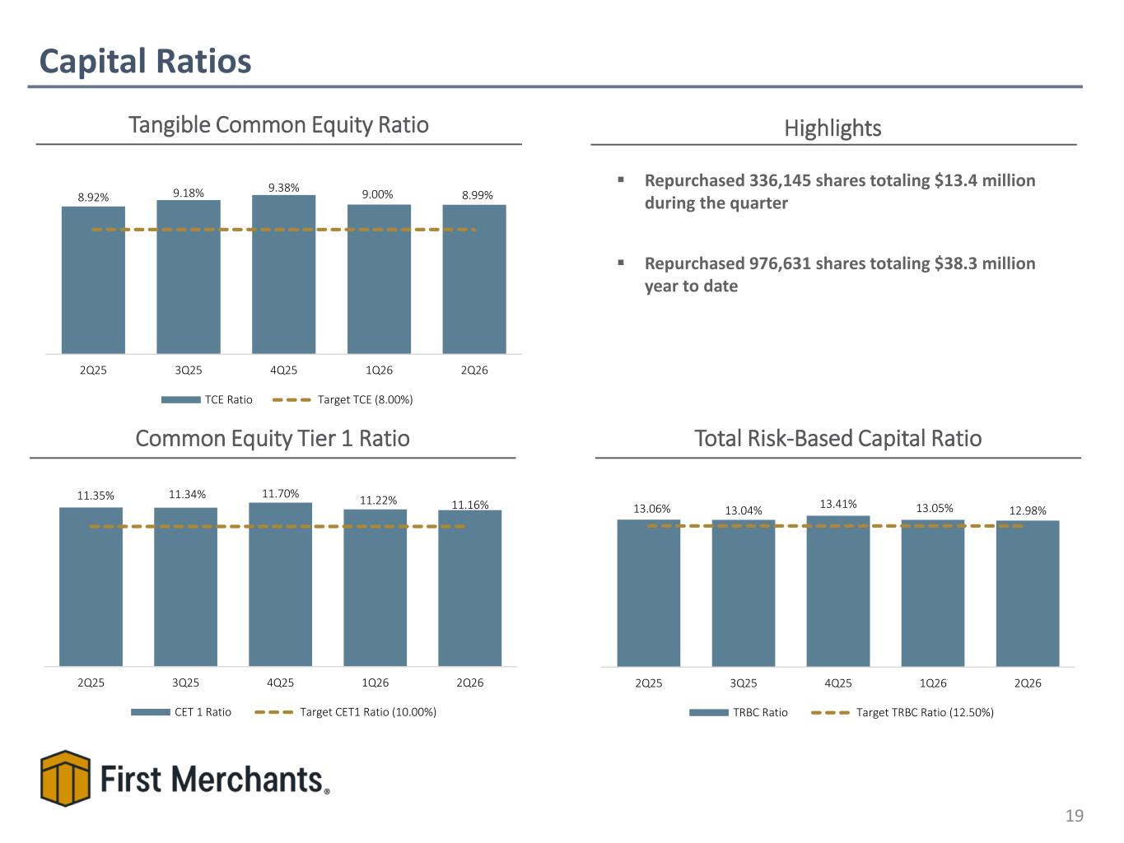
Capital Ratios 19 Tangible Common Equity Ratio Common Equity Tier 1 Ratio Total Risk-Based Capital Ratio 9.31% 9.31% 9.57% 9.31% 9.65%9.57%9.31% 9.57% 9.65% ▪ Repurchased 336,145 shares totaling $13.4 million during the quarter ▪ Repurchased 976,631 shares totaling $38.3 million year to date Highlights 8.92% 9.18% 9.38% 9.00% 8.99% 2Q25 3Q25 4Q25 1Q26 2Q26 TCE Ratio Target TCE (8.00%) 13.06% 13.04% 13.41% 13.05% 12.98% 2Q25 3Q25 4Q25 1Q26 2Q26 TRBC Ratio Target TRBC Ratio (12.50%) 11.35% 11.34% 11.70% 11.22% 11.16% 2Q25 3Q25 4Q25 1Q26 2Q26 CET 1 Ratio Target CET1 Ratio (10.00%)

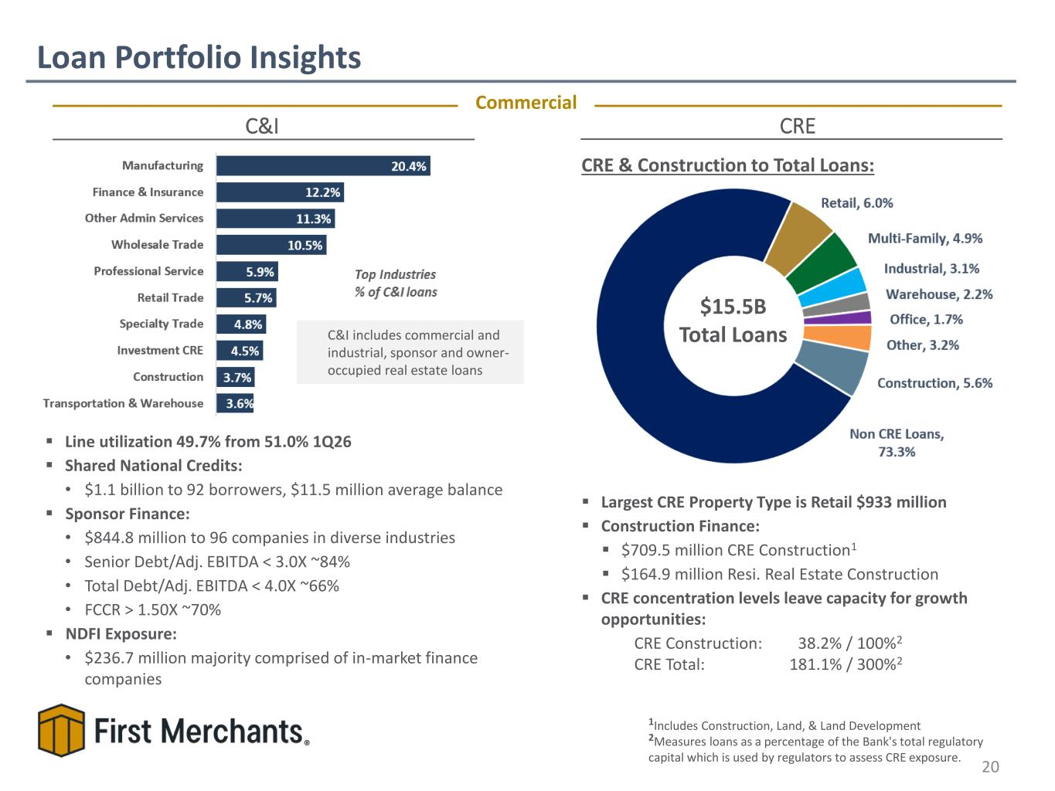
▪ Largest CRE Property Type is Retail $933 million ▪ Construction Finance: ▪ $709.5 million CRE Construction1 ▪ $164.9 million Resi. Real Estate Construction ▪ CRE concentration levels leave capacity for growth opportunities: CRE Construction: 38.2% / 100%2 CRE Total: 181.1% / 300%2 C&I includes commercial and industrial, sponsor and owner- occupied real estate loans CRE ▪ Line utilization 49.7% from 51.0% 1Q26 ▪ Shared National Credits: • $1.1 billion to 92 borrowers, $11.5 million average balance ▪ Sponsor Finance: • $844.8 million to 96 companies in diverse industries • Senior Debt/Adj. EBITDA < 3.0X ~84% • Total Debt/Adj. EBITDA < 4.0X ~66% • FCCR > 1.50X ~70% ▪ NDFI Exposure:​ • $236.7 million majority comprised of in-market finance companies Loan Portfolio Insights 20 C&I Commercial CRE & Construction to Total Loans: 1Includes Construction, Land, & Land Development 2Measures loans as a percentage of the Bank's total regulatory capital which is used by regulators to assess CRE exposure. $15.5B Total Loans

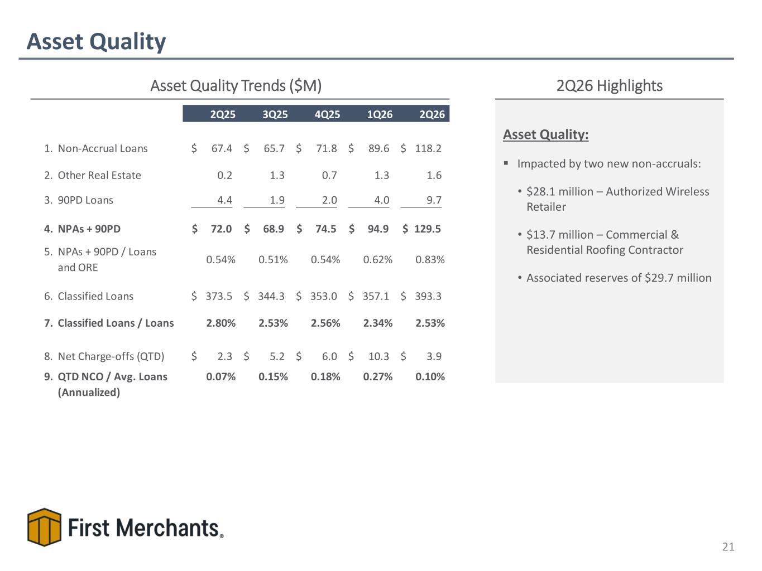
Asset Quality 21 Asset Quality Trends ($M) 2Q26 Highlights Asset Quality: ▪ Impacted by two new non-accruals: • $28.1 million – Authorized Wireless Retailer • $13.7 million – Commercial & Residential Roofing Contractor • Associated reserves of $29.7 million 2Q25 3Q25 4Q25 1Q26 2Q26 1. Non-Accrual Loans 67.4$ 65.7$ 71.8$ 89.6$ 118.2$ 2. Other Real Estate 0.2 1.3 0.7 1.3 1.6 3. 90PD Loans 4.4 1.9 2.0 4.0 9.7 4. NPAs + 90PD 72.0$ 68.9$ 74.5$ 94.9$ 129.5$ 5. NPAs + 90PD / Loans and ORE 0.54% 0.51% 0.54% 0.62% 0.83% 6. Classified Loans 373.5$ 344.3$ 353.0$ 357.1$ 393.3$ 7. Classified Loans / Loans 2.80% 2.53% 2.56% 2.34% 2.53% 8. Net Charge-offs (QTD) 2.3$ 5.2$ 6.0$ 10.3$ 3.9$ 9. QTD NCO / Avg. Loans (Annualized) 0.07% 0.15% 0.18% 0.27% 0.10%

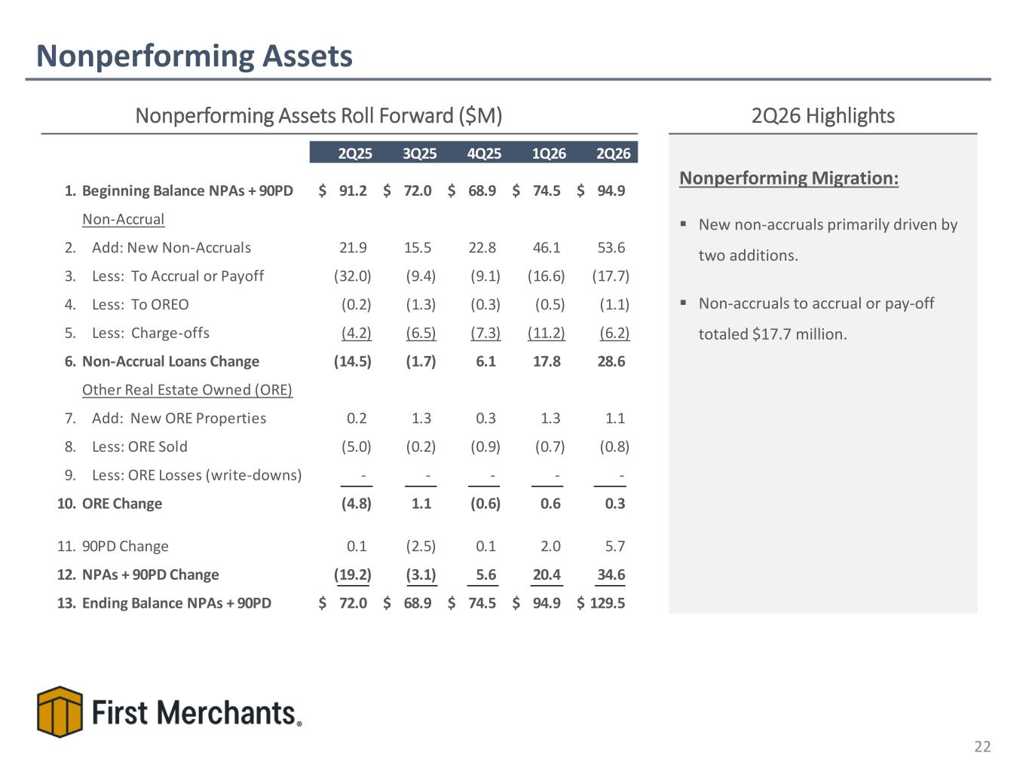
Nonperforming Assets 22 Nonperforming Assets Roll Forward ($M) 2Q26 Highlights Nonperforming Migration: ▪ New non-accruals primarily driven by two additions. ▪ Non-accruals to accrual or pay-off totaled $17.7 million. 2Q25 3Q25 4Q25 1Q26 2Q26 1. Beginning Balance NPAs + 90PD 91.2$ 72.0$ 68.9$ 74.5$ 94.9$ Non-Accrual 2. Add: New Non-Accruals 21.9 15.5 22.8 46.1 53.6 3. Less: To Accrual or Payoff (32.0) (9.4) (9.1) (16.6) (17.7) 4. Less: To OREO (0.2) (1.3) (0.3) (0.5) (1.1) 5. Less: Charge-offs (4.2) (6.5) (7.3) (11.2) (6.2) 6. Non-Accrual Loans Change (14.5) (1.7) 6.1 17.8 28.6 Other Real Estate Owned (ORE) 7. Add: New ORE Properties 0.2 1.3 0.3 1.3 1.1 8. Less: ORE Sold (5.0) (0.2) (0.9) (0.7) (0.8) 9. Less: ORE Losses (write-downs) - - - - - 10. ORE Change (4.8) 1.1 (0.6) 0.6 0.3 11. 90PD Change 0.1 (2.5) 0.1 2.0 5.7 12. NPAs + 90PD Change (19.2) (3.1) 5.6 20.4 34.6 13. Ending Balance NPAs + 90PD 72.0$ 68.9$ 74.5$ 94.9$ 129.5$

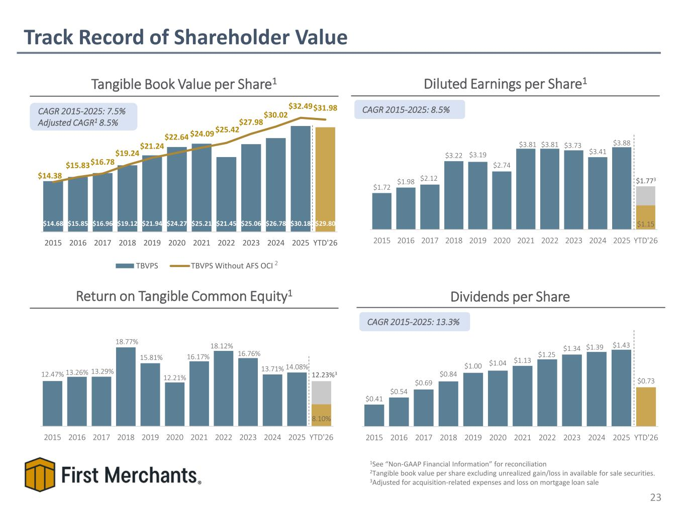
$14.68 $15.85 $16.96 $19.12 $21.94 $24.27 $25.21 $21.45 $25.06 $26.78 $30.18 $29.80 $14.38 $15.83 $16.78 $19.24 $21.24 $22.64 $24.09 $25.42 $27.98 $30.02 $32.49 $31.98 2015 2016 2017 2018 2019 2020 2021 2022 2023 2024 2025 YTD'26 TBVPS TBVPS Without AFS OCI $0.41 $0.54 $0.69 $0.84 $1.00 $1.04 $1.13 $1.25 $1.34 $1.39 $1.43 $0.73 2015 2016 2017 2018 2019 2020 2021 2022 2023 2024 2025 YTD'26 12.47% 13.26% 13.29% 18.77% 15.81% 12.21% 16.17% 18.12% 16.76% 13.71% 14.08% 8.10% 2015 2016 2017 2018 2019 2020 2021 2022 2023 2024 2025 YTD'26 $1.72 $1.98 $2.12 $3.22 $3.19 $2.74 $3.81 $3.81 $3.73 $3.41 $3.88 $1.15 2015 2016 2017 2018 2019 2020 2021 2022 2023 2024 2025 YTD'26 Track Record of Shareholder Value 23 Diluted Earnings per Share1Tangible Book Value per Share1 Dividends per Share CAGR 2015-2025: 8.5% Return on Tangible Common Equity1 1See “Non-GAAP Financial Information” for reconciliation 2Tangible book value per share excluding unrealized gain/loss in available for sale securities. 3Adjusted for acquisition-related expenses and loss on mortgage loan sale CAGR 2015-2025: 13.3% 2 CAGR 2015-2025: 7.5% Adjusted CAGR1 8.5% 12.23%3 $1.773

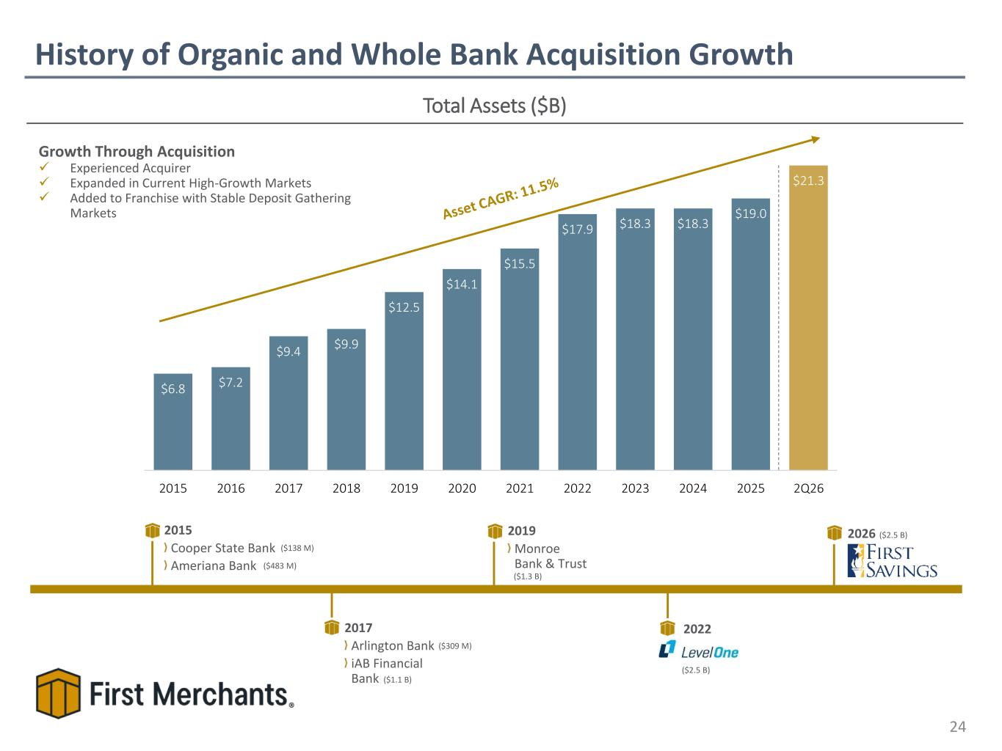
$6.8 $7.2 $9.4 $9.9 $12.5 $14.1 $15.5 $17.9 $18.3 $18.3 $19.0 $21.3 2015 2016 2017 2018 2019 2020 2021 2022 2023 2024 2025 2Q26 History of Organic and Whole Bank Acquisition Growth 24 Total Assets ($B) Growth Through Acquisition ✓ Experienced Acquirer ✓ Expanded in Current High-Growth Markets ✓ Added to Franchise with Stable Deposit Gathering Markets 2015 Cooper State Bank Ameriana Bank 2017 Arlington Bank iAB Financial Bank 2019 Monroe Bank & Trust 2022 ($309 M) ($138 M) ($2.5 B) ($1.3 B) ($483 M) ($1.1 B) 2026 ($2.5 B)

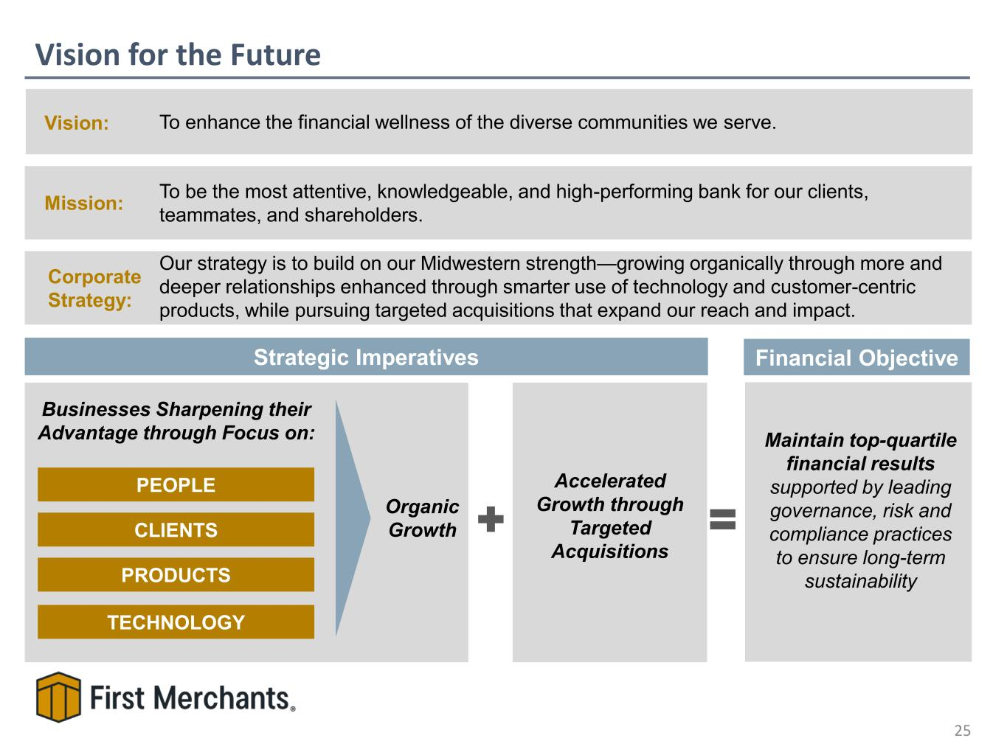
Vision for the Future 25 Mission: To be the most attentive, knowledgeable, and high-performing bank for our clients, teammates, and shareholders. Strategic Imperatives Vision: To enhance the financial wellness of the diverse communities we serve. PEOPLE CLIENTS PRODUCTS TECHNOLOGY Businesses Sharpening their Advantage through Focus on: Accelerated Growth through Targeted Acquisitions Organic Growth Maintain top-quartile financial results supported by leading governance, risk and compliance practices to ensure long-term sustainability Financial Objective Corporate Strategy: Our strategy is to build on our Midwestern strength—growing organically through more and deeper relationships enhanced through smarter use of technology and customer-centric products, while pursuing targeted acquisitions that expand our reach and impact.

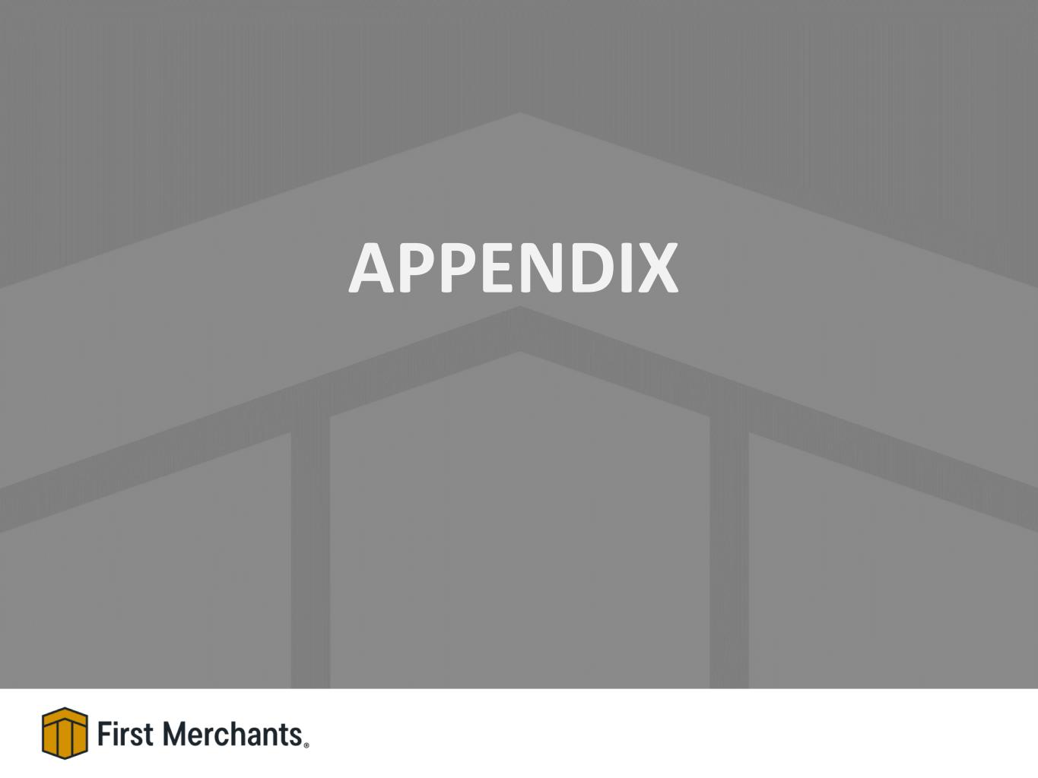
APPENDIX

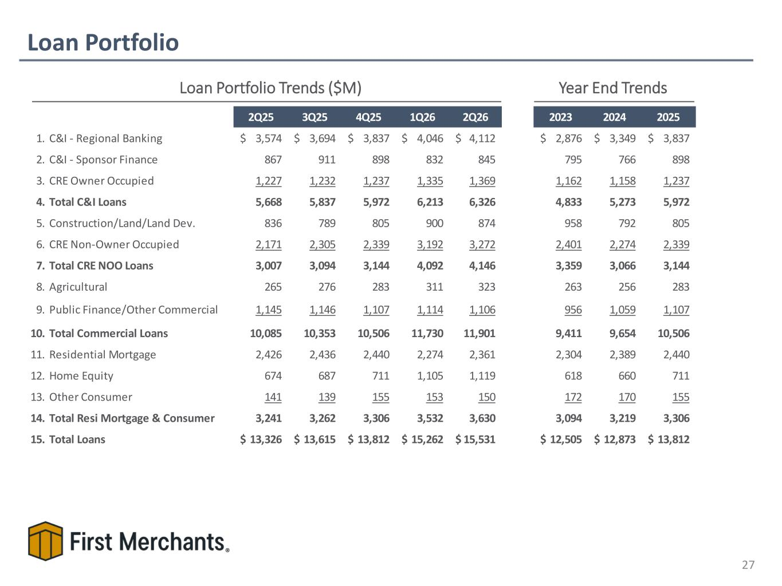
Loan Portfolio 27 Loan Portfolio Trends ($M) Year End Trends 2Q25 3Q25 4Q25 1Q26 2Q26 2023 2024 2025 1. C&I - Regional Banking 3,574$ 3,694$ 3,837$ 4,046$ 4,112$ 2,876$ 3,349$ 3,837$ 2. C&I - Sponsor Finance 867 911 898 832 845 795 766 898 3. CRE Owner Occupied 1,227 1,232 1,237 1,335 1,369 1,162 1,158 1,237 4. Total C&I Loans 5,668 5,837 5,972 6,213 6,326 4,833 5,273 5,972 5. Construction/Land/Land Dev. 836 789 805 900 874 958 792 805 6. CRE Non-Owner Occupied 2,171 2,305 2,339 3,192 3,272 2,401 2,274 2,339 7. Total CRE NOO Loans 3,007 3,094 3,144 4,092 4,146 3,359 3,066 3,144 8. Agricultural 265 276 283 311 323 263 256 283 9. Public Finance/Other Commercial 1,145 1,146 1,107 1,114 1,106 956 1,059 1,107 10. Total Commercial Loans 10,085 10,353 10,506 11,730 11,901 9,411 9,654 10,506 11. Residential Mortgage 2,426 2,436 2,440 2,274 2,361 2,304 2,389 2,440 12. Home Equity 674 687 711 1,105 1,119 618 660 711 13. Other Consumer 141 139 155 153 150 172 170 155 14. Total Resi Mortgage & Consumer 3,241 3,262 3,306 3,532 3,630 3,094 3,219 3,306 15. Total Loans 13,326$ 13,615$ 13,812$ 15,262$ 15,531$ 12,505$ 12,873$ 13,812$

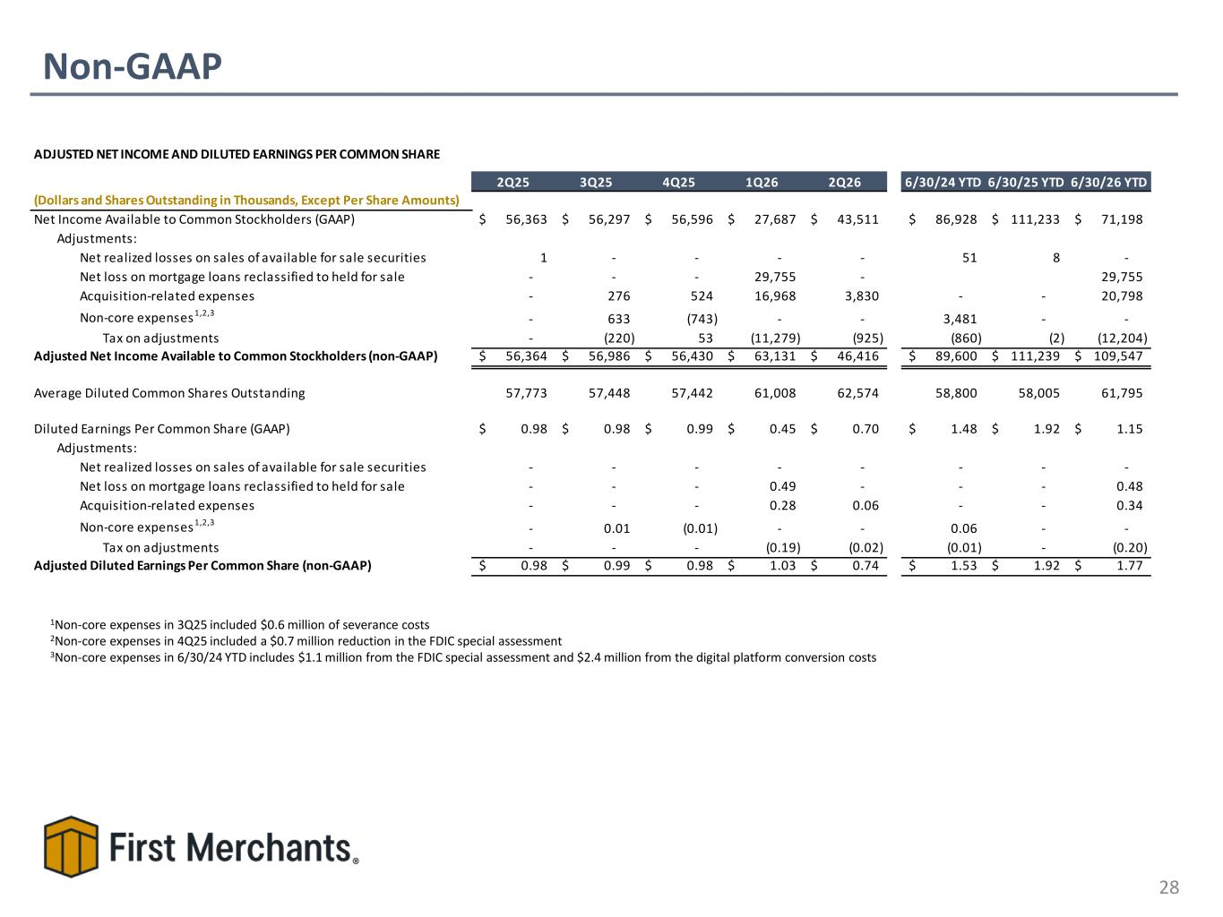
Non-GAAP 28 1Non-core expenses in 3Q25 included $0.6 million of severance costs 2Non-core expenses in 4Q25 included a $0.7 million reduction in the FDIC special assessment 3Non-core expenses in 6/30/24 YTD includes $1.1 million from the FDIC special assessment and $2.4 million from the digital platform conversion costs ADJUSTED NET INCOME AND DILUTED EARNINGS PER COMMON SHARE 2Q25 3Q25 4Q25 1Q26 2Q26 6/30/24 YTD 6/30/25 YTD 6/30/26 YTD (Dollars and Shares Outstanding in Thousands, Except Per Share Amounts) Net Income Available to Common Stockholders (GAAP) 56,363$ 56,297$ 56,596$ 27,687$ 43,511$ 86,928$ 111,233$ 71,198$ Adjustments: Net realized losses on sales of available for sale securities 1 - - - - 51 8 - Net loss on mortgage loans reclassified to held for sale - - - 29,755 - 29,755 Acquisition-related expenses - 276 524 16,968 3,830 - - 20,798 Non-core expenses1,2,3 - 633 (743) - - 3,481 - - Tax on adjustments - (220) 53 (11,279) (925) (860) (2) (12,204) Adjusted Net Income Available to Common Stockholders (non-GAAP) 56,364$ 56,986$ 56,430$ 63,131$ 46,416$ 89,600$ 111,239$ 109,547$ Average Diluted Common Shares Outstanding 57,773 57,448 57,442 61,008 62,574 58,800 58,005 61,795 Diluted Earnings Per Common Share (GAAP) 0.98$ 0.98$ 0.99$ 0.45$ 0.70$ 1.48$ 1.92$ 1.15$ Adjustments: Net realized losses on sales of available for sale securities - - - - - - - - Net loss on mortgage loans reclassified to held for sale - - - 0.49 - - - 0.48 Acquisition-related expenses - - - 0.28 0.06 - - 0.34 Non-core expenses1,2,3 - 0.01 (0.01) - - 0.06 - - Tax on adjustments - - - (0.19) (0.02) (0.01) - (0.20) Adjusted Diluted Earnings Per Common Share (non-GAAP) 0.98$ 0.99$ 0.98$ 1.03$ 0.74$ 1.53$ 1.92$ 1.77$

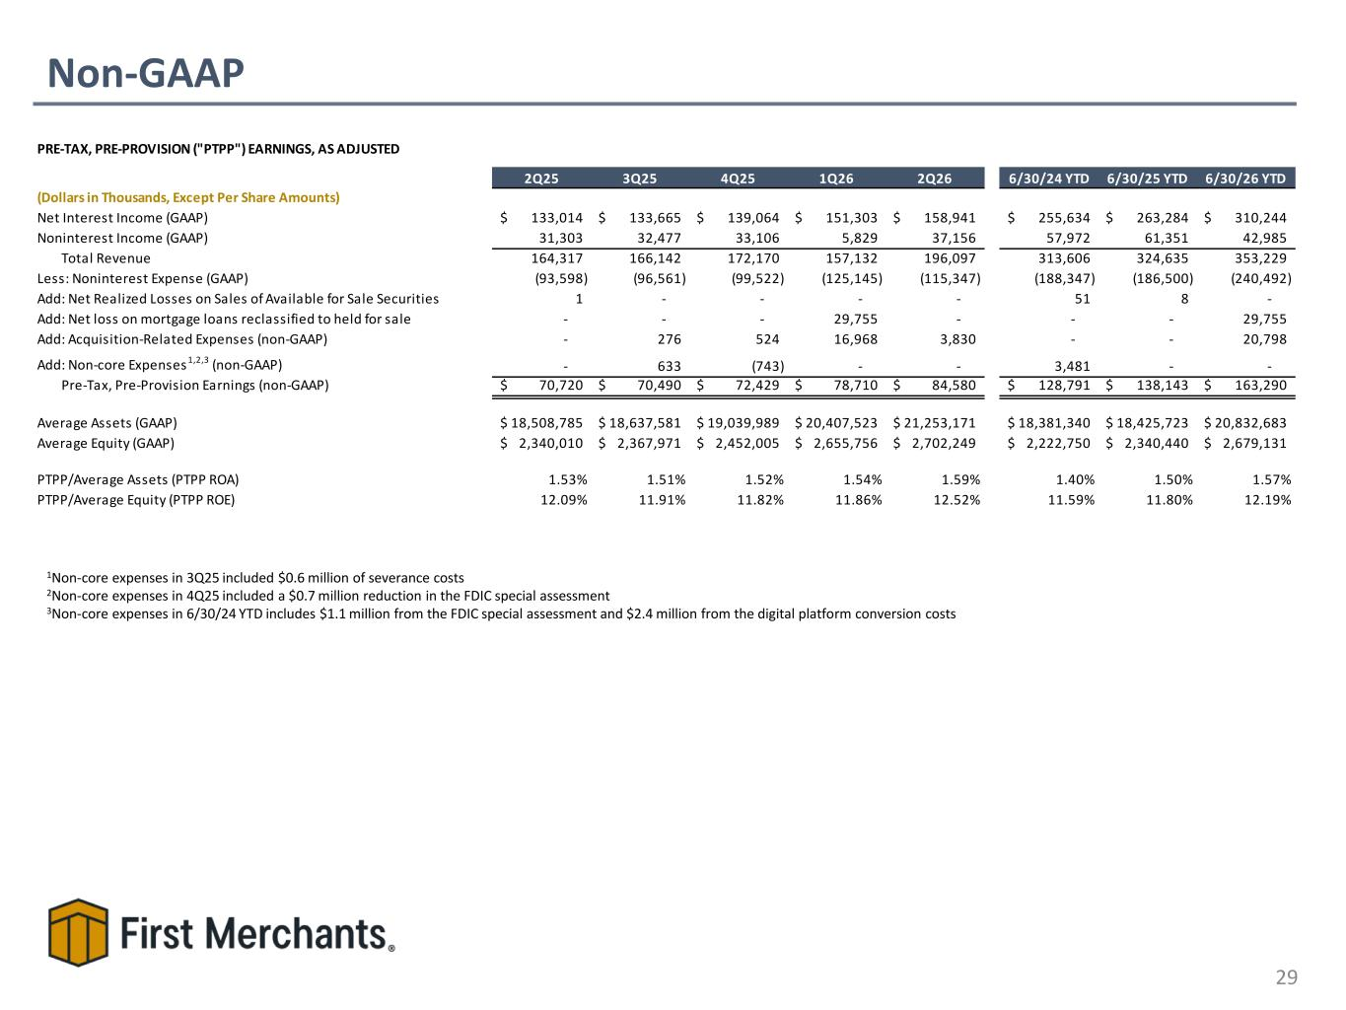
Non-GAAP 29 1Non-core expenses in 3Q25 included $0.6 million of severance costs 2Non-core expenses in 4Q25 included a $0.7 million reduction in the FDIC special assessment 3Non-core expenses in 6/30/24 YTD includes $1.1 million from the FDIC special assessment and $2.4 million from the digital platform conversion costs PRE-TAX, PRE-PROVISION ("PTPP") EARNINGS, AS ADJUSTED 2Q25 3Q25 4Q25 1Q26 2Q26 6/30/24 YTD 6/30/25 YTD 6/30/26 YTD (Dollars in Thousands, Except Per Share Amounts) Net Interest Income (GAAP) 133,014$ 133,665$ 139,064$ 151,303$ 158,941$ 255,634$ 263,284$ 310,244$ Noninterest Income (GAAP) 31,303 32,477 33,106 5,829 37,156 57,972 61,351 42,985 Total Revenue 164,317 166,142 172,170 157,132 196,097 313,606 324,635 353,229 Less: Noninterest Expense (GAAP) (93,598) (96,561) (99,522) (125,145) (115,347) (188,347) (186,500) (240,492) Add: Net Realized Losses on Sales of Available for Sale Securities 1 - - - - 51 8 - Add: Net loss on mortgage loans reclassified to held for sale - - - 29,755 - - - 29,755 Add: Acquisition-Related Expenses (non-GAAP) - 276 524 16,968 3,830 - - 20,798 Add: Non-core Expenses1,2,3 (non-GAAP) - 633 (743) - - 3,481 - - Pre-Tax, Pre-Provision Earnings (non-GAAP) 70,720$ 70,490$ 72,429$ 78,710$ 84,580$ 128,791$ 138,143$ 163,290$ Average Assets (GAAP) 18,508,785$ 18,637,581$ 19,039,989$ 20,407,523$ 21,253,171$ 18,381,340$ 18,425,723$ 20,832,683$ Average Equity (GAAP) 2,340,010$ 2,367,971$ 2,452,005$ 2,655,756$ 2,702,249$ 2,222,750$ 2,340,440$ 2,679,131$ PTPP/Average Assets (PTPP ROA) 1.53% 1.51% 1.52% 1.54% 1.59% 1.40% 1.50% 1.57% PTPP/Average Equity (PTPP ROE) 12.09% 11.91% 11.82% 11.86% 12.52% 11.59% 11.80% 12.19%

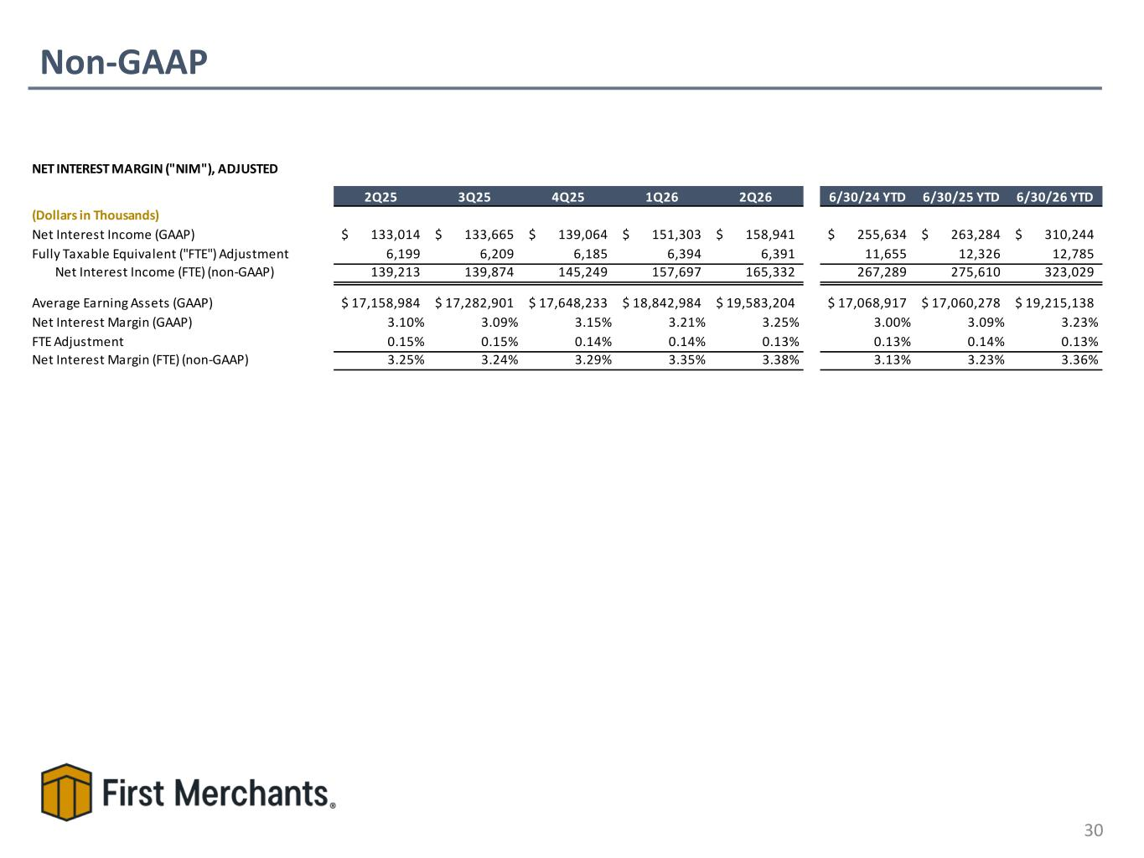
Non-GAAP 30 NET INTEREST MARGIN ("NIM"), ADJUSTED 2Q25 3Q25 4Q25 1Q26 2Q26 6/30/24 YTD 6/30/25 YTD 6/30/26 YTD (Dollars in Thousands) Net Interest Income (GAAP) 133,014$ 133,665$ 139,064$ 151,303$ 158,941$ 255,634$ 263,284$ 310,244$ Fully Taxable Equivalent ("FTE") Adjustment 6,199 6,209 6,185 6,394 6,391 11,655 12,326 12,785 Net Interest Income (FTE) (non-GAAP) 139,213 139,874 145,249 157,697 165,332 267,289 275,610 323,029 Average Earning Assets (GAAP) 17,158,984$ 17,282,901$ 17,648,233$ 18,842,984$ 19,583,204$ 17,068,917$ 17,060,278$ 19,215,138$ Net Interest Margin (GAAP) 3.10% 3.09% 3.15% 3.21% 3.25% 3.00% 3.09% 3.23% FTE Adjustment 0.15% 0.15% 0.14% 0.14% 0.13% 0.13% 0.14% 0.13% Net Interest Margin (FTE) (non-GAAP) 3.25% 3.24% 3.29% 3.35% 3.38% 3.13% 3.23% 3.36%

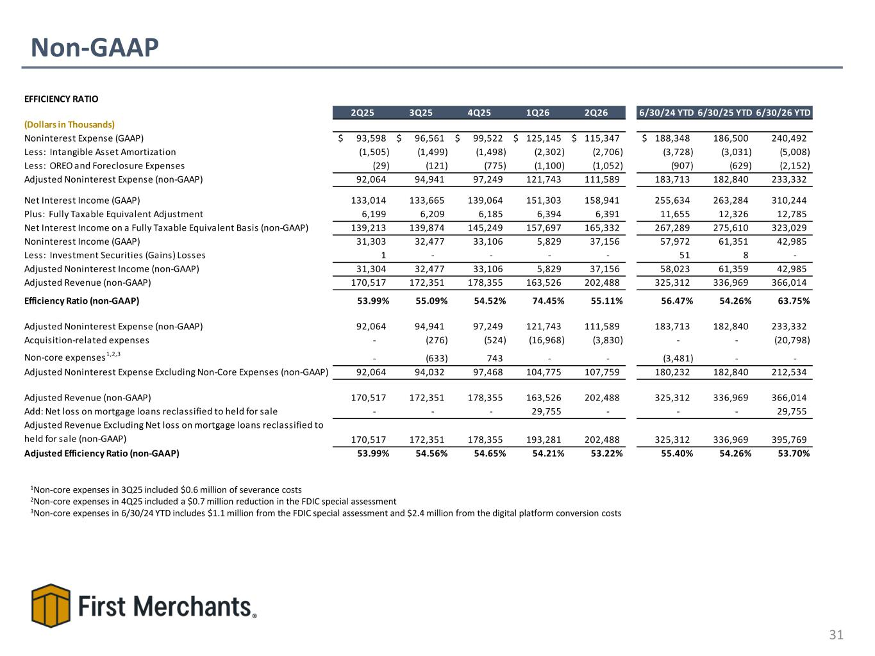
Non-GAAP 31 1Non-core expenses in 3Q25 included $0.6 million of severance costs 2Non-core expenses in 4Q25 included a $0.7 million reduction in the FDIC special assessment 3Non-core expenses in 6/30/24 YTD includes $1.1 million from the FDIC special assessment and $2.4 million from the digital platform conversion costs EFFICIENCY RATIO 2Q25 3Q25 4Q25 1Q26 2Q26 6/30/24 YTD 6/30/25 YTD 6/30/26 YTD (Dollars in Thousands) Noninterest Expense (GAAP) 93,598$ 96,561$ 99,522$ 125,145$ 115,347$ 188,348$ 186,500 240,492 Less: Intangible Asset Amortization (1,505) (1,499) (1,498) (2,302) (2,706) (3,728) (3,031) (5,008) Less: OREO and Foreclosure Expenses (29) (121) (775) (1,100) (1,052) (907) (629) (2,152) Adjusted Noninterest Expense (non-GAAP) 92,064 94,941 97,249 121,743 111,589 183,713 182,840 233,332 Net Interest Income (GAAP) 133,014 133,665 139,064 151,303 158,941 255,634 263,284 310,244 Plus: Fully Taxable Equivalent Adjustment 6,199 6,209 6,185 6,394 6,391 11,655 12,326 12,785 Net Interest Income on a Fully Taxable Equivalent Basis (non-GAAP) 139,213 139,874 145,249 157,697 165,332 267,289 275,610 323,029 Noninterest Income (GAAP) 31,303 32,477 33,106 5,829 37,156 57,972 61,351 42,985 Less: Investment Securities (Gains) Losses 1 - - - - 51 8 - Adjusted Noninterest Income (non-GAAP) 31,304 32,477 33,106 5,829 37,156 58,023 61,359 42,985 Adjusted Revenue (non-GAAP) 170,517 172,351 178,355 163,526 202,488 325,312 336,969 366,014 Efficiency Ratio (non-GAAP) 53.99% 55.09% 54.52% 74.45% 55.11% 56.47% 54.26% 63.75% Adjusted Noninterest Expense (non-GAAP) 92,064 94,941 97,249 121,743 111,589 183,713 182,840 233,332 Acquisition-related expenses - (276) (524) (16,968) (3,830) - - (20,798) Non-core expenses1,2,3 - (633) 743 - - (3,481) - - Adjusted Noninterest Expense Excluding Non-Core Expenses (non-GAAP) 92,064 94,032 97,468 104,775 107,759 180,232 182,840 212,534 Adjusted Revenue (non-GAAP) 170,517 172,351 178,355 163,526 202,488 325,312 336,969 366,014 Add: Net loss on mortgage loans reclassified to held for sale - - - 29,755 - - - 29,755 Adjusted Revenue Excluding Net loss on mortgage loans reclassified to held for sale (non-GAAP) 170,517 172,351 178,355 193,281 202,488 325,312 336,969 395,769 Adjusted Efficiency Ratio (non-GAAP) 53.99% 54.56% 54.65% 54.21% 53.22% 55.40% 54.26% 53.70%

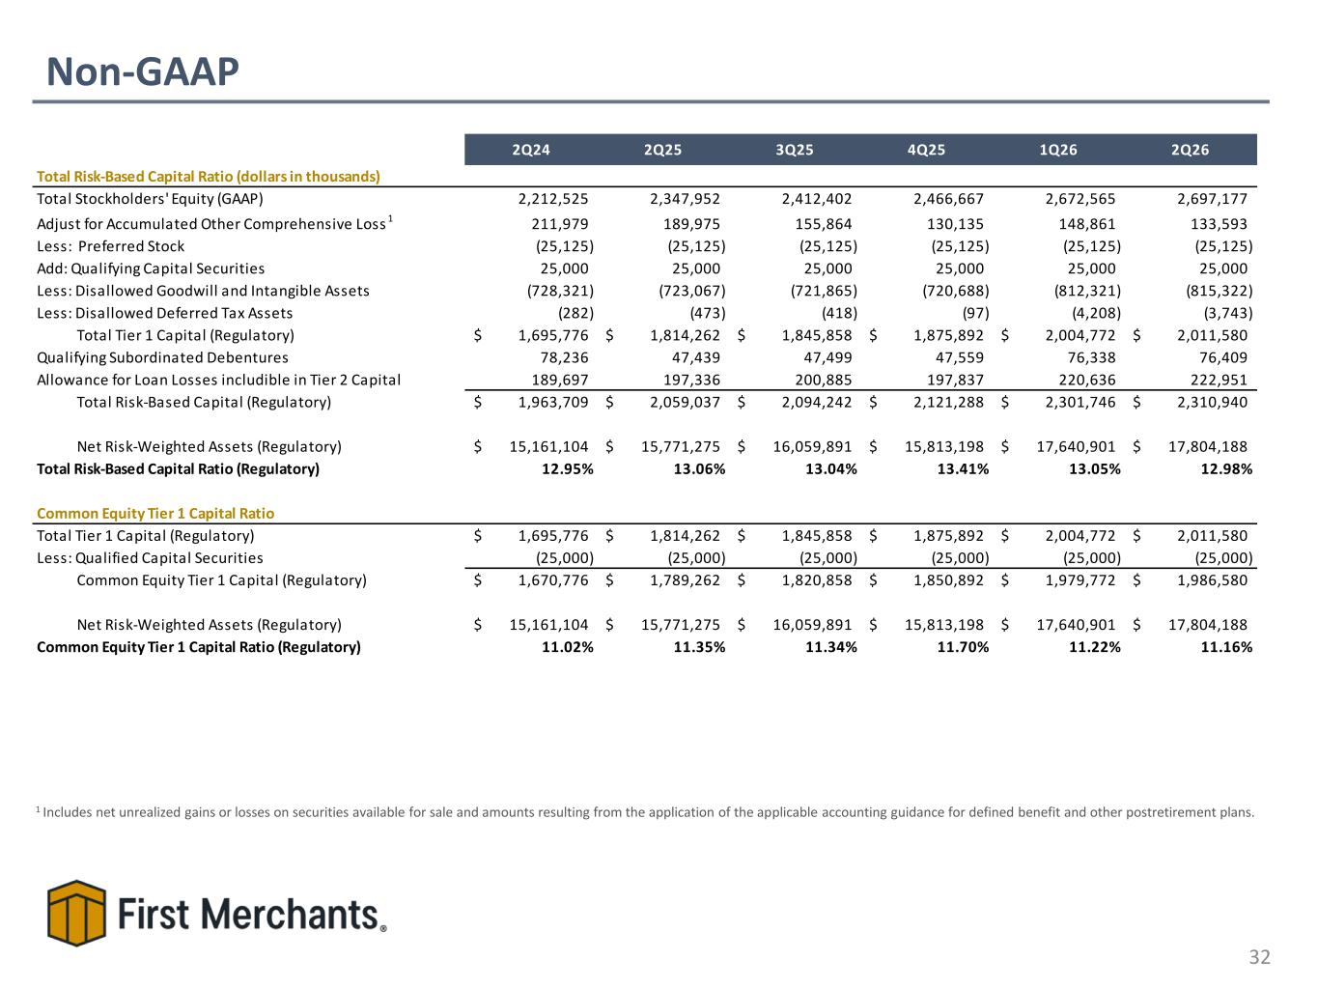
Non-GAAP 32 1 Includes net unrealized gains or losses on securities available for sale and amounts resulting from the application of the applicable accounting guidance for defined benefit and other postretirement plans. 2Q24 2Q25 3Q25 4Q25 1Q26 2Q26 Total Risk-Based Capital Ratio (dollars in thousands) Total Stockholders' Equity (GAAP) 2,212,525 2,347,952 2,412,402 2,466,667 2,672,565 2,697,177 Adjust for Accumulated Other Comprehensive Loss 1 211,979 189,975 155,864 130,135 148,861 133,593 Less: Preferred Stock (25,125) (25,125) (25,125) (25,125) (25,125) (25,125) Add: Qualifying Capital Securities 25,000 25,000 25,000 25,000 25,000 25,000 Less: Disallowed Goodwill and Intangible Assets (728,321) (723,067) (721,865) (720,688) (812,321) (815,322) Less: Disallowed Deferred Tax Assets (282) (473) (418) (97) (4,208) (3,743) Total Tier 1 Capital (Regulatory) 1,695,776$ 1,814,262$ 1,845,858$ 1,875,892$ 2,004,772$ 2,011,580$ Qualifying Subordinated Debentures 78,236 47,439 47,499 47,559 76,338 76,409 Allowance for Loan Losses includible in Tier 2 Capital 189,697 197,336 200,885 197,837 220,636 222,951 Total Risk-Based Capital (Regulatory) 1,963,709$ 2,059,037$ 2,094,242$ 2,121,288$ 2,301,746$ 2,310,940$ Net Risk-Weighted Assets (Regulatory) 15,161,104$ 15,771,275$ 16,059,891$ 15,813,198$ 17,640,901$ 17,804,188$ Total Risk-Based Capital Ratio (Regulatory) 12.95% 13.06% 13.04% 13.41% 13.05% 12.98% Common Equity Tier 1 Capital Ratio Total Tier 1 Capital (Regulatory) 1,695,776$ 1,814,262$ 1,845,858$ 1,875,892$ 2,004,772$ 2,011,580$ Less: Qualified Capital Securities (25,000) (25,000) (25,000) (25,000) (25,000) (25,000) Common Equity Tier 1 Capital (Regulatory) 1,670,776$ 1,789,262$ 1,820,858$ 1,850,892$ 1,979,772$ 1,986,580$ Net Risk-Weighted Assets (Regulatory) 15,161,104$ 15,771,275$ 16,059,891$ 15,813,198$ 17,640,901$ 17,804,188$ Common Equity Tier 1 Capital Ratio (Regulatory) 11.02% 11.35% 11.34% 11.70% 11.22% 11.16%

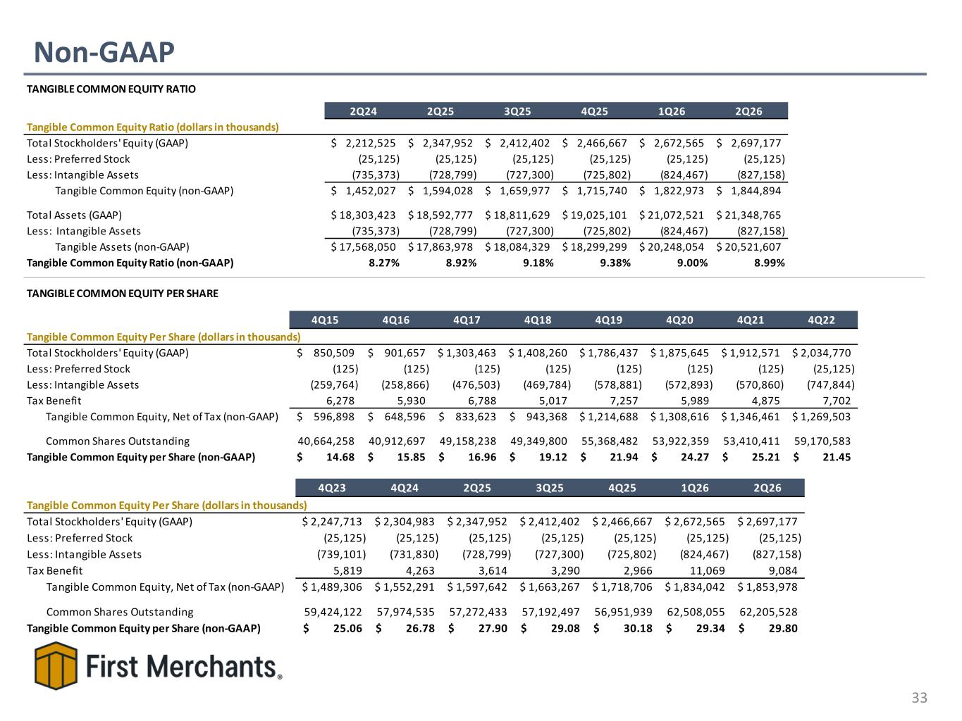
Non-GAAP 33 TANGIBLE COMMON EQUITY RATIO 2Q24 2Q25 3Q25 4Q25 1Q26 2Q26 Tangible Common Equity Ratio (dollars in thousands) Total Stockholders' Equity (GAAP) 2,212,525$ 2,347,952$ 2,412,402$ 2,466,667$ 2,672,565$ 2,697,177$ Less: Preferred Stock (25,125) (25,125) (25,125) (25,125) (25,125) (25,125) Less: Intangible Assets (735,373) (728,799) (727,300) (725,802) (824,467) (827,158) Tangible Common Equity (non-GAAP) 1,452,027$ 1,594,028$ 1,659,977$ 1,715,740$ 1,822,973$ 1,844,894$ Total Assets (GAAP) 18,303,423$ 18,592,777$ 18,811,629$ 19,025,101$ 21,072,521$ 21,348,765$ Less: Intangible Assets (735,373) (728,799) (727,300) (725,802) (824,467) (827,158) Tangible Assets (non-GAAP) 17,568,050$ 17,863,978$ 18,084,329$ 18,299,299$ 20,248,054$ 20,521,607$ Tangible Common Equity Ratio (non-GAAP) 8.27% 8.92% 9.18% 9.38% 9.00% 8.99% TANGIBLE COMMON EQUITY PER SHARE 4Q15 4Q16 4Q17 4Q18 4Q19 4Q20 4Q21 4Q22 Tangible Common Equity Per Share (dollars in thousands) Total Stockholders' Equity (GAAP) 850,509$ 901,657$ 1,303,463$ 1,408,260$ 1,786,437$ 1,875,645$ 1,912,571$ 2,034,770$ Less: Preferred Stock (125) (125) (125) (125) (125) (125) (125) (25,125) Less: Intangible Assets (259,764) (258,866) (476,503) (469,784) (578,881) (572,893) (570,860) (747,844) Tax Benefit 6,278 5,930 6,788 5,017 7,257 5,989 4,875 7,702 Tangible Common Equity, Net of Tax (non-GAAP) 596,898$ 648,596$ 833,623$ 943,368$ 1,214,688$ 1,308,616$ 1,346,461$ 1,269,503$ Common Shares Outstanding 40,664,258 40,912,697 49,158,238 49,349,800 55,368,482 53,922,359 53,410,411 59,170,583 Tangible Common Equity per Share (non-GAAP) 14.68$ 15.85$ 16.96$ 19.12$ 21.94$ 24.27$ 25.21$ 21.45$ 4Q23 4Q24 2Q25 3Q25 4Q25 1Q26 2Q26 Tangible Common Equity Per Share (dollars in thousands) Total Stockholders' Equity (GAAP) 2,247,713$ 2,304,983$ 2,347,952$ 2,412,402$ 2,466,667$ 2,672,565$ 2,697,177$ Less: Preferred Stock (25,125) (25,125) (25,125) (25,125) (25,125) (25,125) (25,125) Less: Intangible Assets (739,101) (731,830) (728,799) (727,300) (725,802) (824,467) (827,158) Tax Benefit 5,819 4,263 3,614 3,290 2,966 11,069 9,084 Tangible Common Equity, Net of Tax (non-GAAP) 1,489,306$ 1,552,291$ 1,597,642$ 1,663,267$ 1,718,706$ 1,834,042$ 1,853,978$ Common Shares Outstanding 59,424,122 57,974,535 57,272,433 57,192,497 56,951,939 62,508,055 62,205,528 Tangible Common Equity per Share (non-GAAP) 25.06$ 26.78$ 27.90$ 29.08$ 30.18$ 29.34$ 29.80$

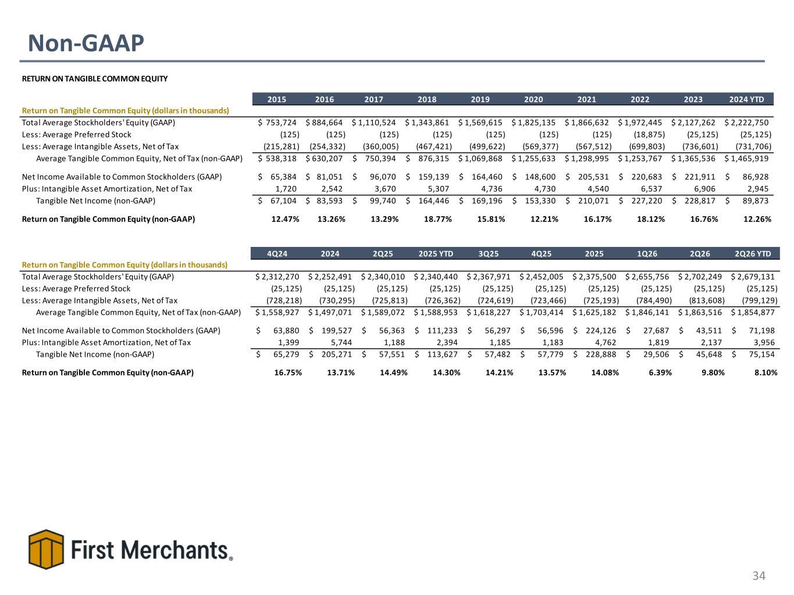
Non-GAAP 34 RETURN ON TANGIBLE COMMON EQUITY 2015 2016 2017 2018 2019 2020 2021 2022 2023 2024 YTD Return on Tangible Common Equity (dollars in thousands) Total Average Stockholders' Equity (GAAP) 753,724$ 884,664$ 1,110,524$ 1,343,861$ 1,569,615$ 1,825,135$ 1,866,632$ 1,972,445$ 2,127,262$ 2,222,750$ Less: Average Preferred Stock (125) (125) (125) (125) (125) (125) (125) (18,875) (25,125) (25,125) Less: Average Intangible Assets, Net of Tax (215,281) (254,332) (360,005) (467,421) (499,622) (569,377) (567,512) (699,803) (736,601) (731,706) Average Tangible Common Equity, Net of Tax (non-GAAP) 538,318$ 630,207$ 750,394$ 876,315$ 1,069,868$ 1,255,633$ 1,298,995$ 1,253,767$ 1,365,536$ 1,465,919$ Net Income Available to Common Stockholders (GAAP) 65,384$ 81,051$ 96,070$ 159,139$ 164,460$ 148,600$ 205,531$ 220,683$ 221,911$ 86,928$ Plus: Intangible Asset Amortization, Net of Tax 1,720 2,542 3,670 5,307 4,736 4,730 4,540 6,537 6,906 2,945 Tangible Net Income (non-GAAP) 67,104$ 83,593$ 99,740$ 164,446$ 169,196$ 153,330$ 210,071$ 227,220$ 228,817$ 89,873$ Return on Tangible Common Equity (non-GAAP) 12.47% 13.26% 13.29% 18.77% 15.81% 12.21% 16.17% 18.12% 16.76% 12.26% 4Q24 2024 2Q25 2025 YTD 3Q25 4Q25 2025 1Q26 2Q26 2Q26 YTD Return on Tangible Common Equity (dollars in thousands) Total Average Stockholders' Equity (GAAP) 2,312,270$ 2,252,491$ 2,340,010$ 2,340,440$ 2,367,971$ 2,452,005$ 2,375,500$ 2,655,756$ 2,702,249$ 2,679,131$ Less: Average Preferred Stock (25,125) (25,125) (25,125) (25,125) (25,125) (25,125) (25,125) (25,125) (25,125) (25,125) Less: Average Intangible Assets, Net of Tax (728,218) (730,295) (725,813) (726,362) (724,619) (723,466) (725,193) (784,490) (813,608) (799,129) Average Tangible Common Equity, Net of Tax (non-GAAP) 1,558,927$ 1,497,071$ 1,589,072$ 1,588,953$ 1,618,227$ 1,703,414$ 1,625,182$ 1,846,141$ 1,863,516$ 1,854,877$ Net Income Available to Common Stockholders (GAAP) 63,880$ 199,527$ 56,363$ 111,233$ 56,297$ 56,596$ 224,126$ 27,687$ 43,511$ 71,198$ Plus: Intangible Asset Amortization, Net of Tax 1,399 5,744 1,188 2,394 1,185 1,183 4,762 1,819 2,137 3,956 Tangible Net Income (non-GAAP) 65,279$ 205,271$ 57,551$ 113,627$ 57,482$ 57,779$ 228,888$ 29,506$ 45,648$ 75,154$ Return on Tangible Common Equity (non-GAAP) 16.75% 13.71% 14.49% 14.30% 14.21% 13.57% 14.08% 6.39% 9.80% 8.10%

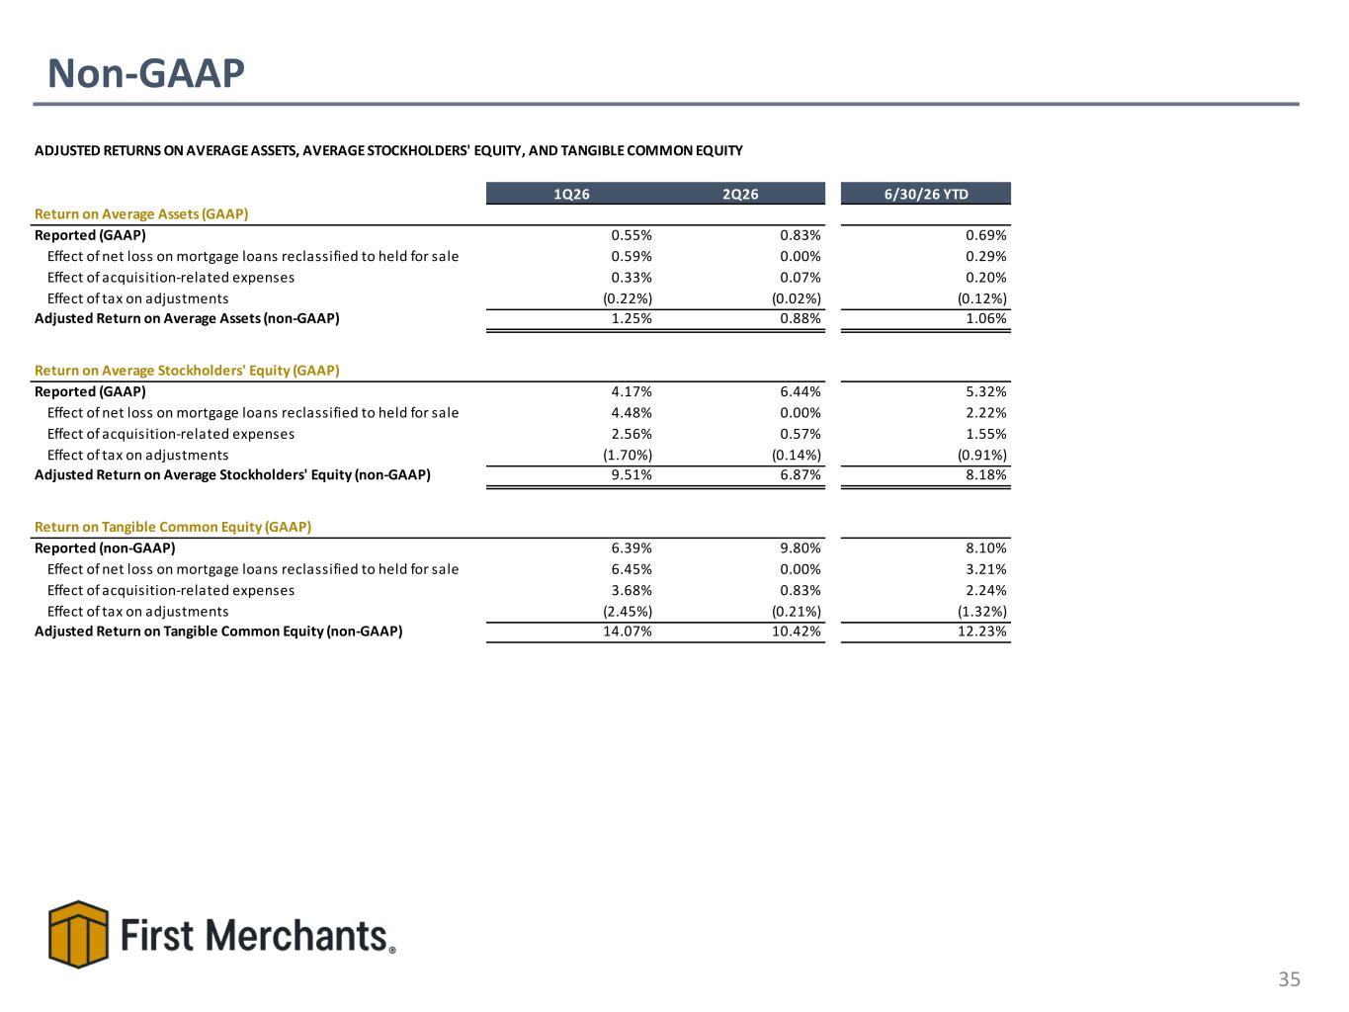
Non-GAAP 35 ADJUSTED RETURNS ON AVERAGE ASSETS, AVERAGE STOCKHOLDERS' EQUITY, AND TANGIBLE COMMON EQUITY 1Q26 2Q26 6/30/26 YTD Return on Average Assets (GAAP) Reported (GAAP) 0.55% 0.83% 0.69% Effect of net loss on mortgage loans reclassified to held for sale 0.59% 0.00% 0.29% Effect of acquisition-related expenses 0.33% 0.07% 0.20% Effect of tax on adjustments (0.22%) (0.02%) (0.12%) Adjusted Return on Average Assets (non-GAAP) 1.25% 0.88% 1.06% Return on Average Stockholders' Equity (GAAP) Reported (GAAP) 4.17% 6.44% 5.32% Effect of net loss on mortgage loans reclassified to held for sale 4.48% 0.00% 2.22% Effect of acquisition-related expenses 2.56% 0.57% 1.55% Effect of tax on adjustments (1.70%) (0.14%) (0.91%) Adjusted Return on Average Stockholders' Equity (non-GAAP) 9.51% 6.87% 8.18% Return on Tangible Common Equity (GAAP) Reported (non-GAAP) 6.39% 9.80% 8.10% Effect of net loss on mortgage loans reclassified to held for sale 6.45% 0.00% 3.21% Effect of acquisition-related expenses 3.68% 0.83% 2.24% Effect of tax on adjustments (2.45%) (0.21%) (1.32%) Adjusted Return on Tangible Common Equity (non-GAAP) 14.07% 10.42% 12.23%

